**201. TRELLO_UPDATE_BOARD_STAR_POSITION**

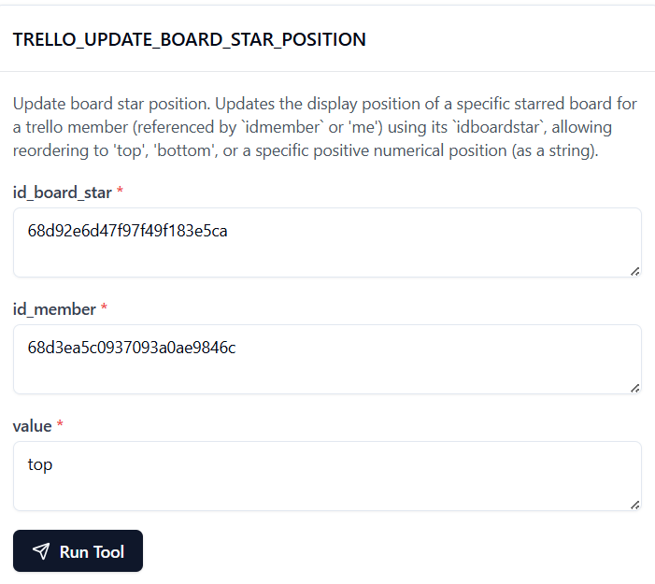

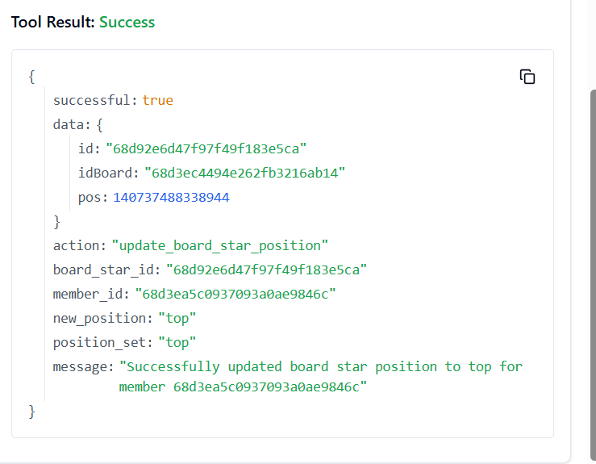

**202. TRELLO_UPDATE_CARD_CHECKLIST_ITEM_POSITION**

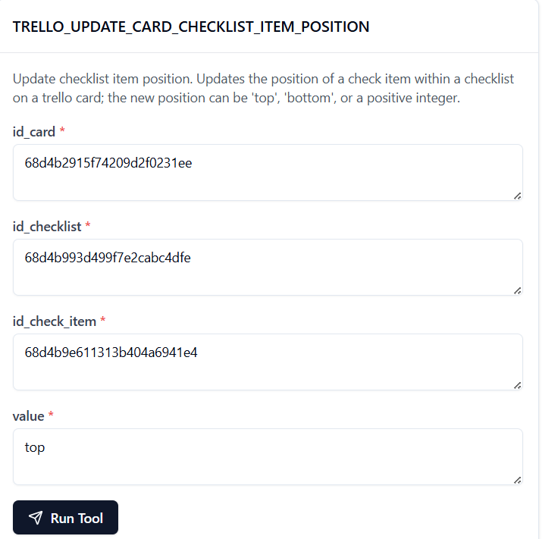

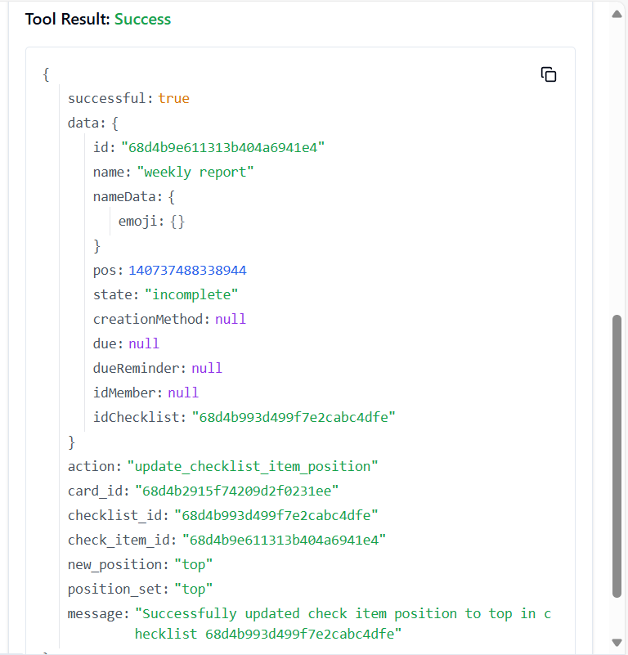

**203. TRELLO_UPDATE_CARD_CHECKLIST_ITEM_STATE_BY_IDS**

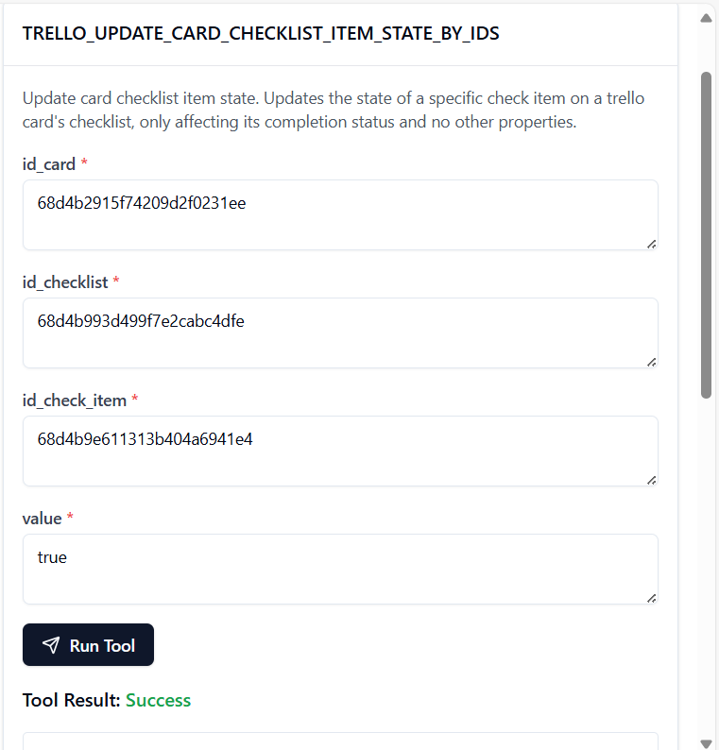

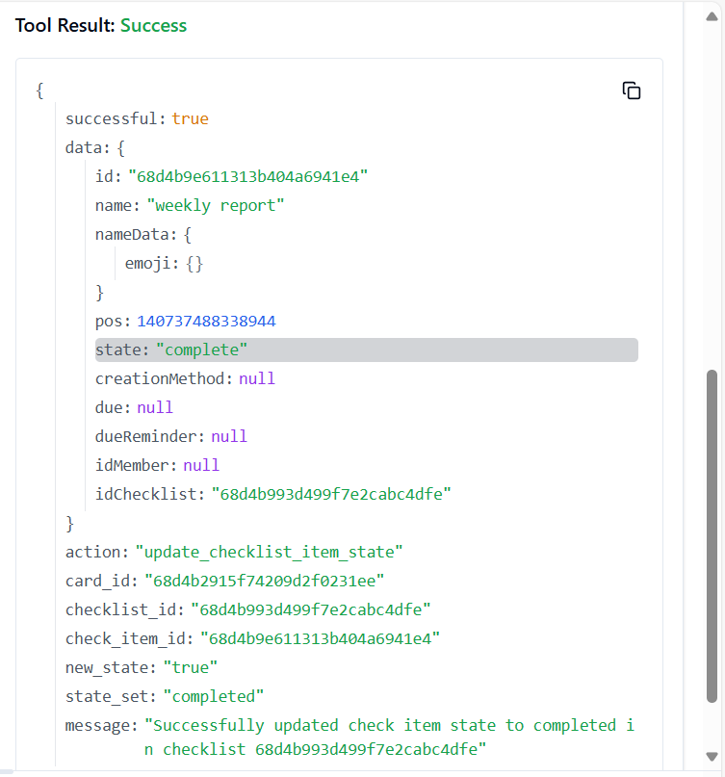

**204. TRELLO_UPDATE_CARD_COMMENT**

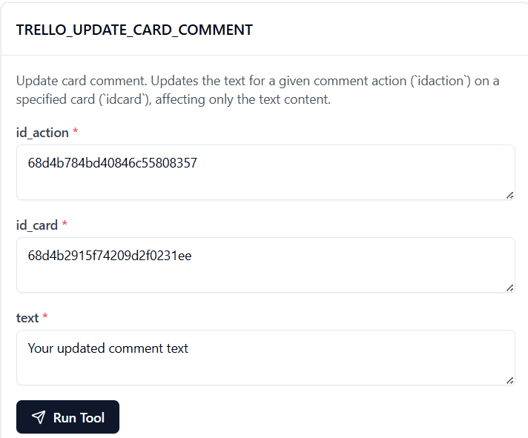

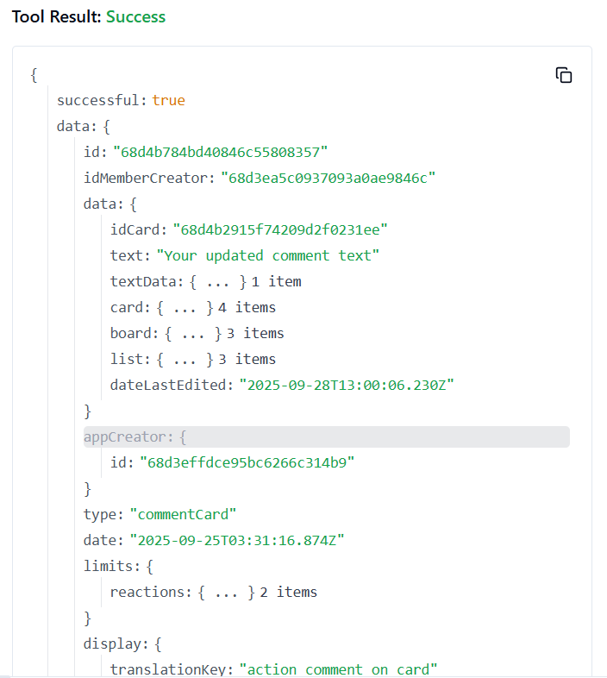

**205. TRELLO_UPDATE_CARDS_CLOSED_BY_ID_CARD**

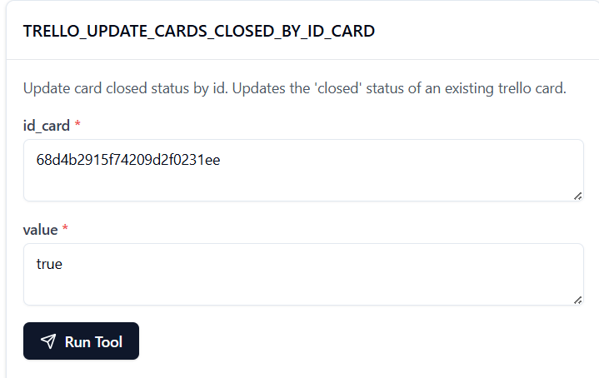

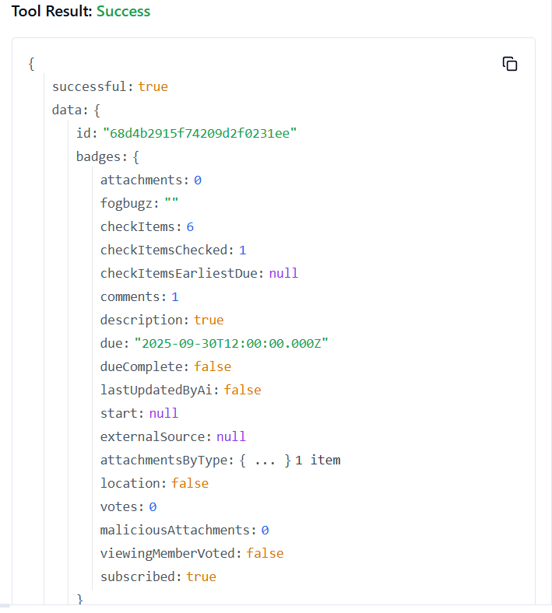

**206. TRELLO_UPDATE_CARDS_DESC_BY_ID_CARD**

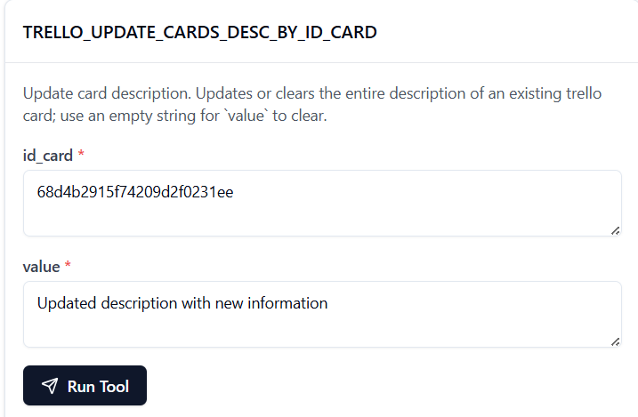

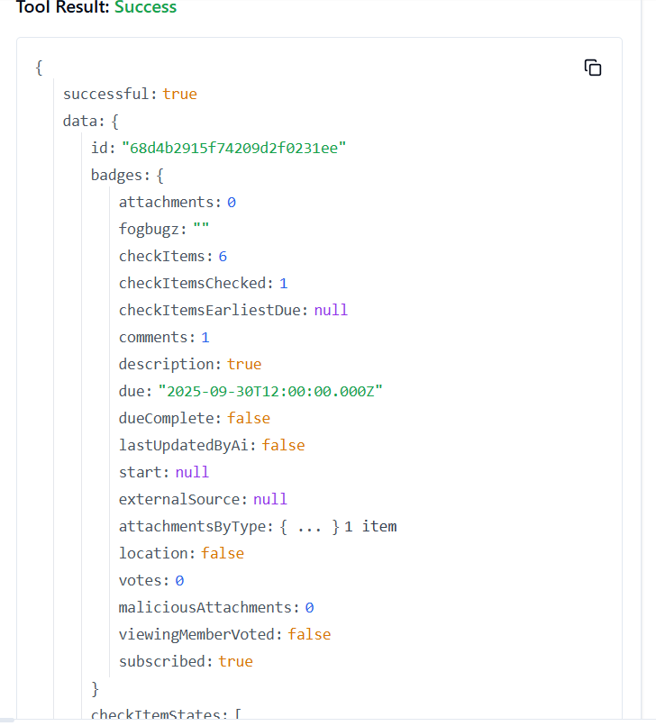

**207. TRELLO_UPDATE_CARDS_DUE_BY_ID_CARD**

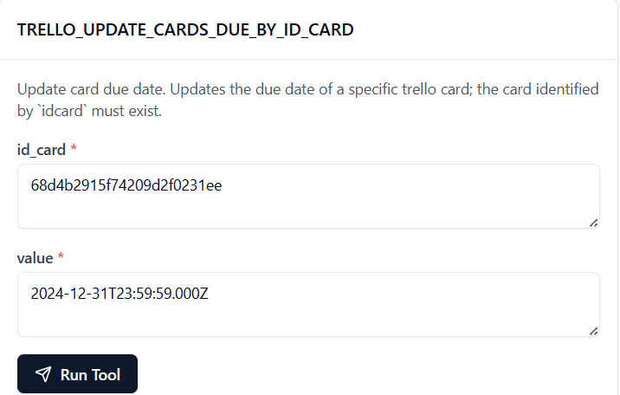

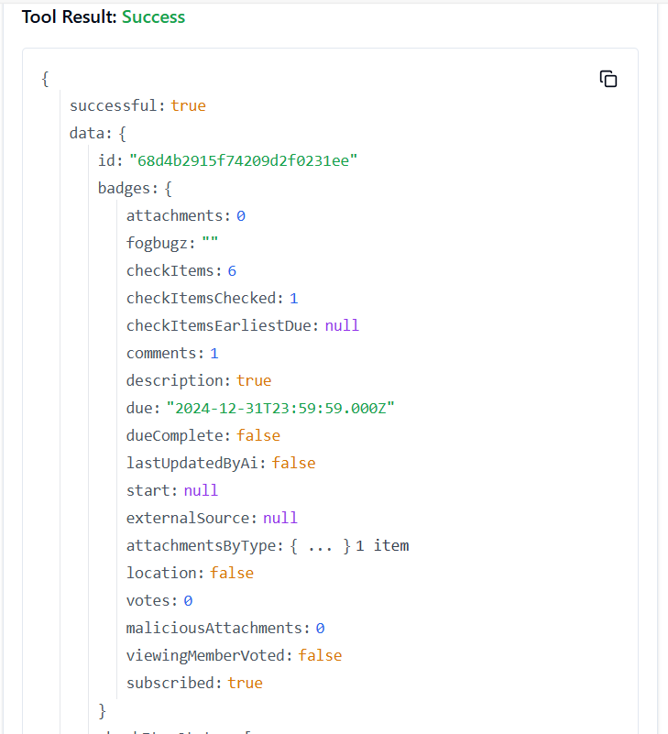

**208. TRELLO_UPDATE_CARDS_ID_BOARD_BY_ID_CARD**

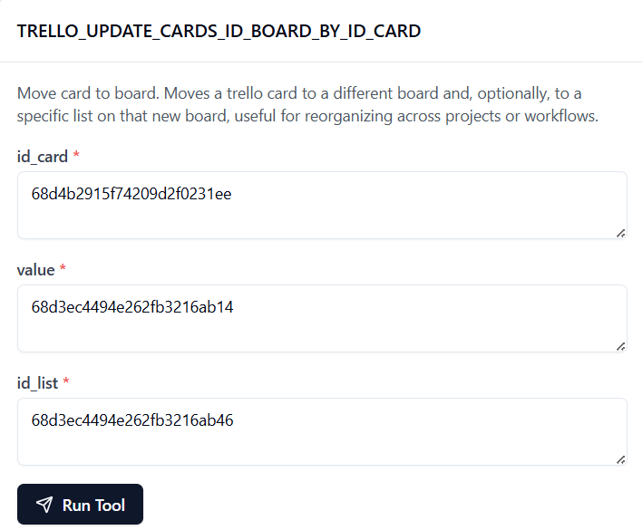

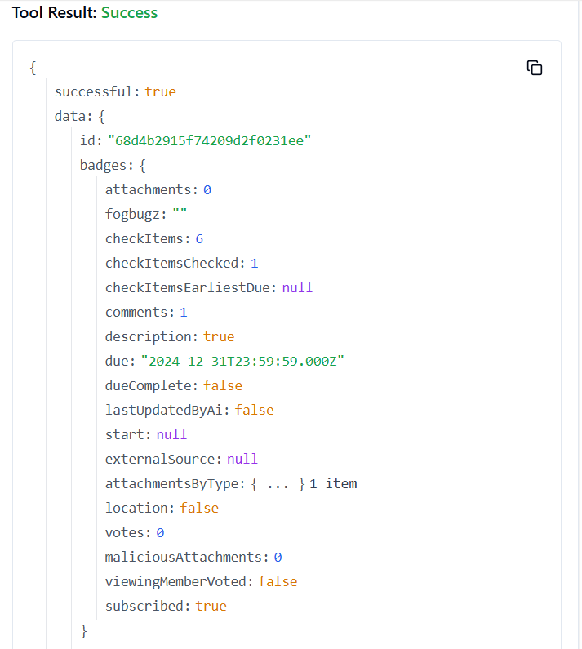

**209. TRELLO_UPDATE_CARDS_ID_LIST_BY_ID_CARD**

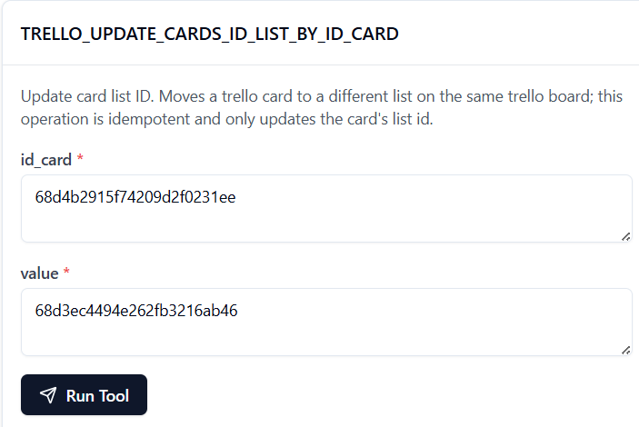

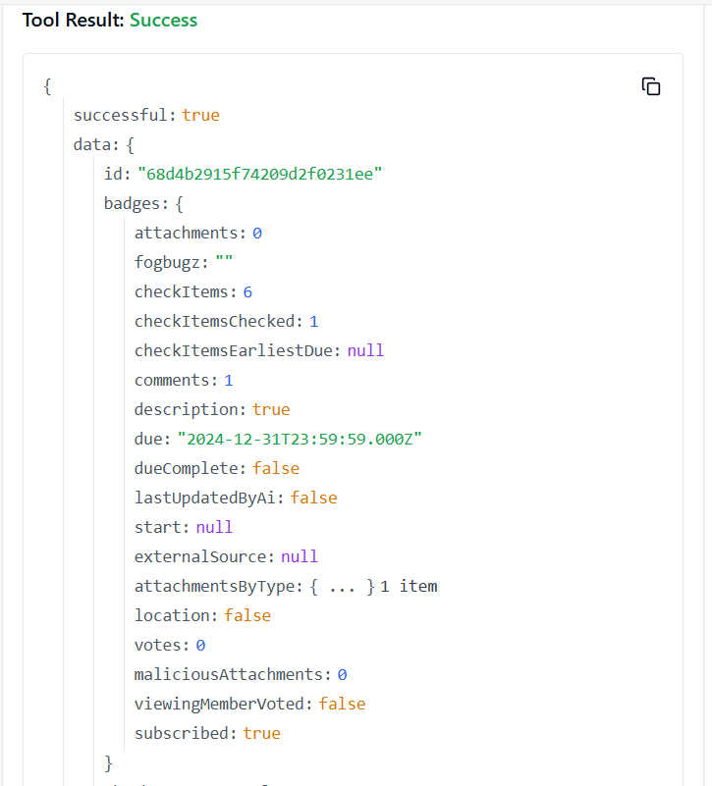

**210. TRELLO_UPDATE_CARDS_ID_MEMBERS_BY_ID_CARD**

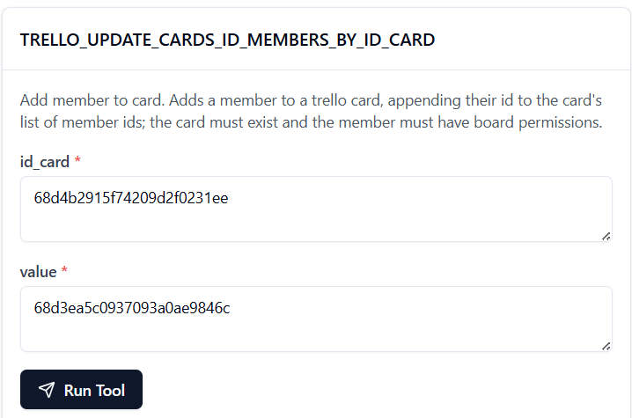

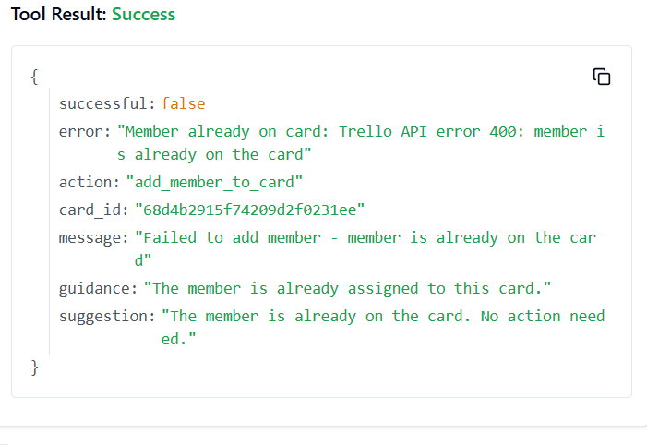

**211. TRELLO_UPDATE_CARDS_LABELS_BY_ID_CARD**

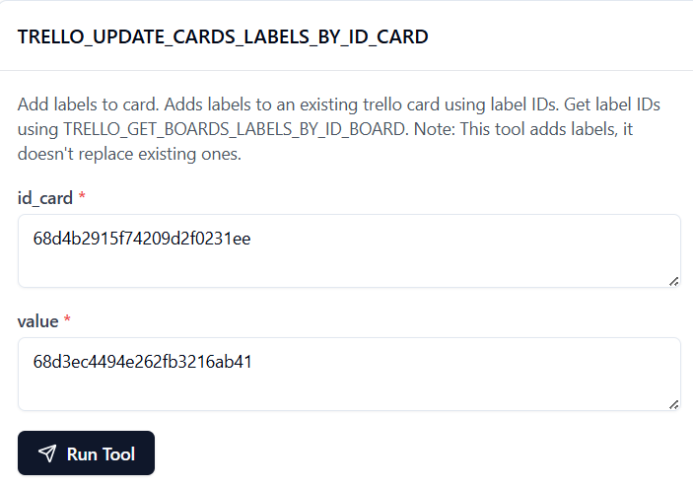

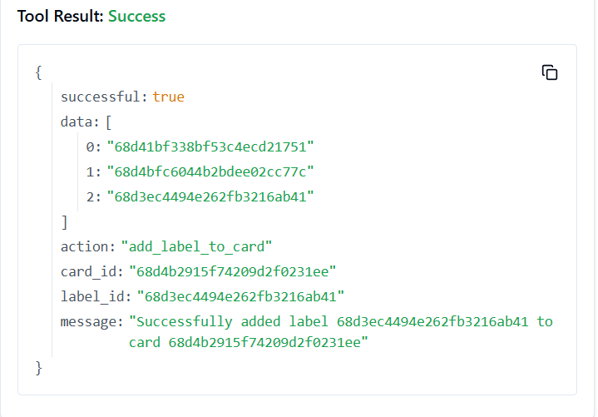

**212. TRELLO_UPDATE_CARDS_NAME_BY_ID_CARD**

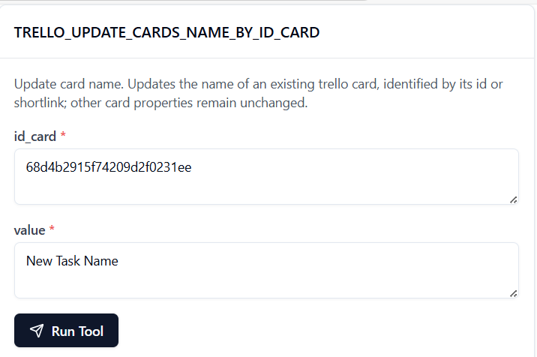

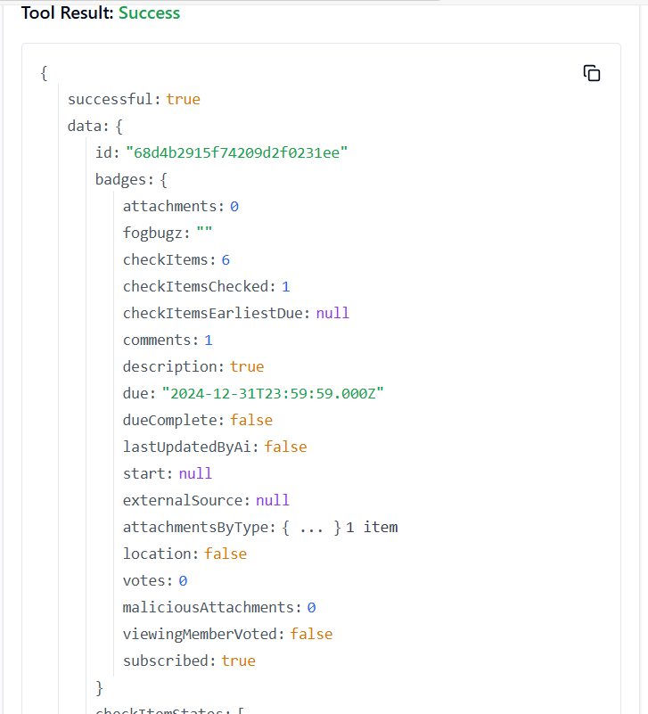

**213. TRELLO_UPDATE_CARDS_POS_BY_ID_CARD**

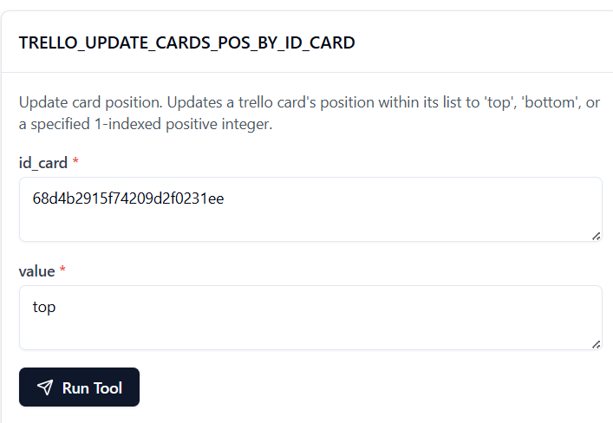

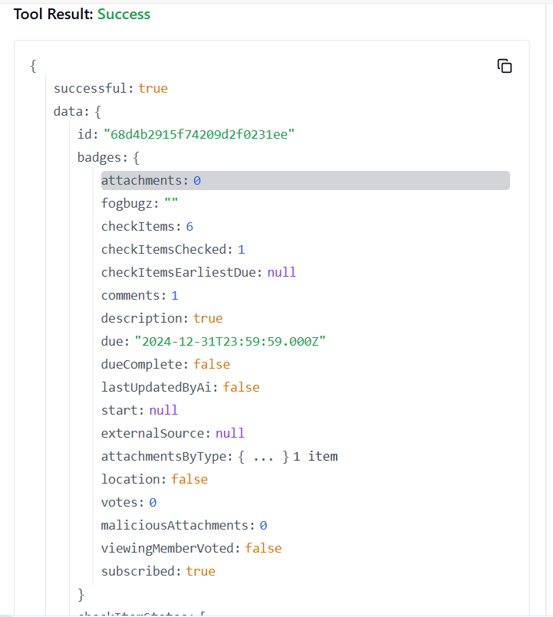

**214. TRELLO_UPDATE_CARDS_SUBSCRIBED_BY_ID_CARD**

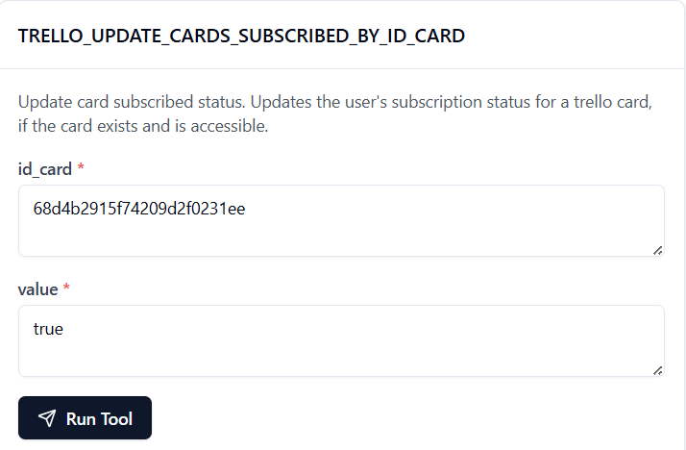

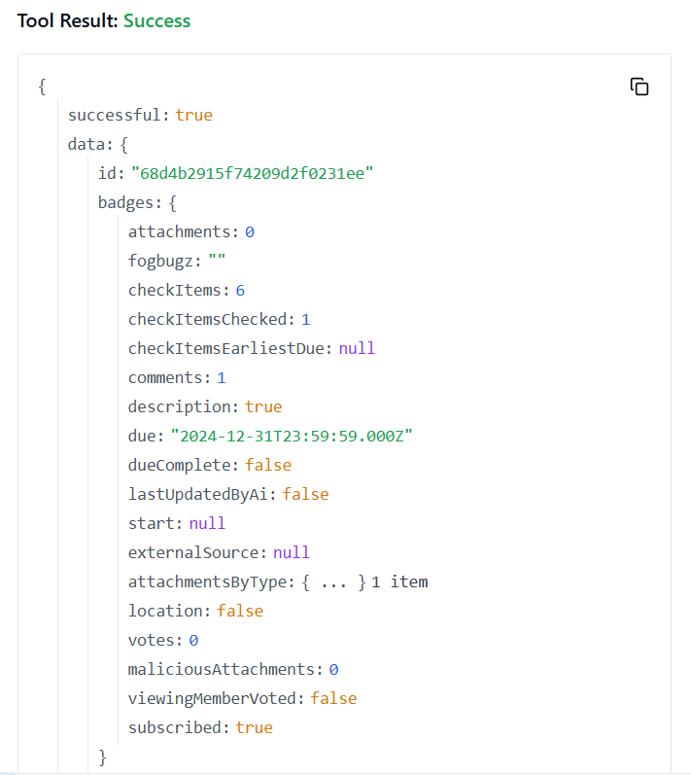

**215. TRELLO_UPDATE_CHECKLIST_ITEM_BY_IDS**

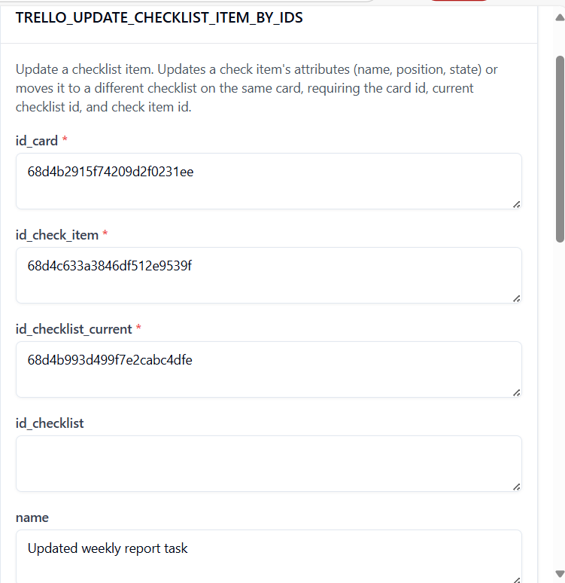

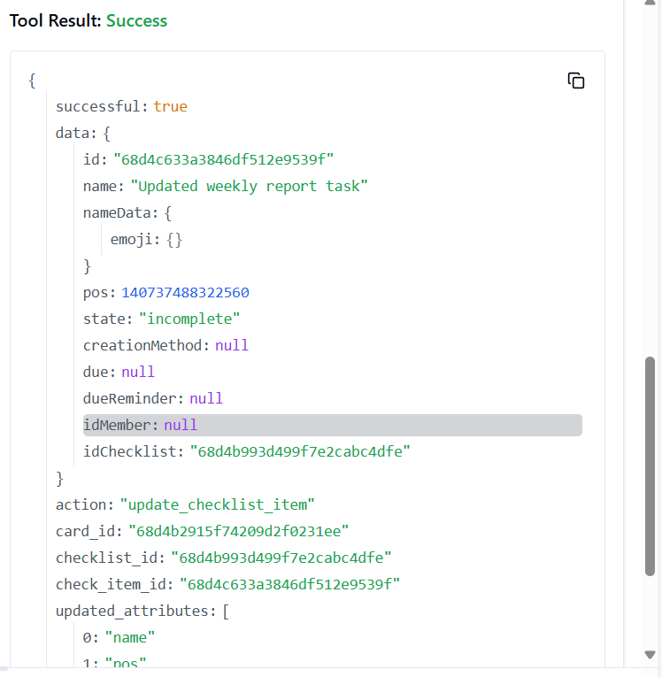

**216. TRELLO_UPDATE_CHECKLIST_ITEM_NAME_IN_CARD**

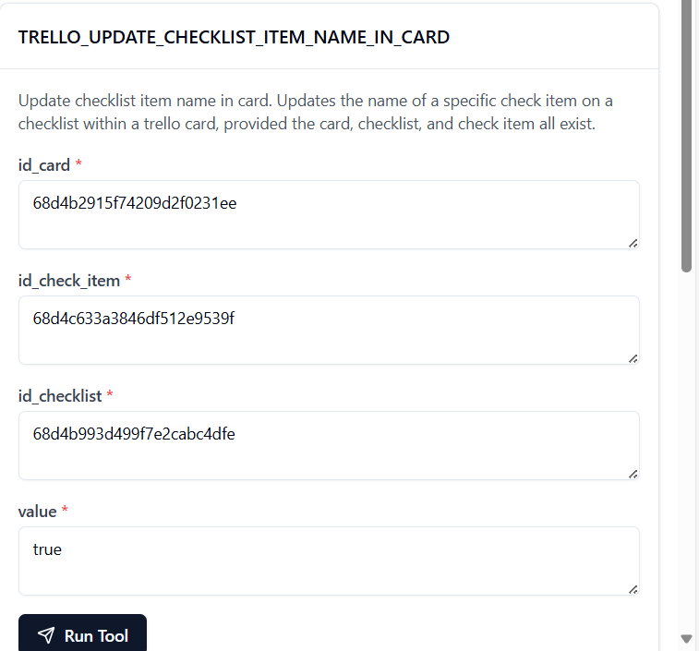

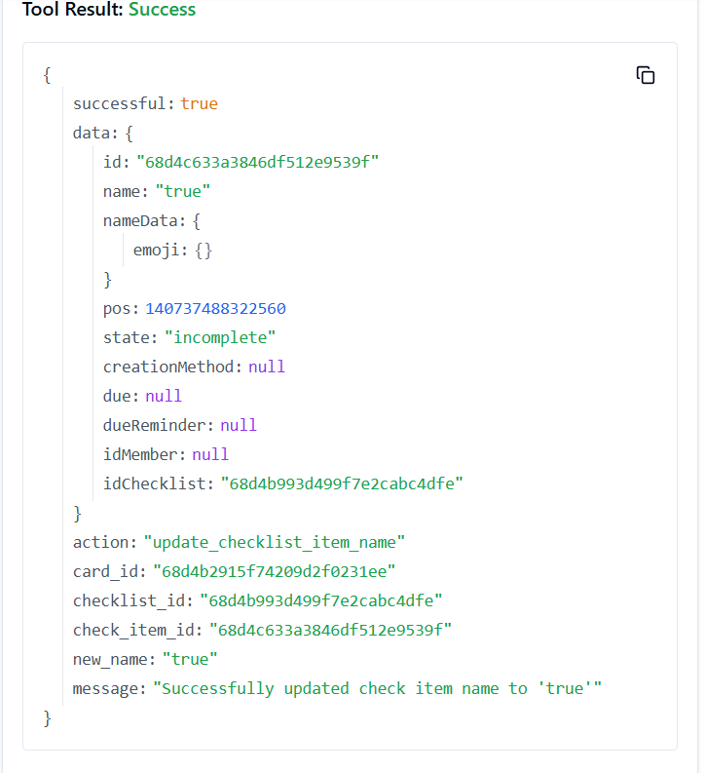

**217. TRELLO_UPDATE_CHECKLISTS_BY_ID_CHECKLIST**

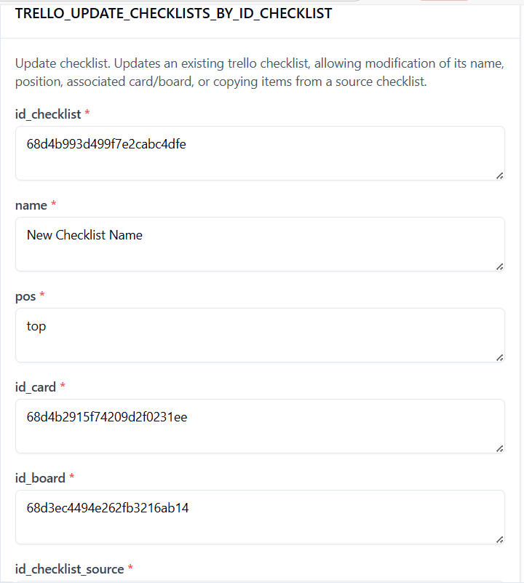

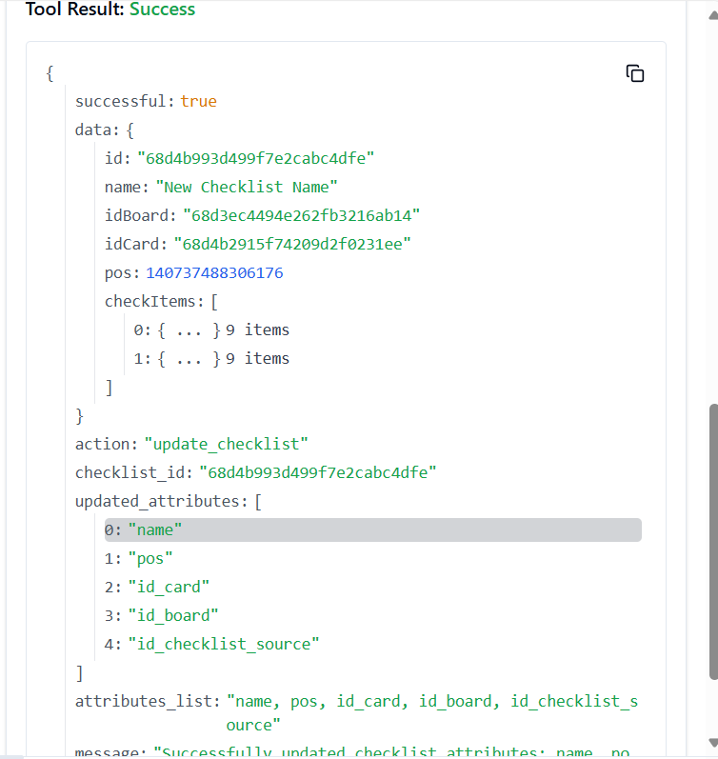

**218. TRELLO_UPDATE_CHECKLISTS_ID_CARD_BY_ID_CHECKLIST**

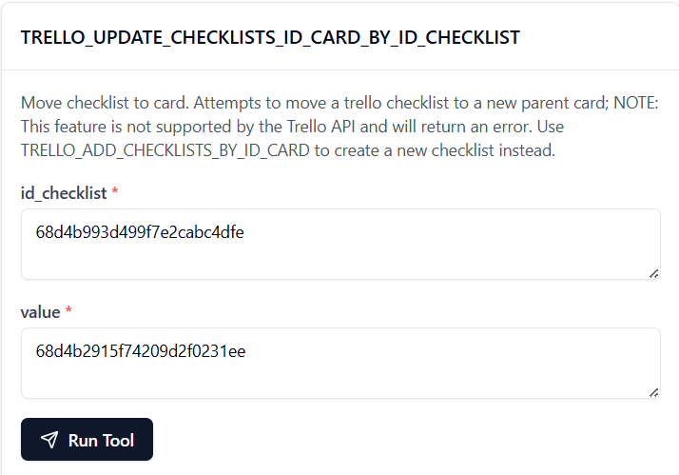

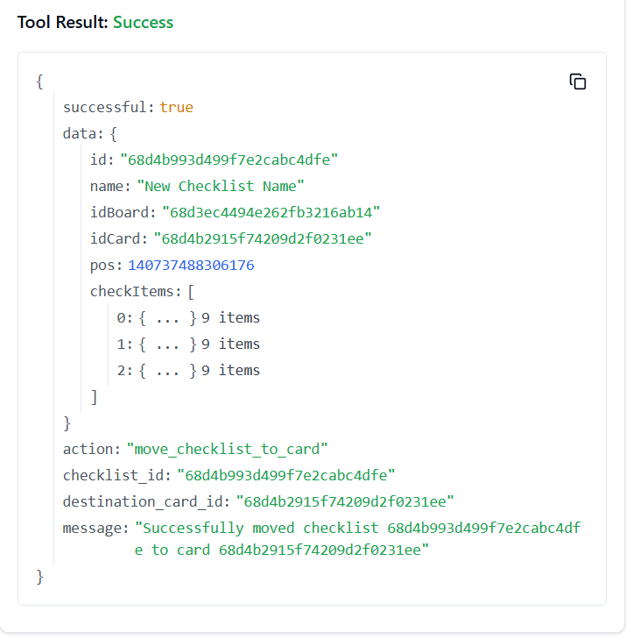

**219. TRELLO_UPDATE_CHECKLISTS_NAME_BY_ID_CHECKLIST**

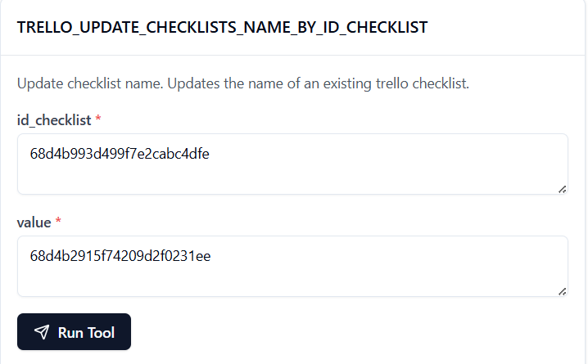

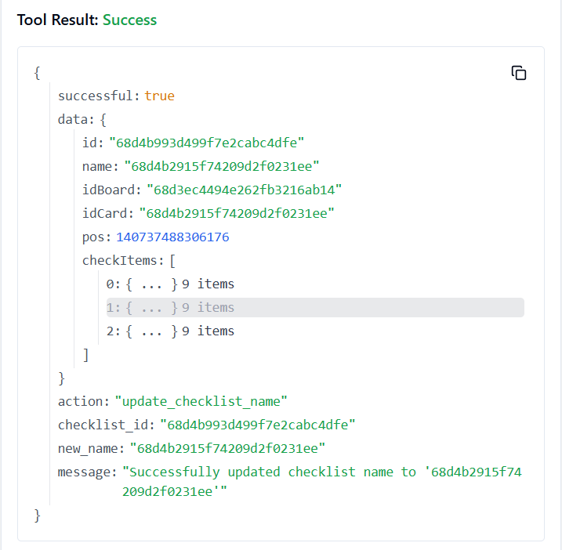

**220. TRELLO_UPDATE_CHECKLISTS_POS_BY_ID_CHECKLIST**

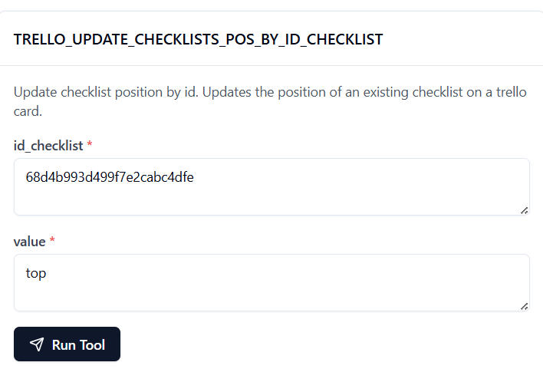

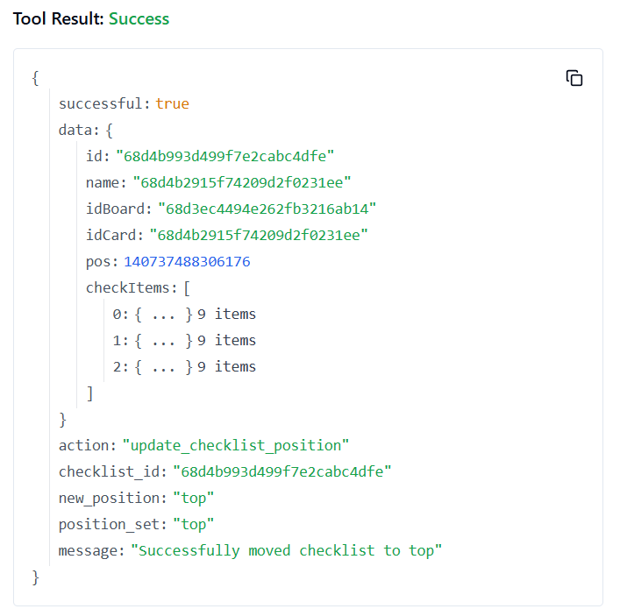

**221. TRELLO_UPDATE_LABELS_BY_ID_LABEL**

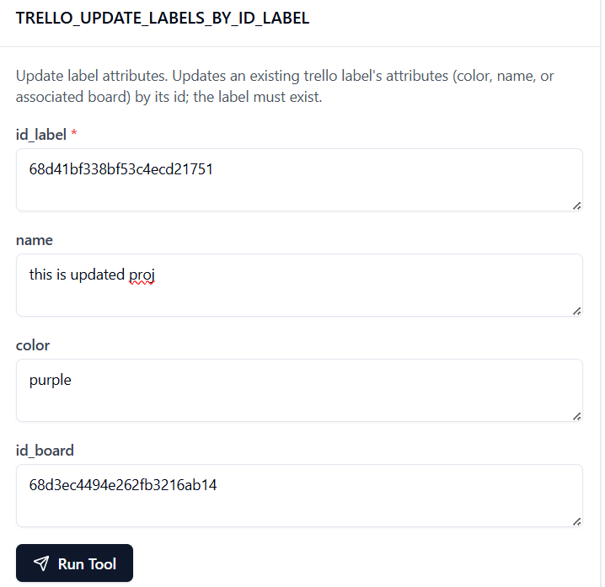

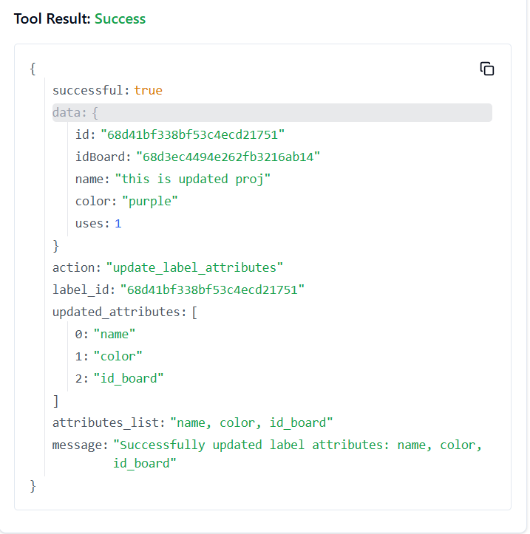

**222. TRELLO_UPDATE_LABELS_COLOR_BY_ID_LABEL**

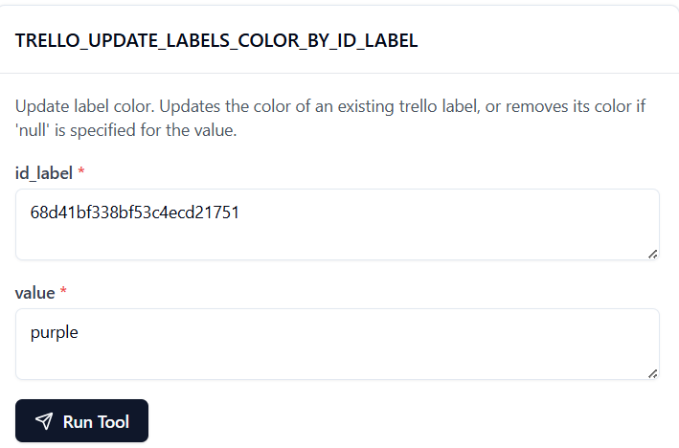

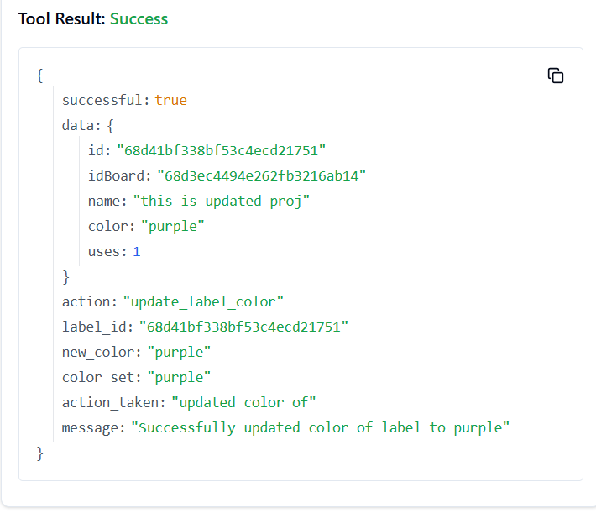

**223. TRELLO_UPDATE_LABELS_NAME_BY_ID_LABEL**

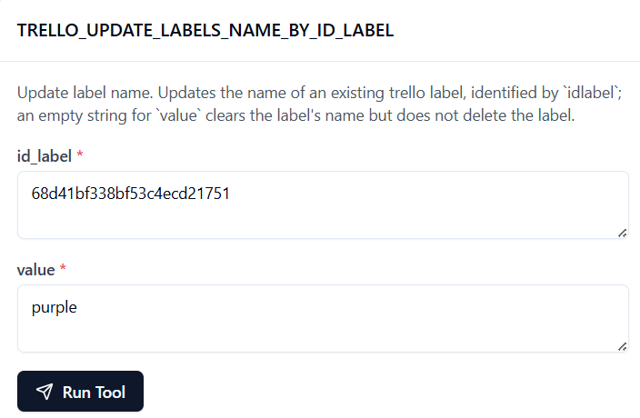

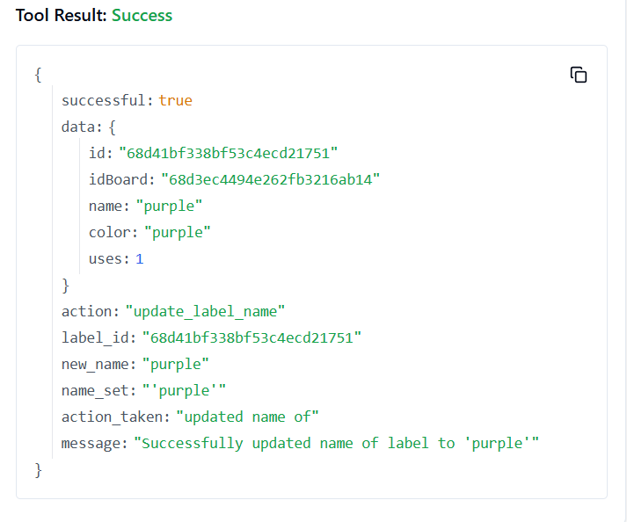

**224. TRELLO_UPDATE_LISTS_BY_ID_LIST**

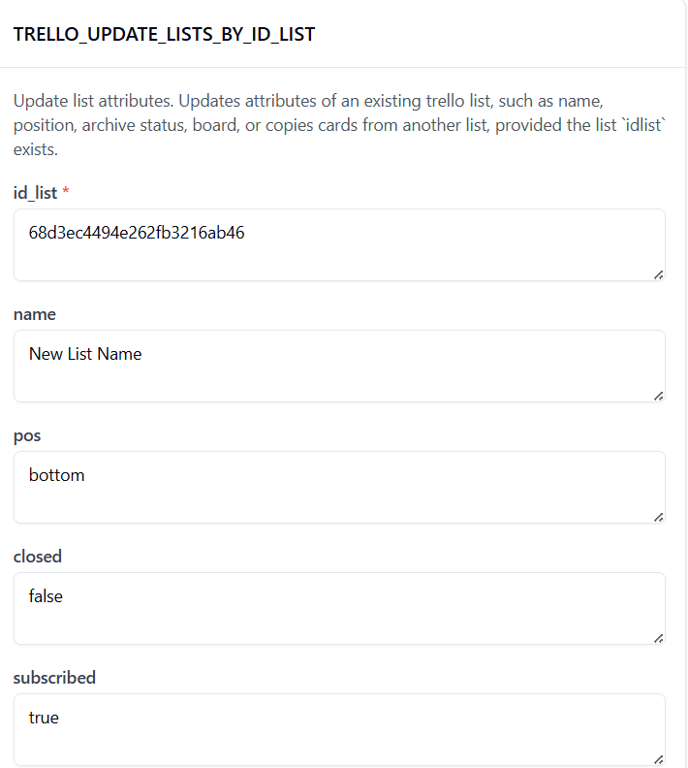

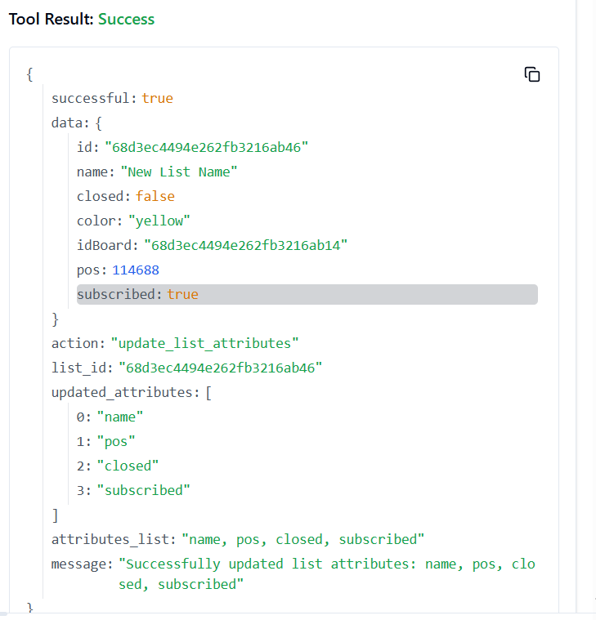

**225. TRELLO_UPDATE_LISTS_CLOSED_BY_ID_LIST**

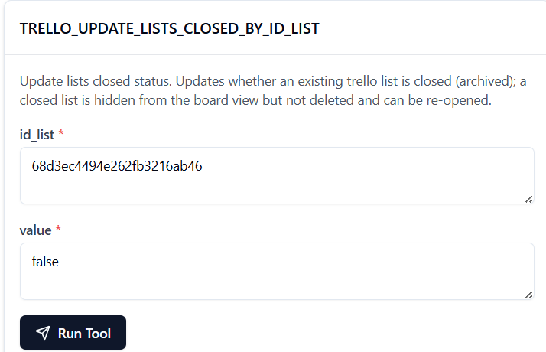

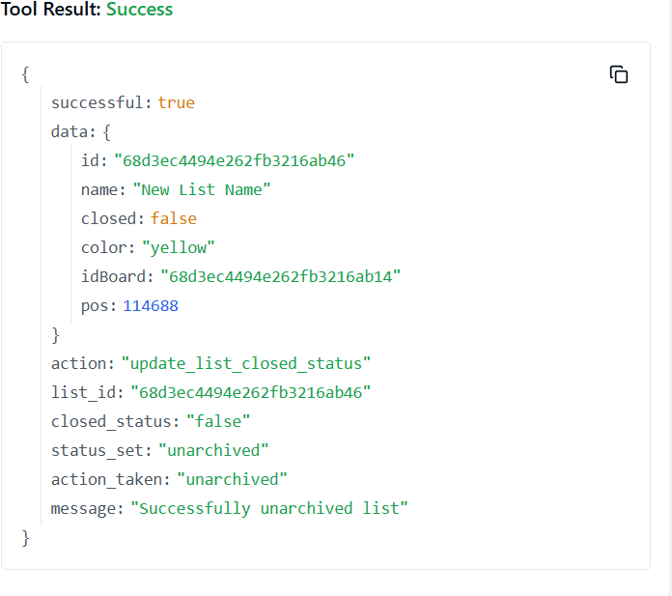

**226. TRELLO_UPDATE_LISTS_ID_BOARD_BY_ID_LIST**

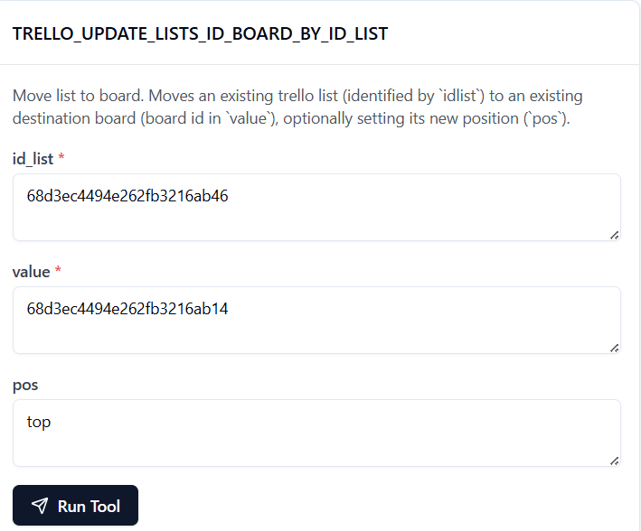

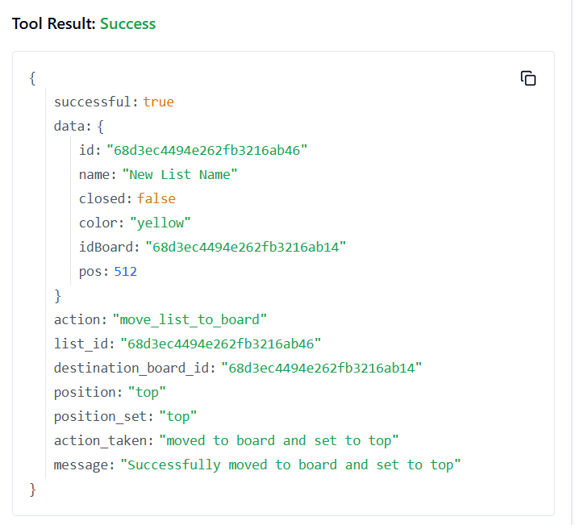

**227. TRELLO_UPDATE_LISTS_NAME_BY_ID_LIST**

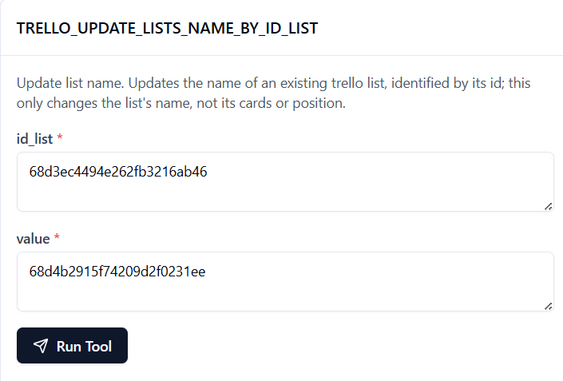

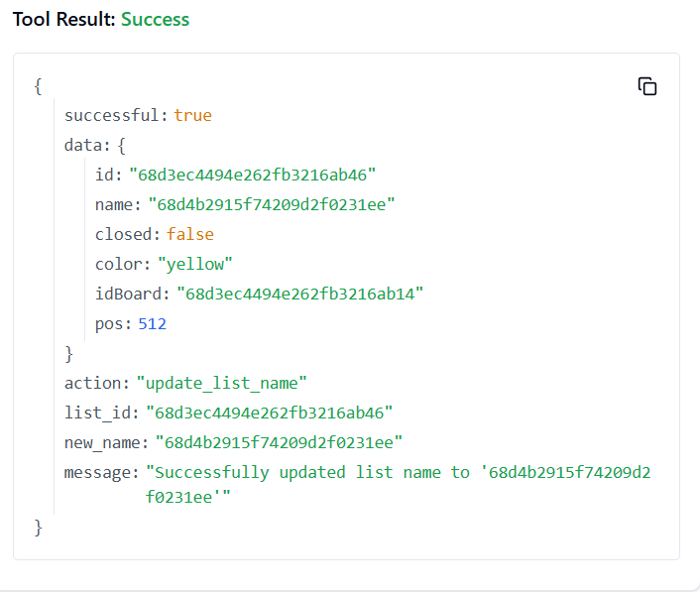

**228. TRELLO_UPDATE_LISTS_POS_BY_ID_LIST**

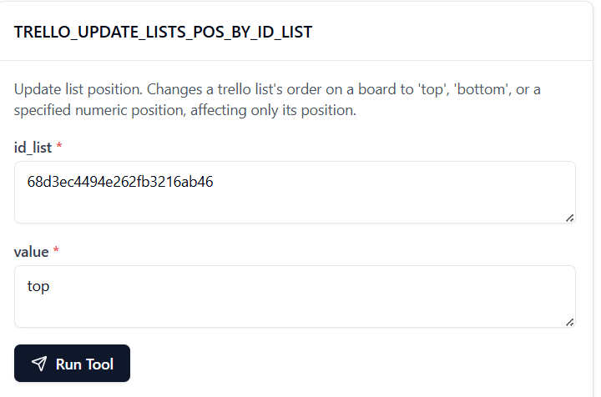

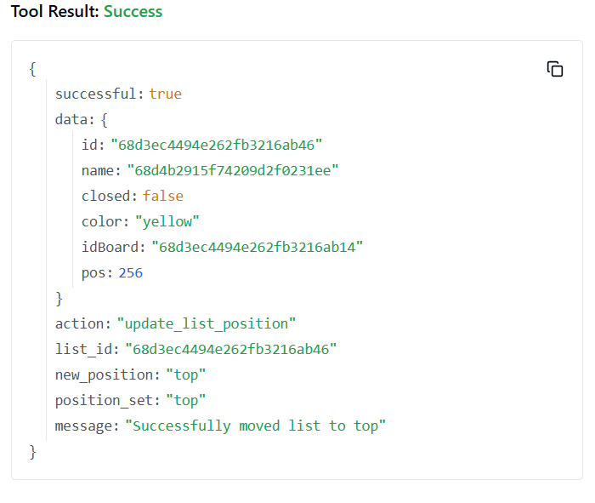

**229. TRELLO_UPDATE_LISTS_SUBSCRIBED_BY_ID_LIST**

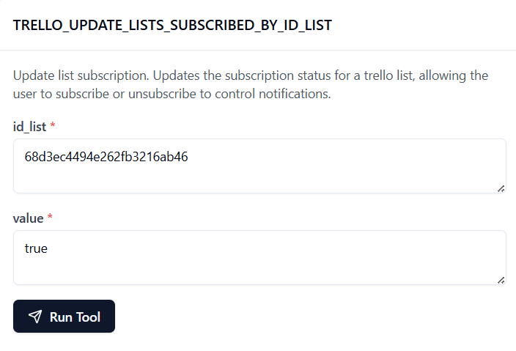

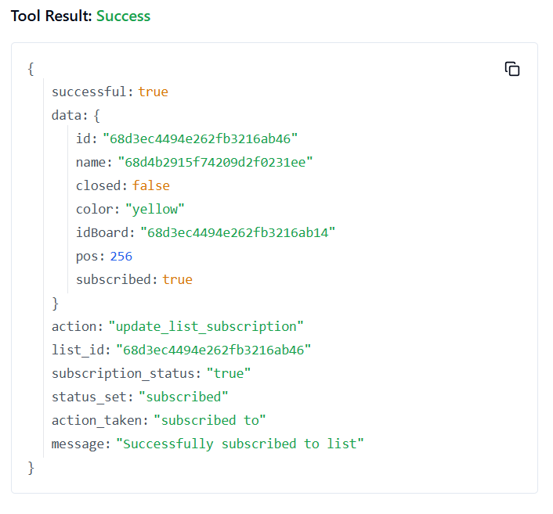

**230. TRELLO_UPDATE_MEMBER_BOARD_BACKGROUND**

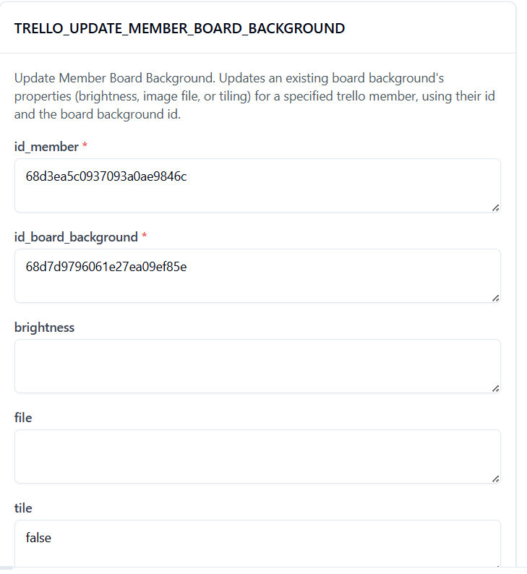

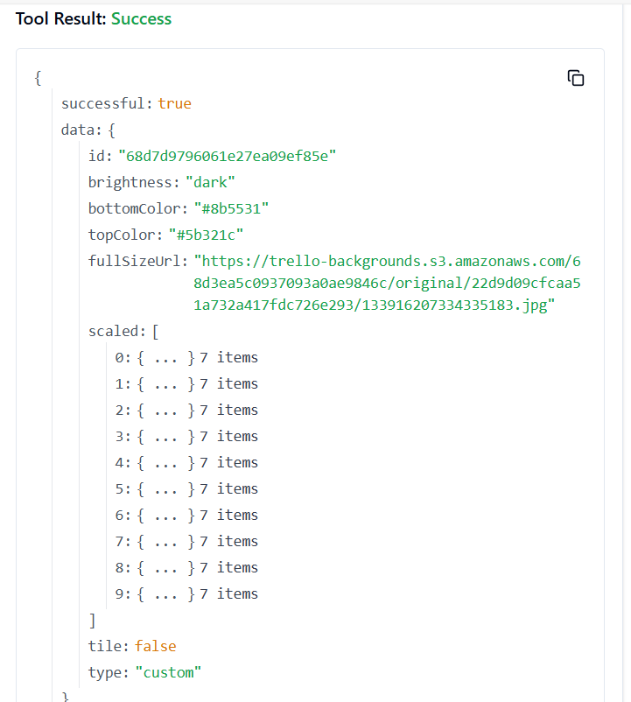

**231. TRELLO_UPDATE_MEMBER_SAVED_SEARCH**

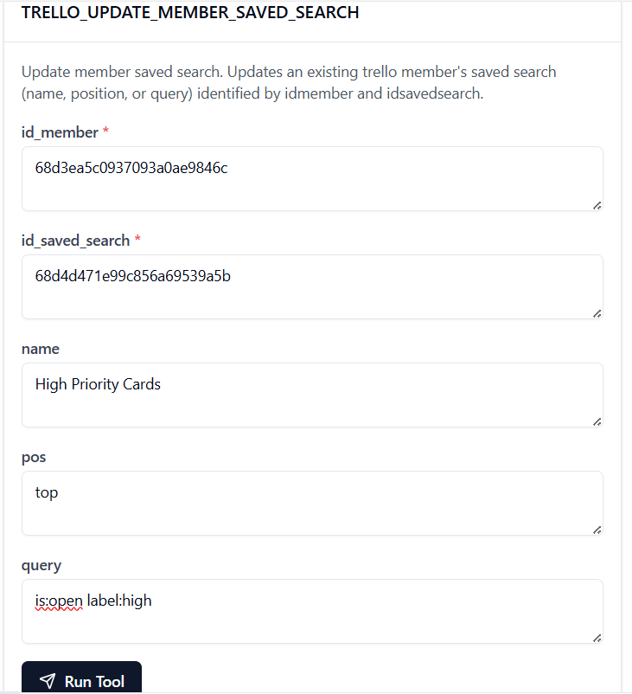

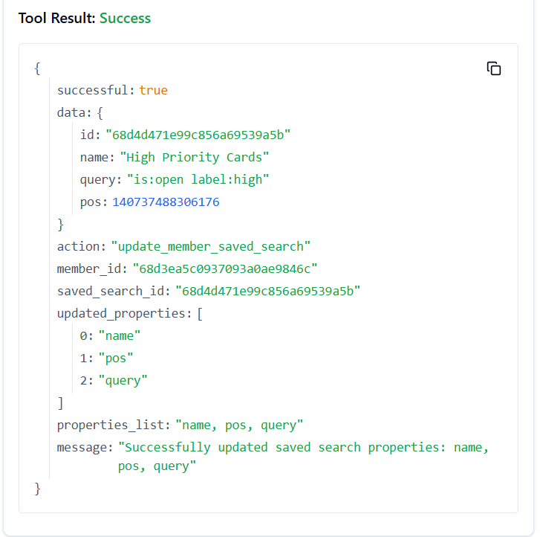

**232. TRELLO_UPDATE_MEMBER_SAVED_SEARCH_NAME**

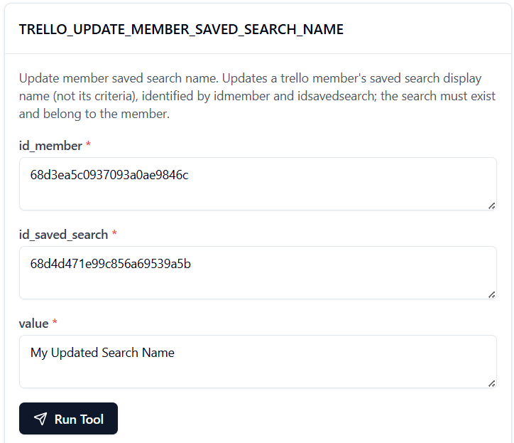

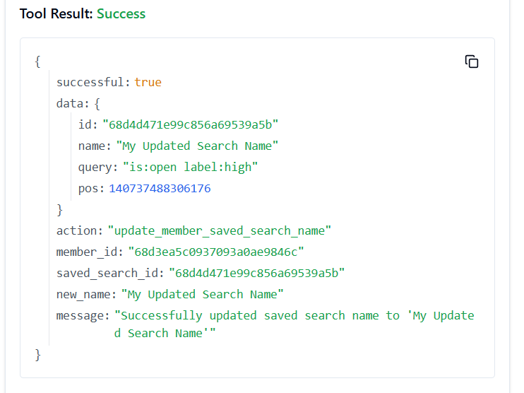

**233. TRELLO_UPDATE_MEMBER_SAVED_SEARCH_POS**

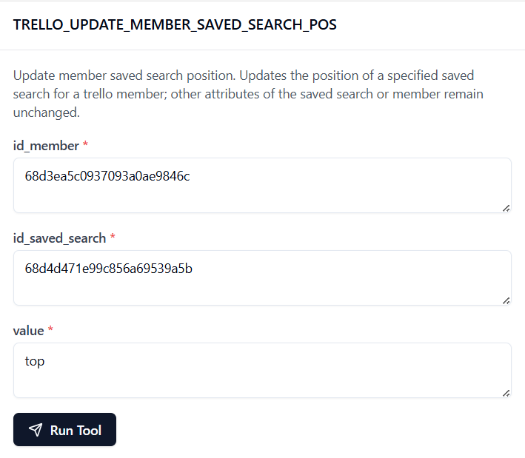

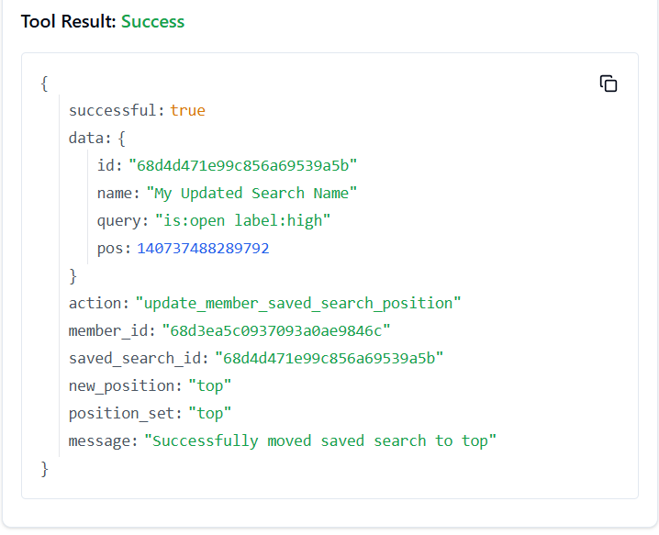

**234. TRELLO_UPDATE_MEMBER_SAVED_SEARCH_QUERY**

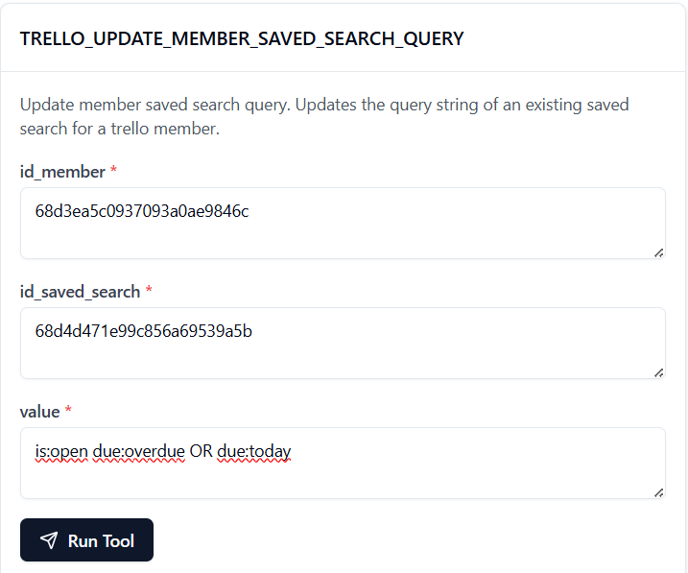

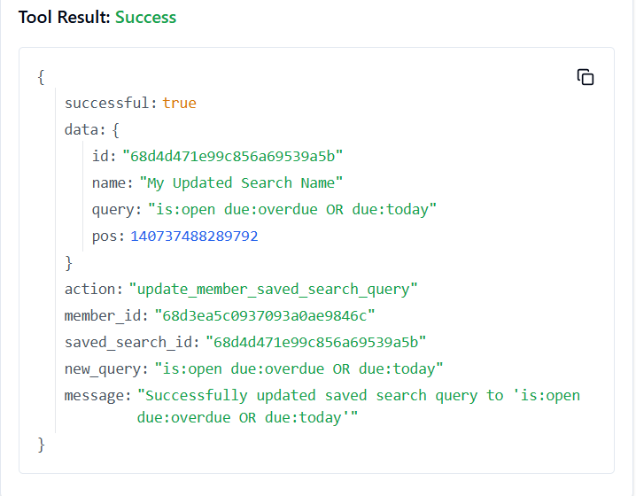

**235. TRELLO_UPDATE_MEMBERS_BIO_BY_ID_MEMBER**

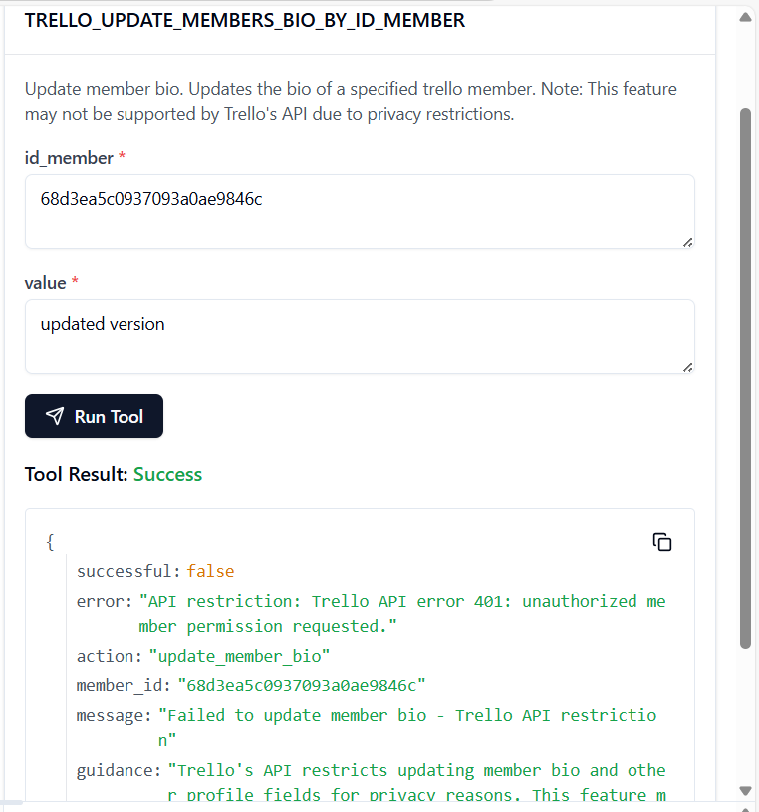

**Tool is running properly but it shows api restrictions**

**236. TRELLO_UPDATE_MEMBER_S_CUSTOM_BOARD_BACKGROUNDS**

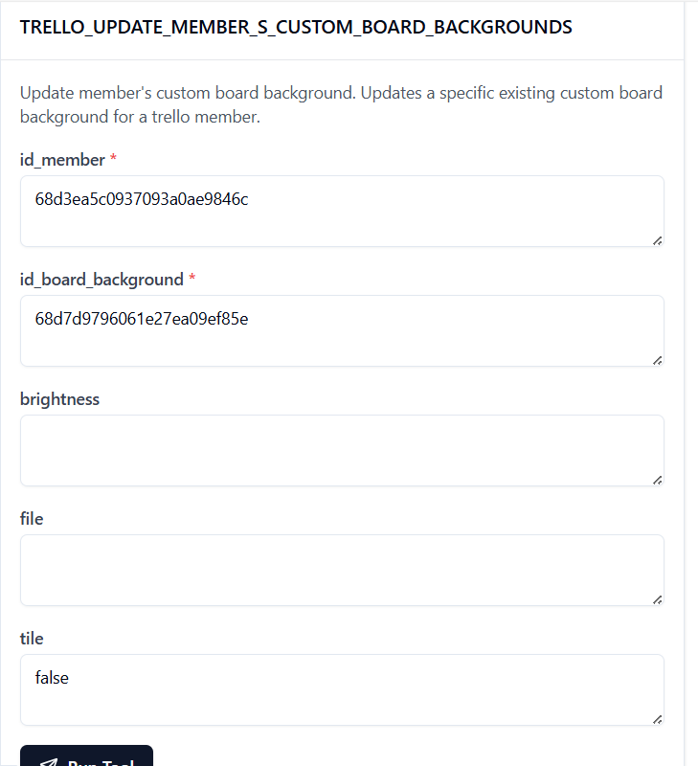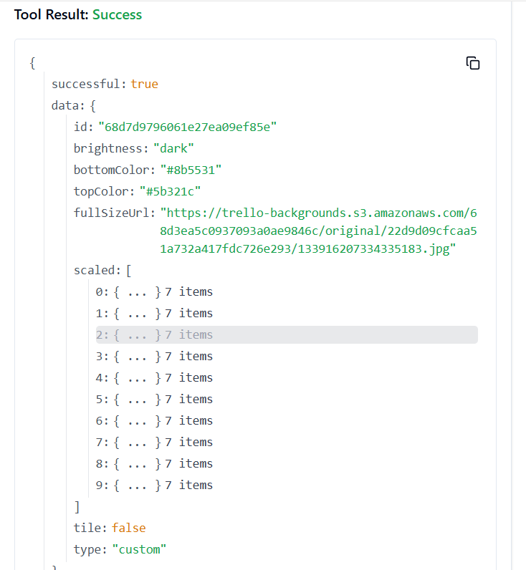

**237. TRELLO_UPDATE_NOTIFICATIONS_BY_ID_NOTIFICATION**

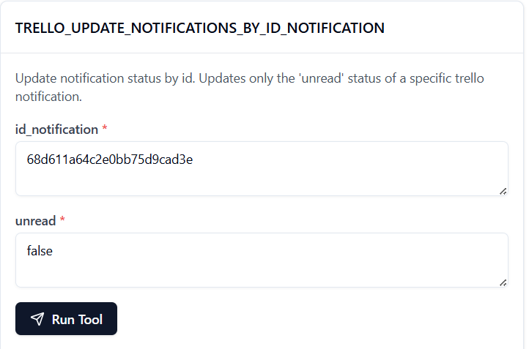

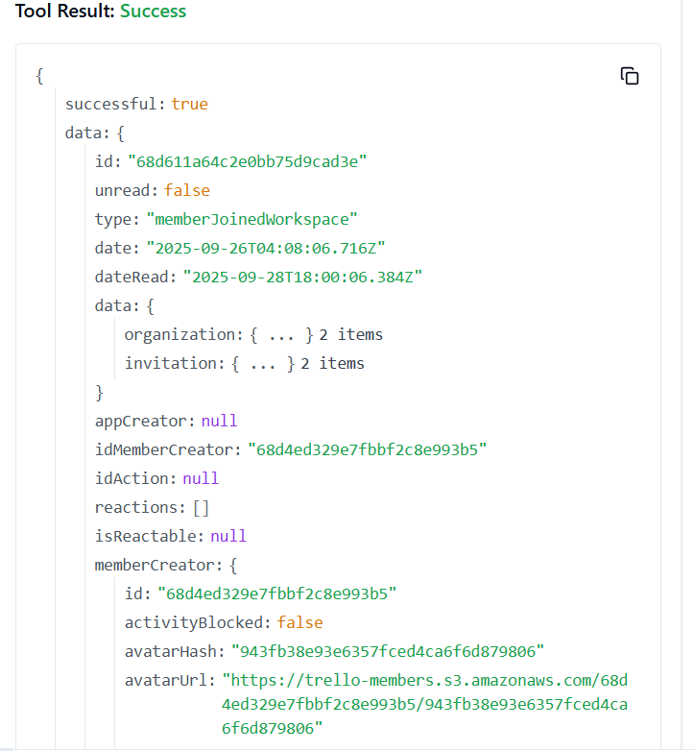

**238. TRELLO_UPDATE_NOTIFICATION_UNREAD_STATUS**

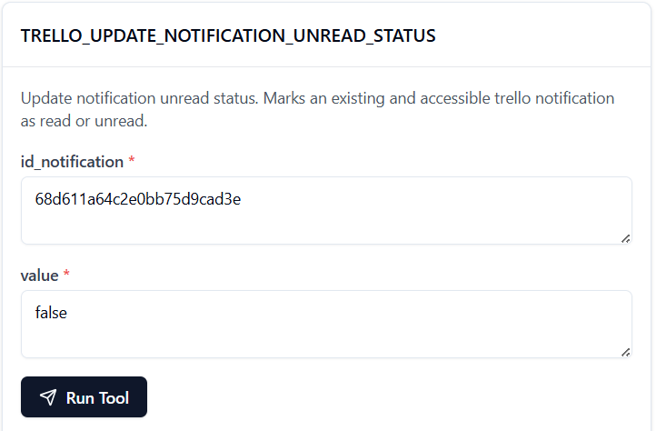

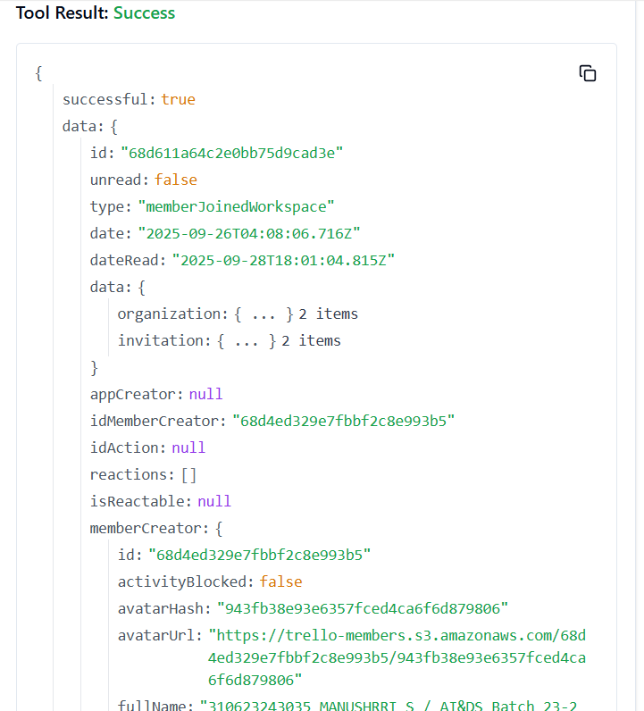

**239. TRELLO_UPDATE_ORGANIZATIONS_BY_ID_ORG**

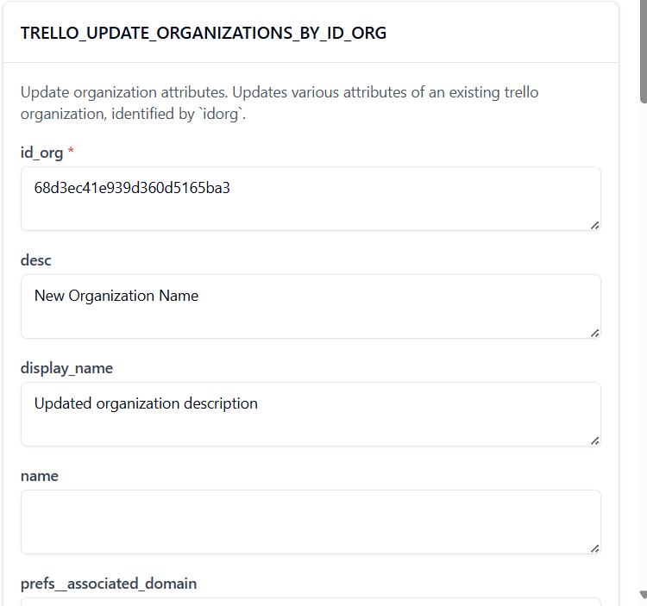

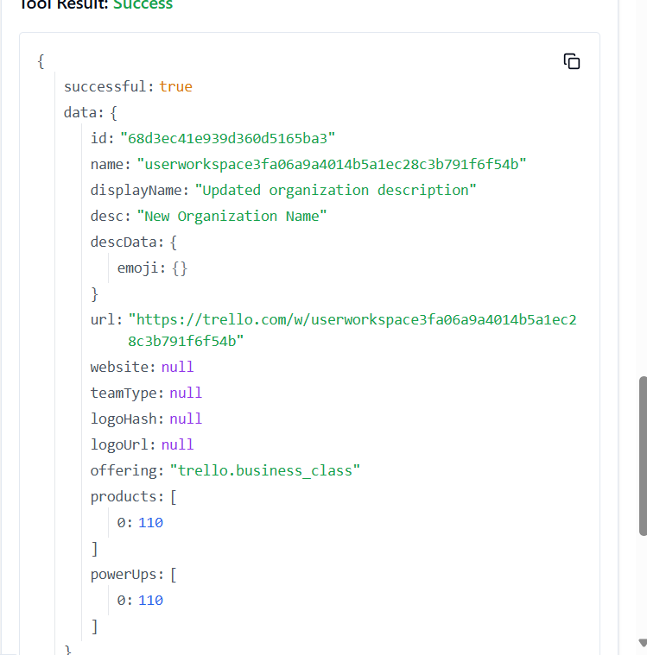

**240. TRELLO_UPDATE_ORGANIZATIONS_DESC_BY_ID_ORG**

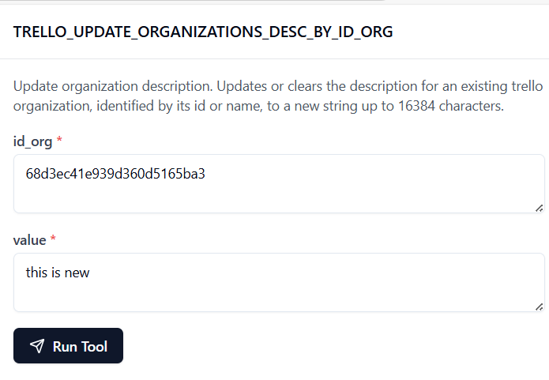

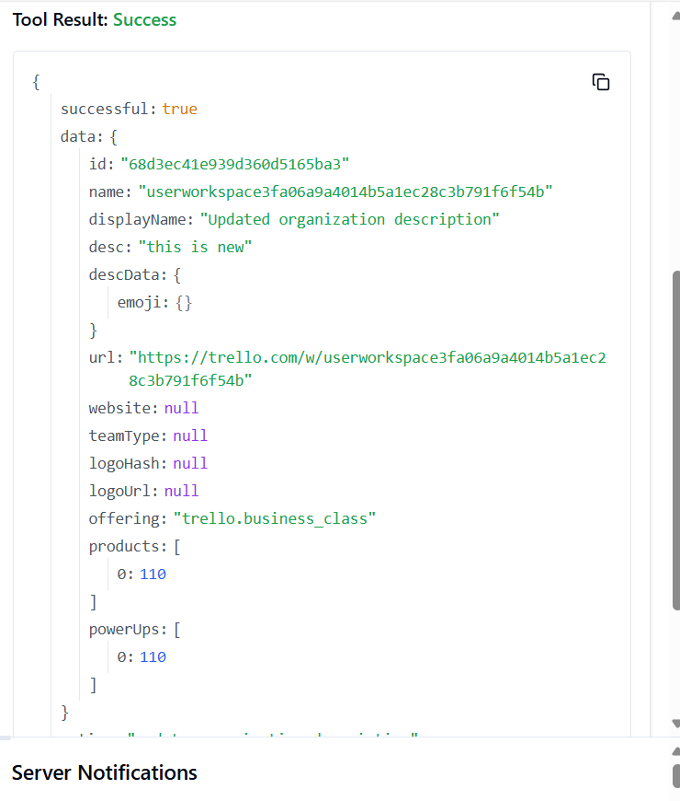

**241. TRELLO_UPDATE_ORGANIZATIONS_DISPLAY_NAME_BY_ID_ORG**

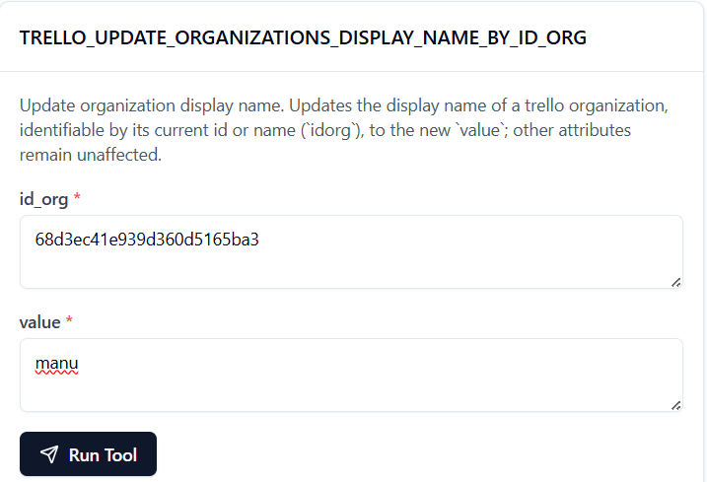

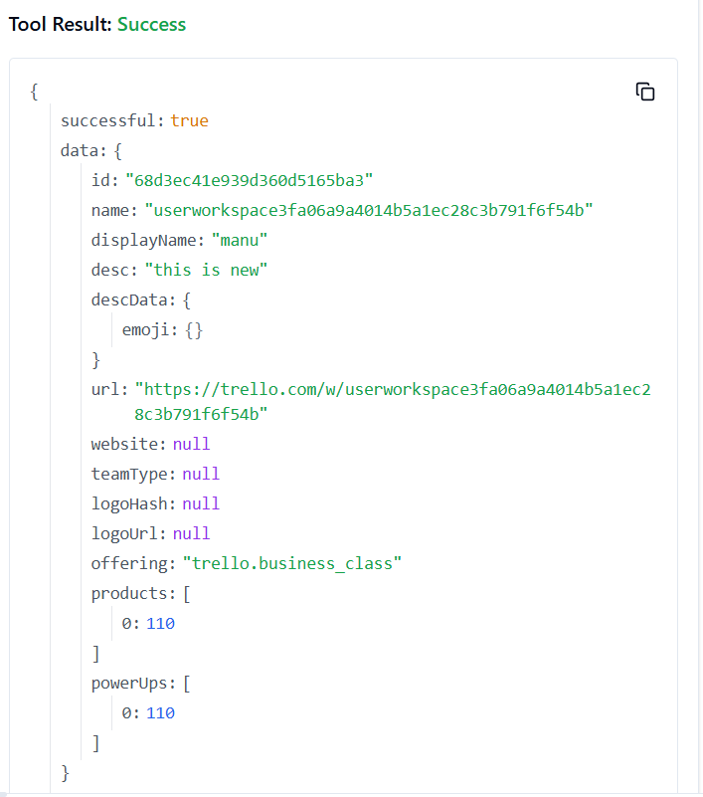

**242. TRELLO_UPDATE_ORGANIZATIONS_PREFS_GOOGLE_APPS_VERSION_BY_ID_ORG**

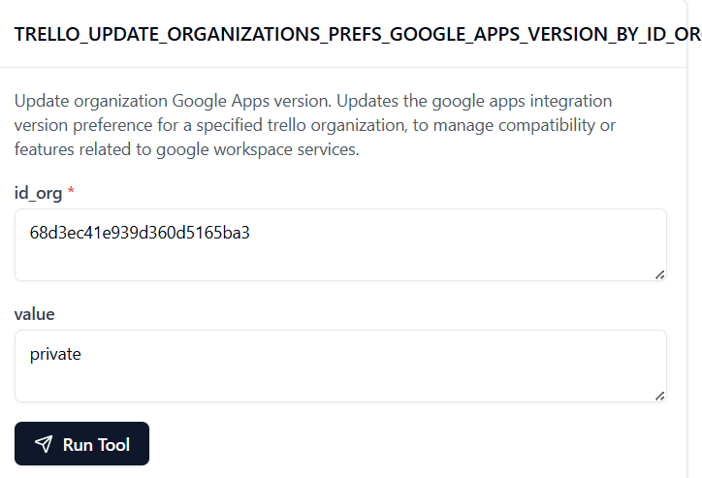

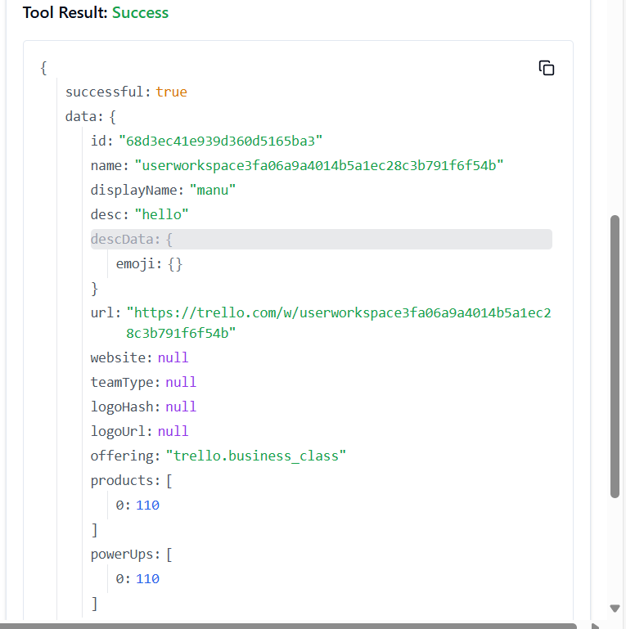

**243. TRELLO_UPDATE_ORGANIZATIONS_PREFS_PERMISSION_LEVEL_BY_ID_ORG**

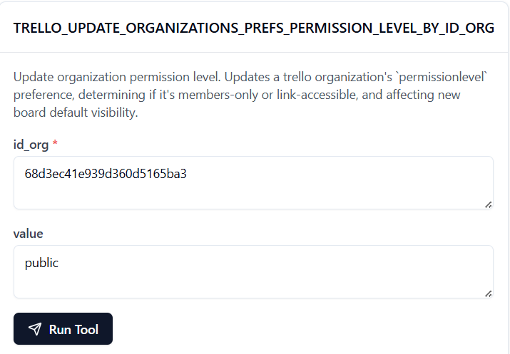

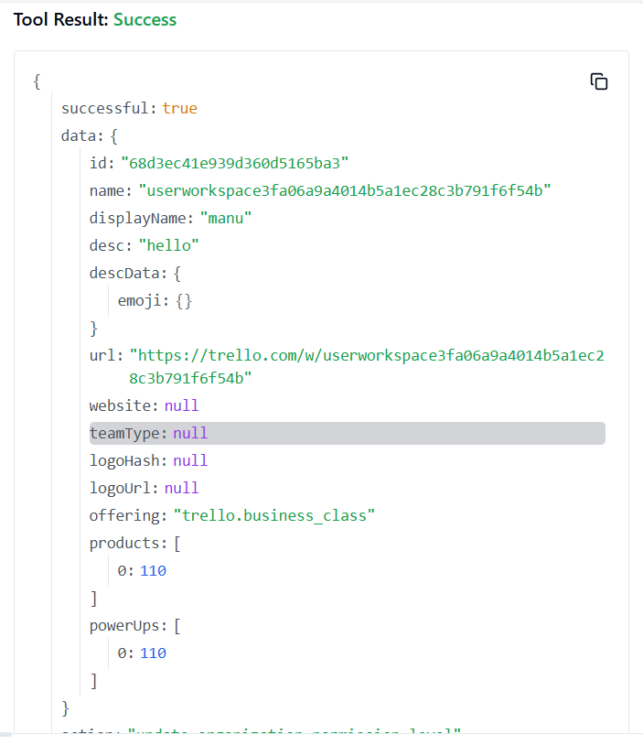

**244. TRELLO_UPDATE_ORG_ASSOCIATED_DOMAIN_PREFS**

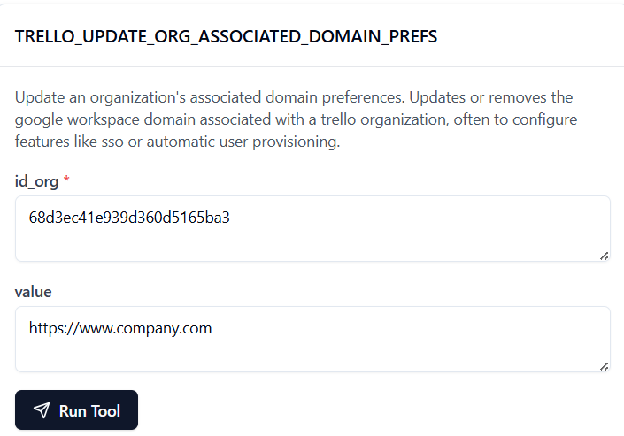

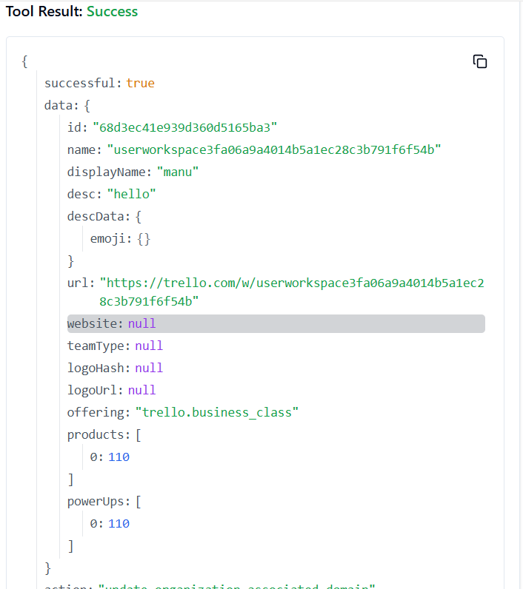

**245. TRELLO_UPDATE_ORGANIZATIONS_WEBSITE_BY_ID_ORG**

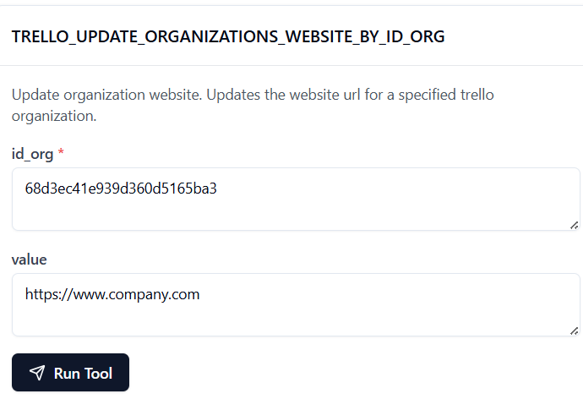

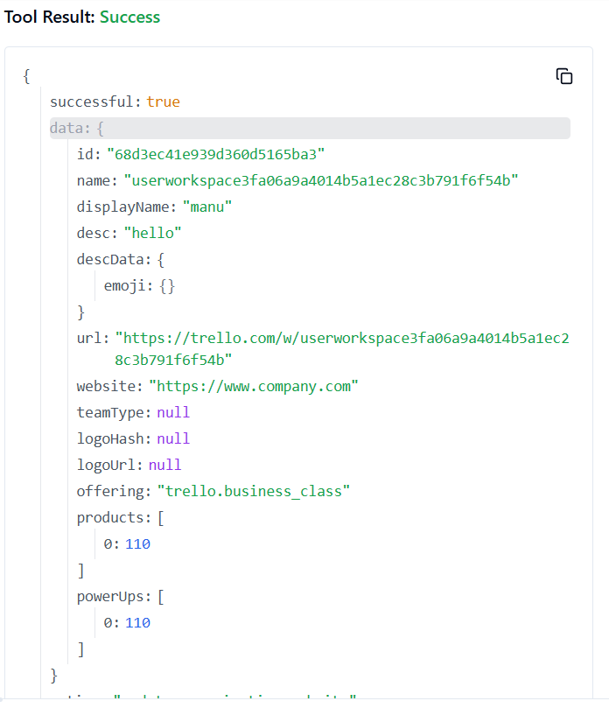

**246. TRELLO_UPDATE_ORG_EXTERNAL_MEMBERS_ACCESS**

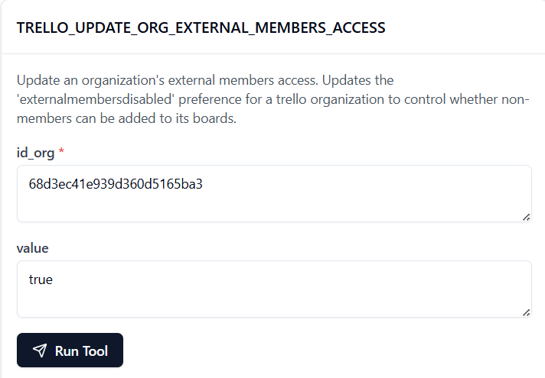

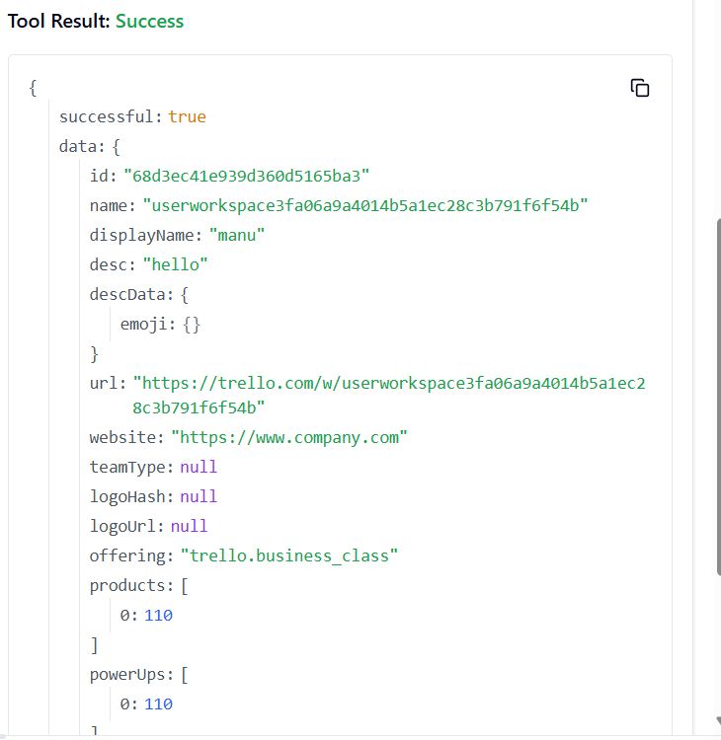

**247. TRELLO_UPDATE_WEBHOOKS_BY_ID_WEBHOOK**

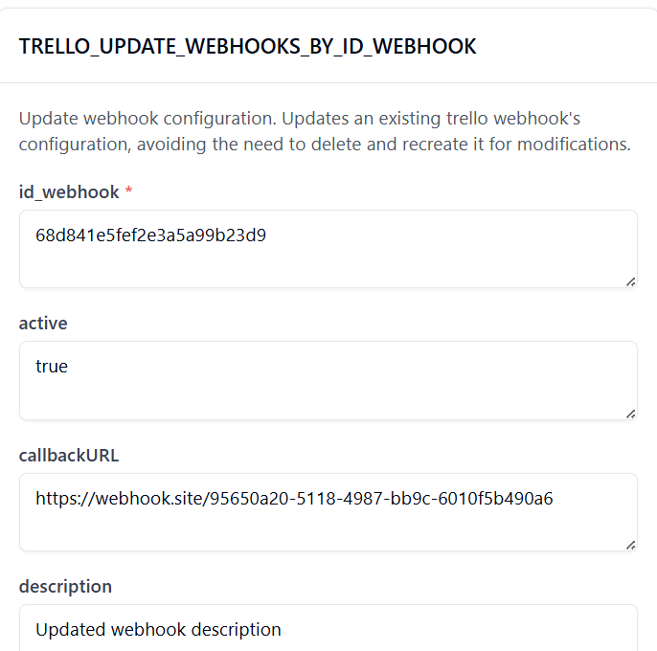

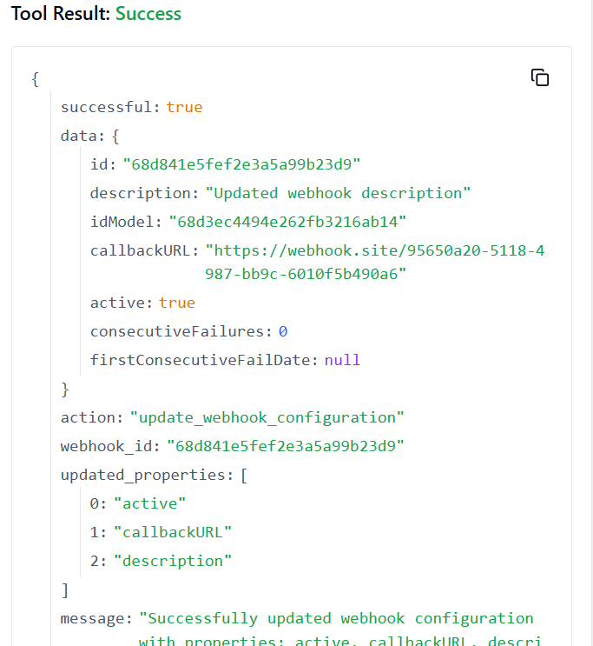

**248. TRELLO_UPDATE_WEBHOOKS_CALLBACK_URLBY_ID_WEBHOOK**

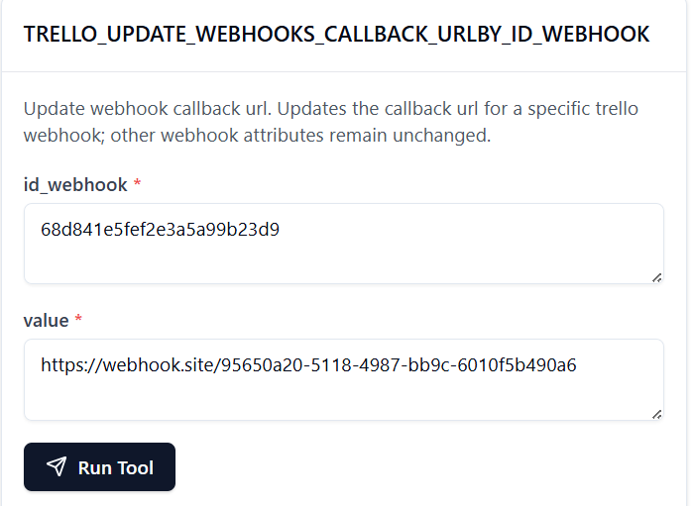

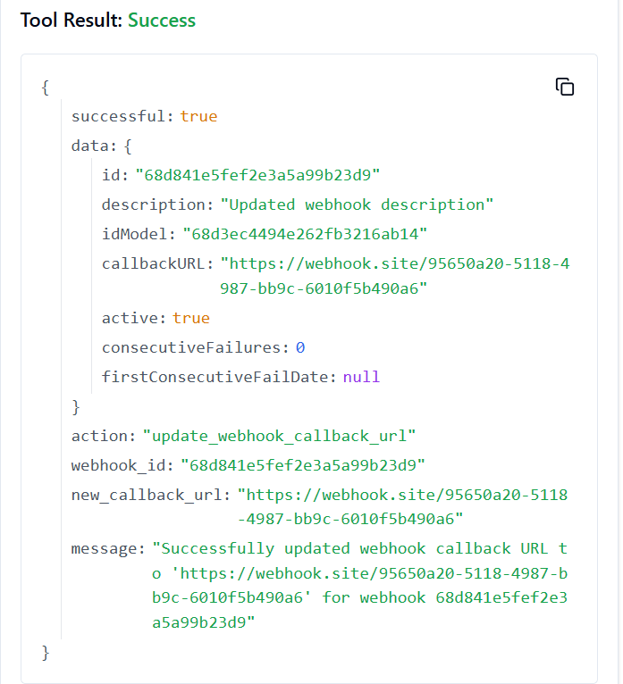

**249. TRELLO_UPDATE_WEBHOOKS_DESCRIPTION_BY_ID_WEBHOOK**

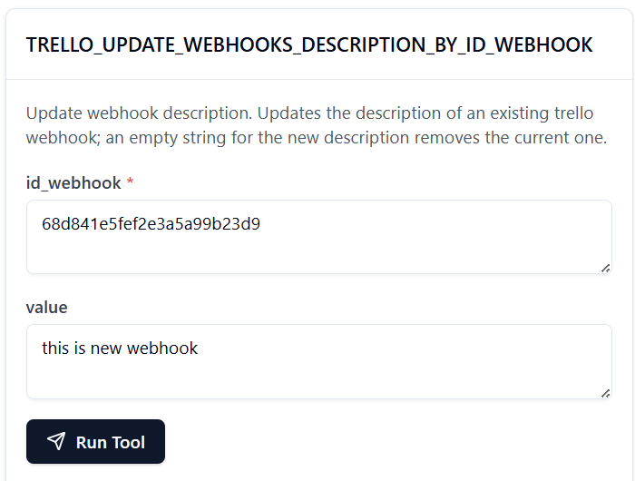

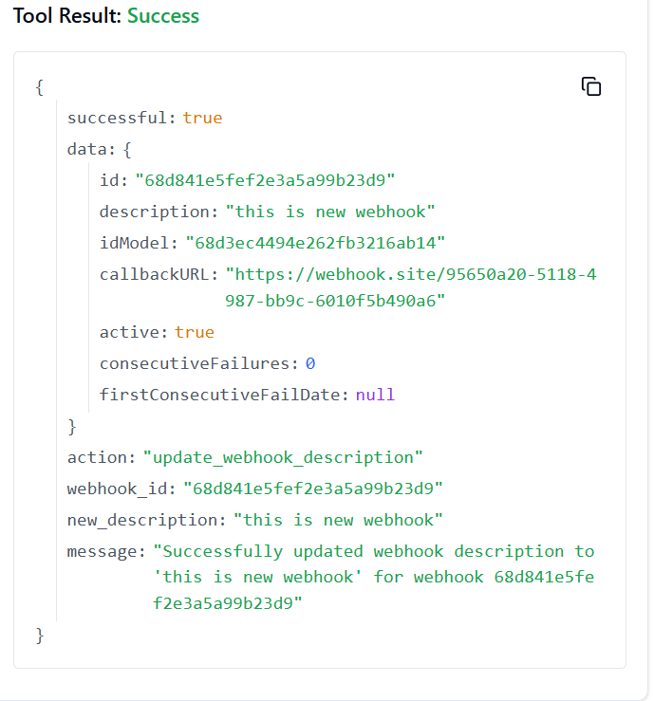

**250. TRELLO_UPDATE_WEBHOOKS_ID_MODEL_BY_ID_WEBHOOK**

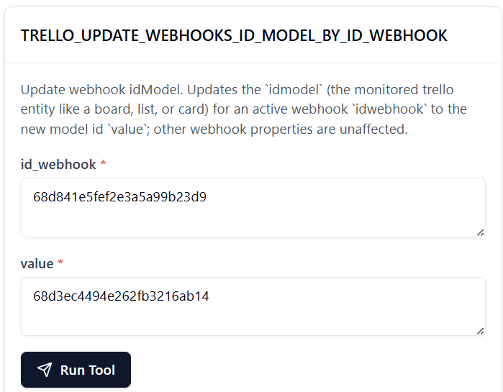

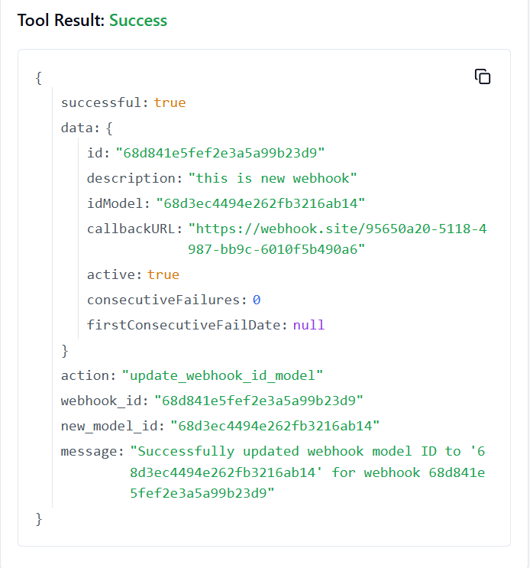

**251. TRELLO_UPDATE_WEBHOOKS**

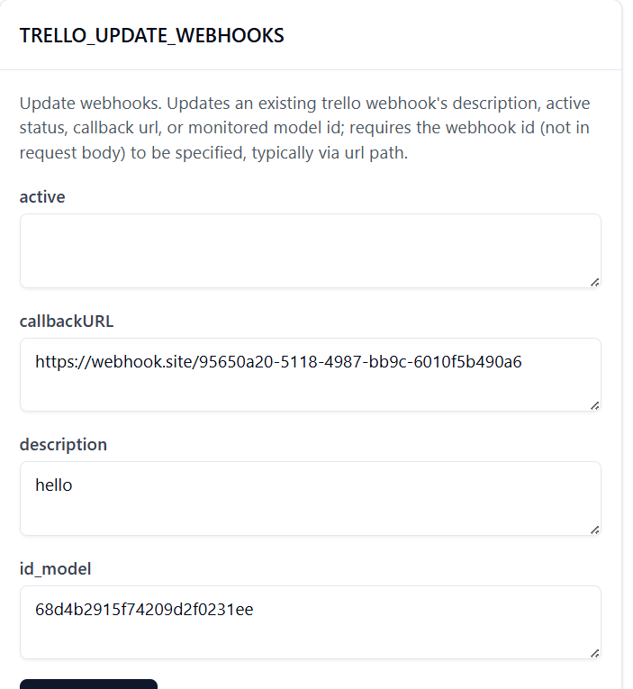

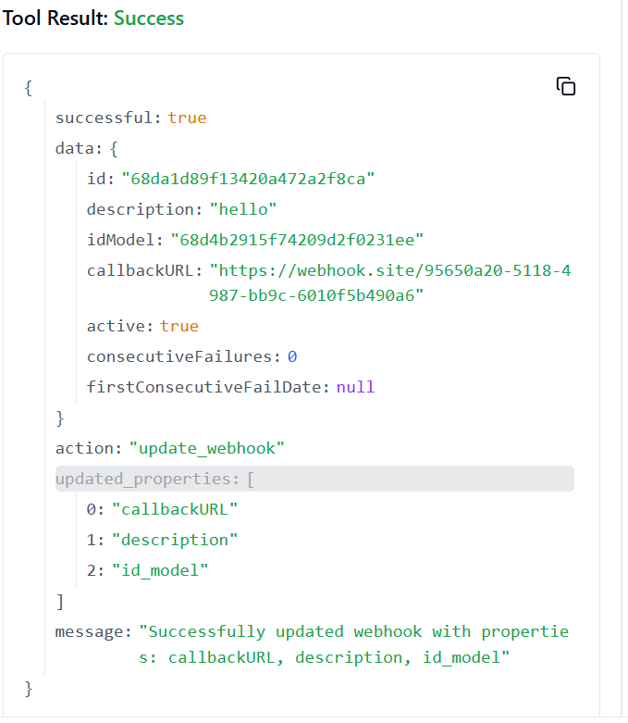

**252. TRELLO_UPDATE_WEBHOOKS_ACTIVE_BY_ID_WEBHOOK**

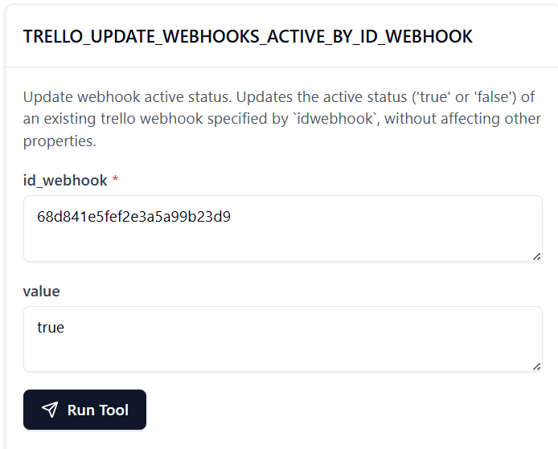

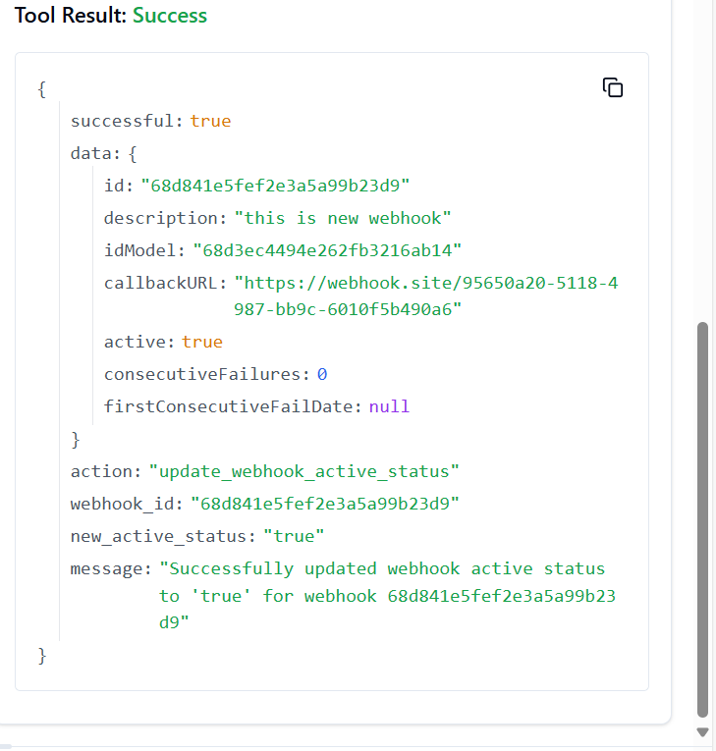

**253. TRELLO_UPDATE_WEBHOOKS**

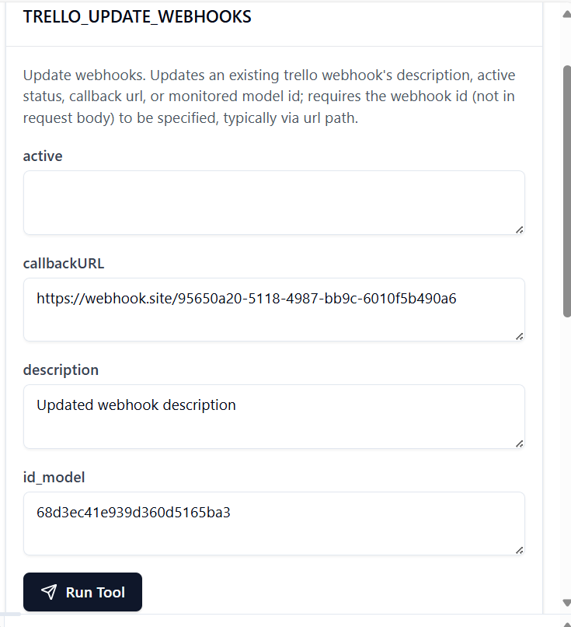

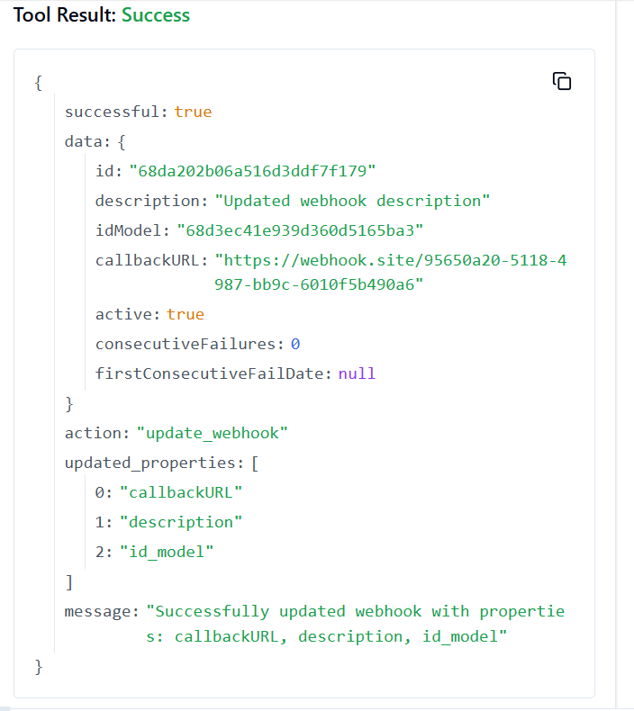

**254. TRELLO_UPDATE_ORG_BOARD_VISIBILITY**

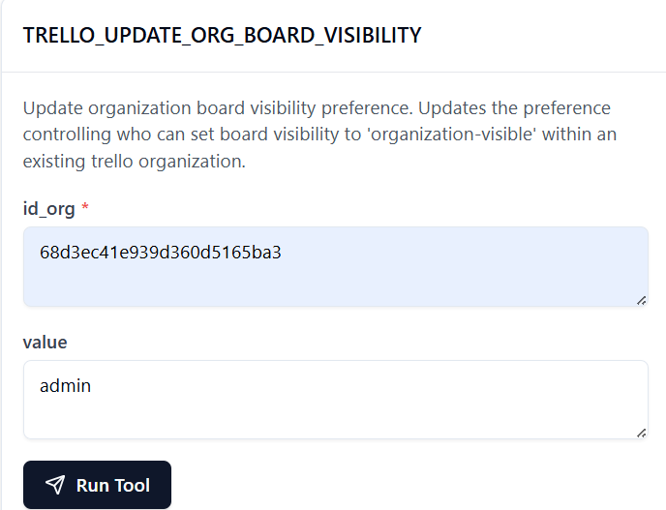

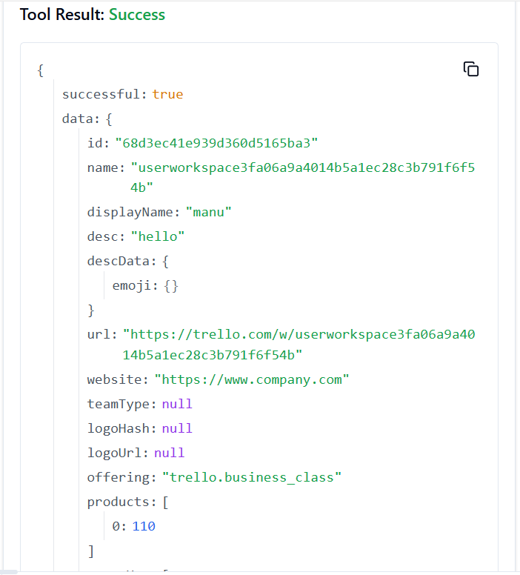

**255. TRELLO_UPDATE_ORG_MEMBER_DEACTIVATION**

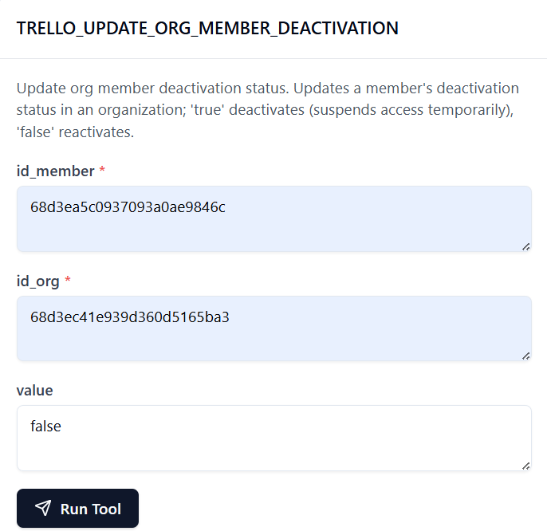

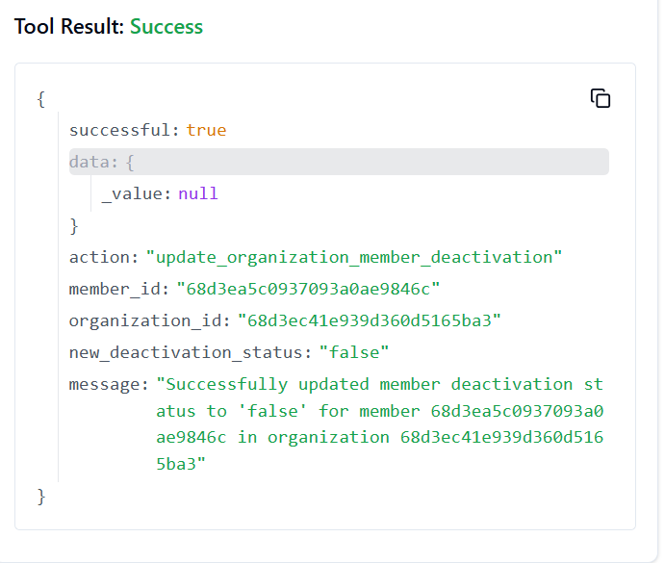

**256. TRELLO_UPDATE_ORG_MEMBERSHIP**

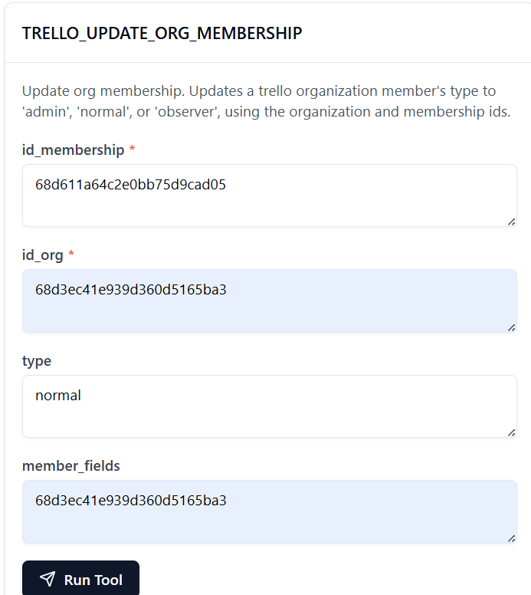

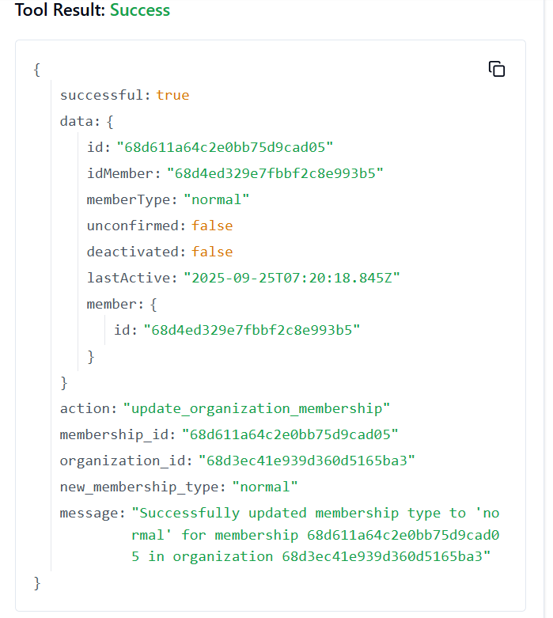

**257. TRELLO_UPDATE_ORG_PRIVATE_BOARD_VISIBILITY**

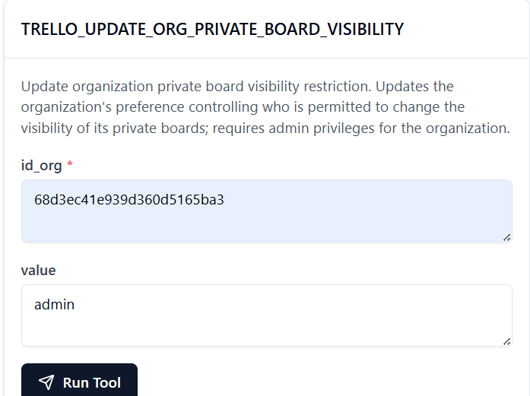

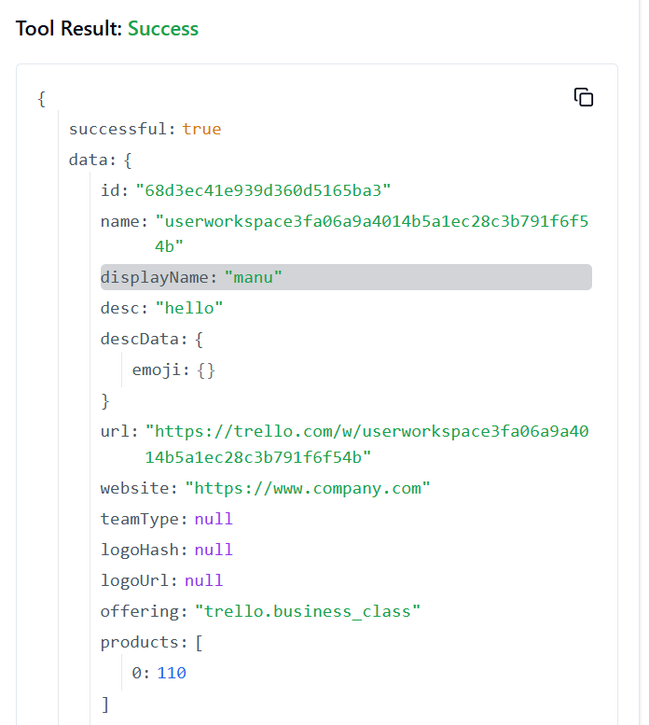

**258. TRELLO_UPDATE_ORG_PUBLIC_BOARD_VISIBILITY**

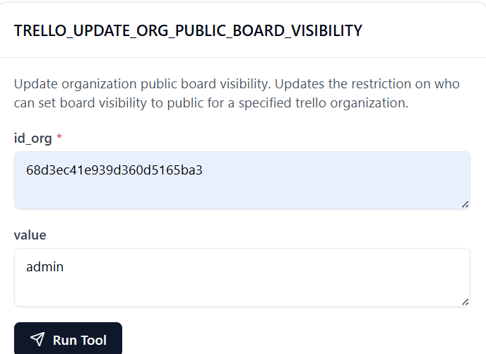

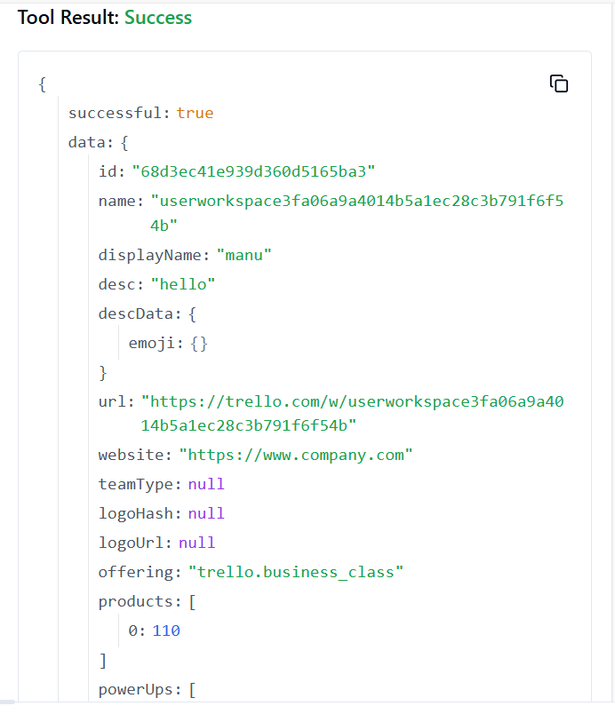

**259. TRELLO_ADD_SESSIONS**

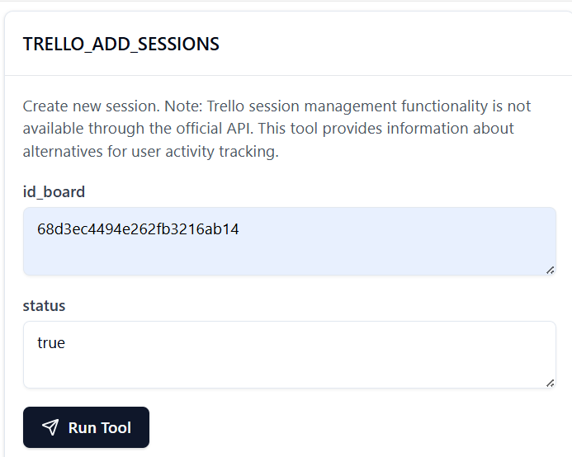

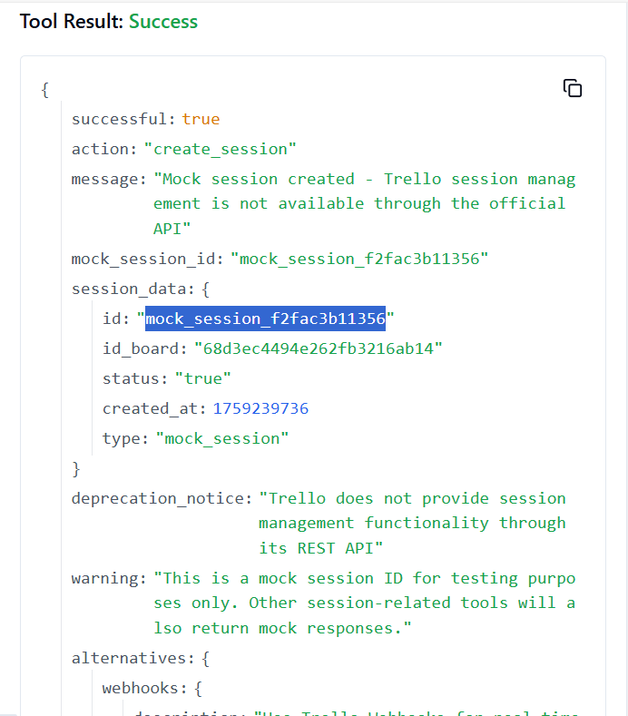

**260. TRELLO_UPDATE_SESSIONS_BY_ID_SESSION**

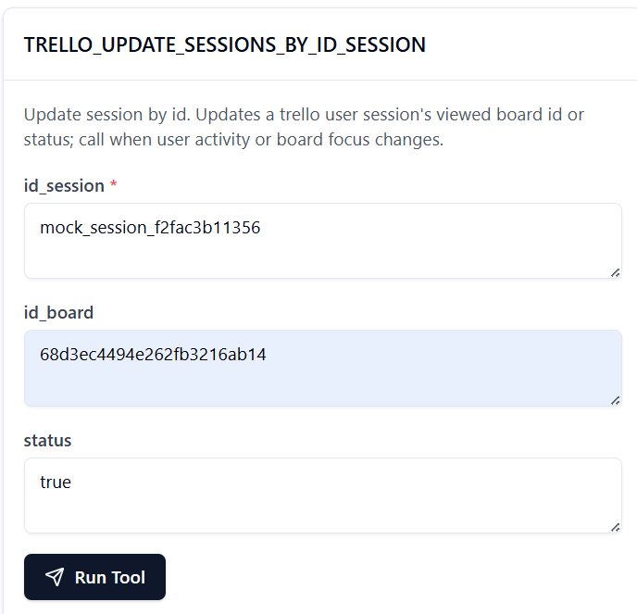

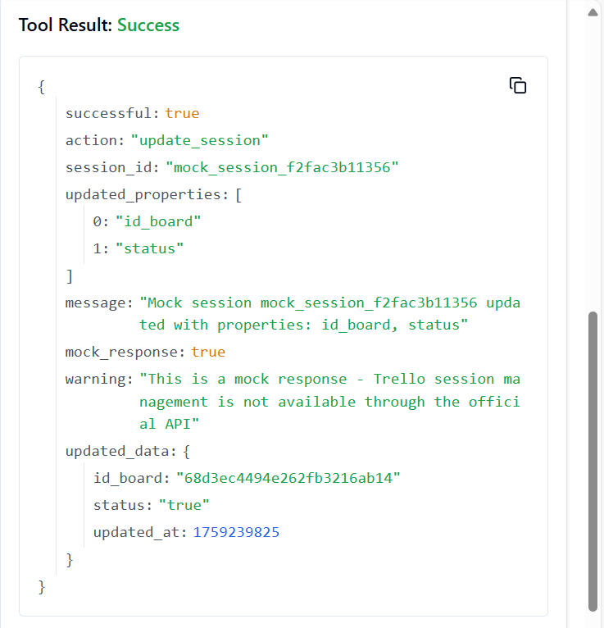

**261. TRELLO_UPDATE_SESSIONS_STATUS_BY_ID_SESSION**

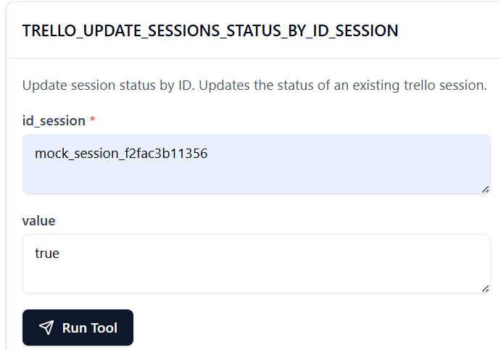

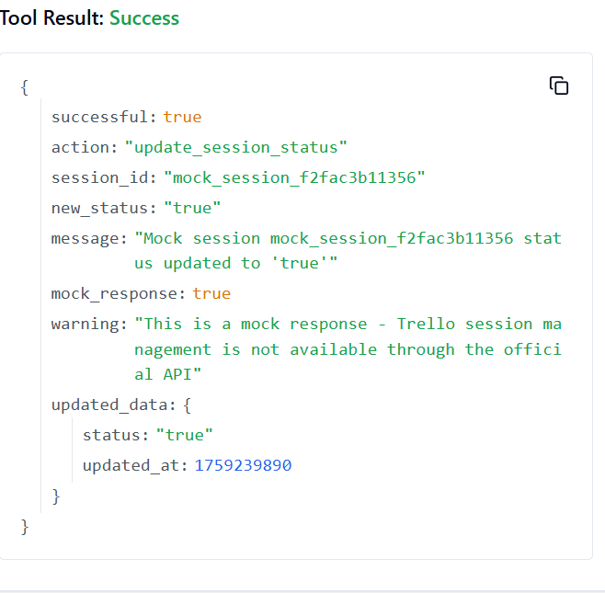

**262. TRELLO_UPDATE_TOKENS_WEBHOOKS_BY_TOKEN**

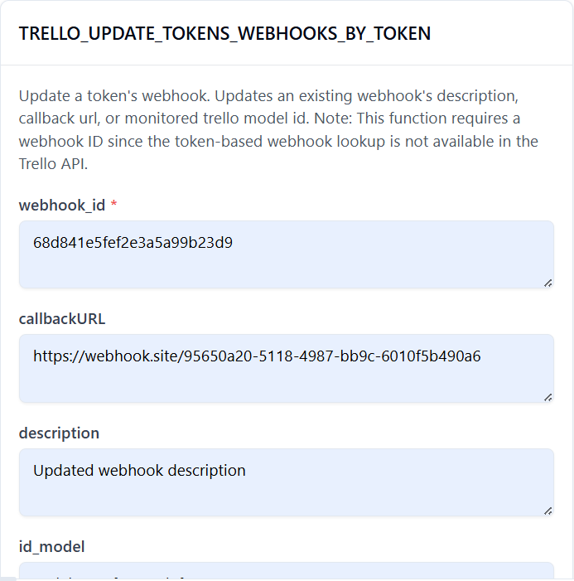

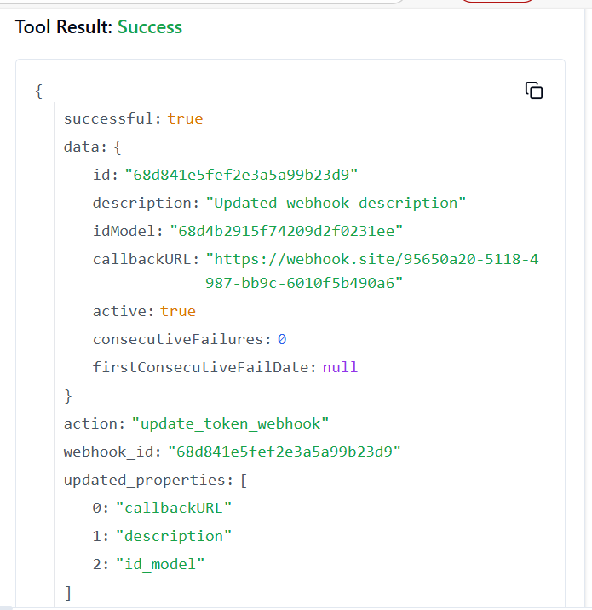

**263. TRELLO_UPDATE_ORGANIZATIONS_PREFS_ORG_INVITE_RESTRICT_BY_ID_ORG**

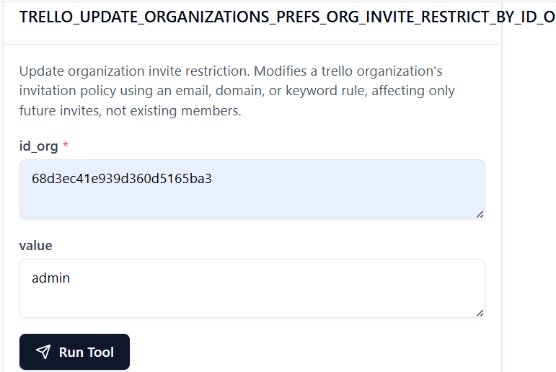

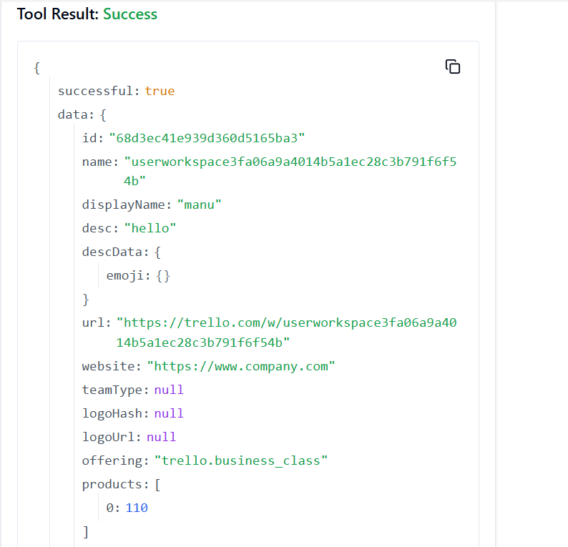

**264. TRELLO_UPDATE_ORGANIZATIONS_NAME_BY_ID_ORG**

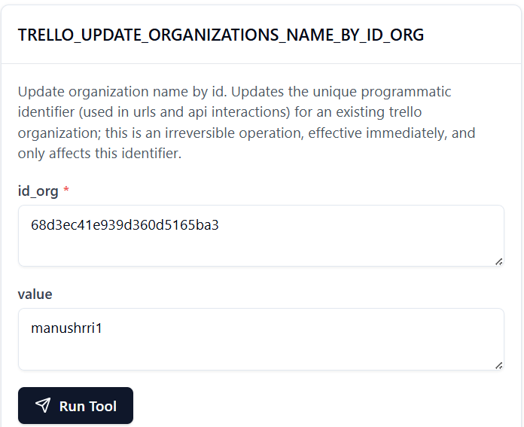

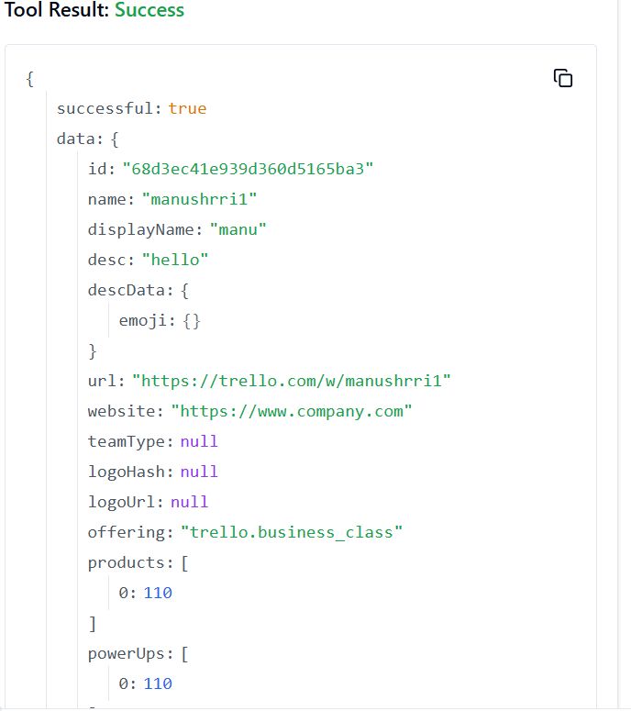

**265. TRELLO_UPDATE_ORGANIZATIONS_MEMBERS_BY_ID_ORG**

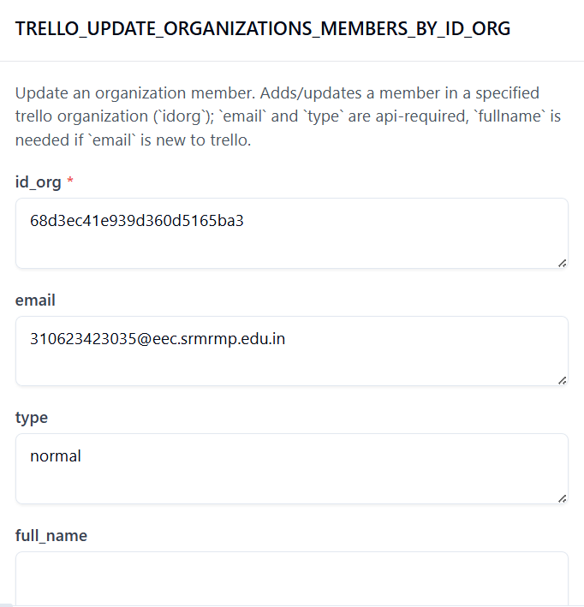

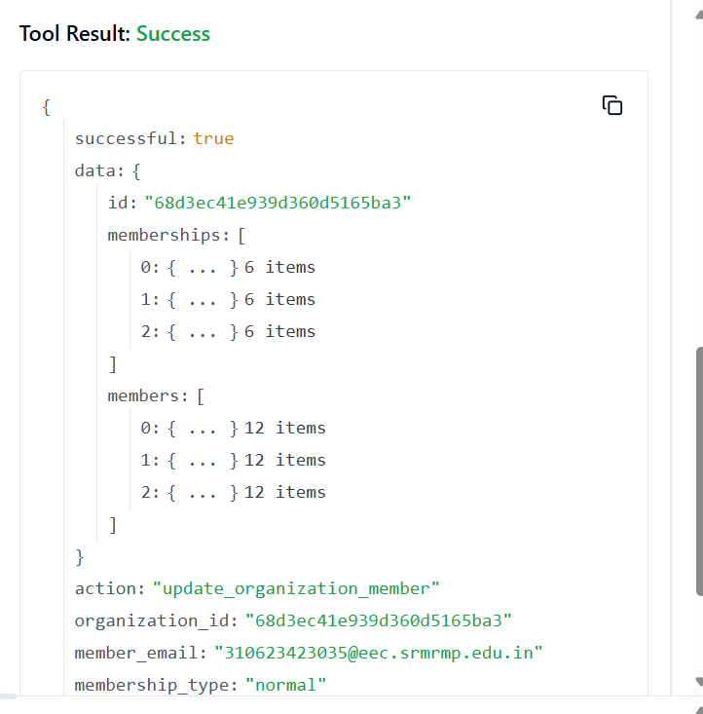

**266. TRELLO_UPDATE_ORGANIZATIONS_MEMBERS_BY_ID_ORG_BY_ID_MEMBER**

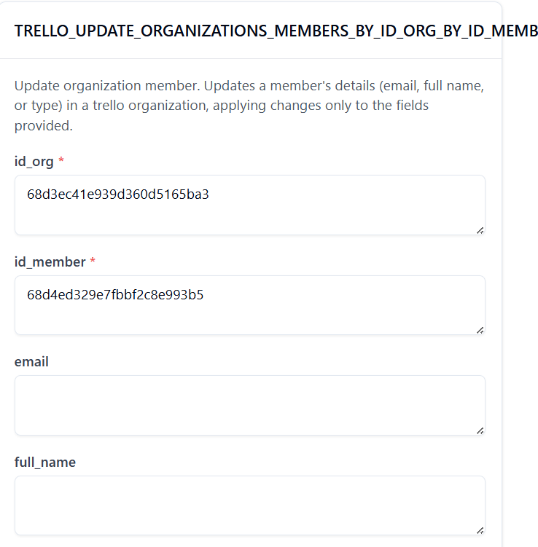

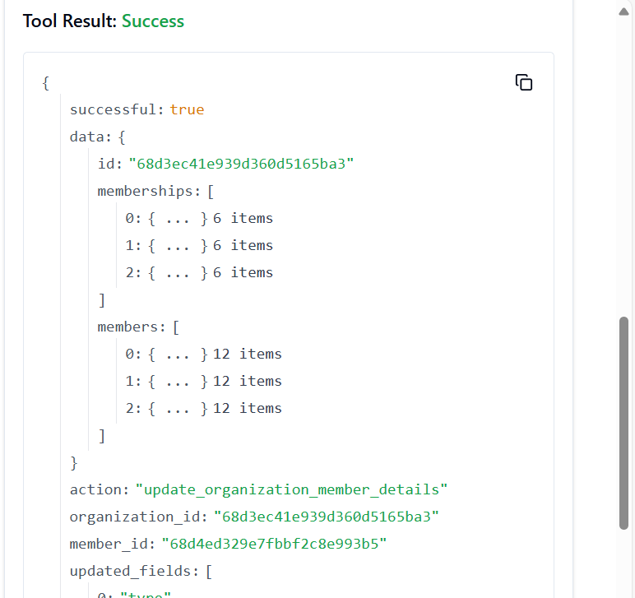

**267. TRELLO_UPDATE_MEMBERS_PREFS_LOCALE_BY_ID_MEMBER**

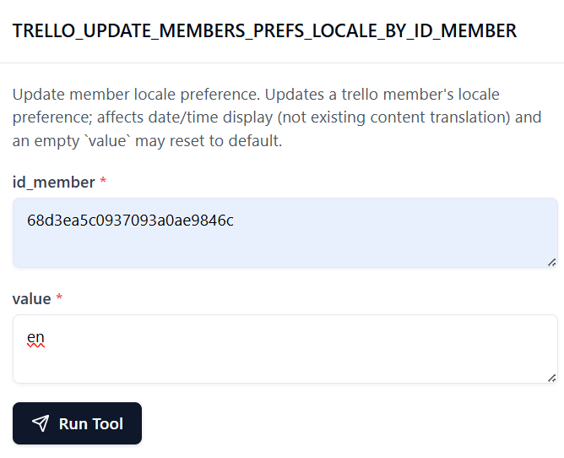

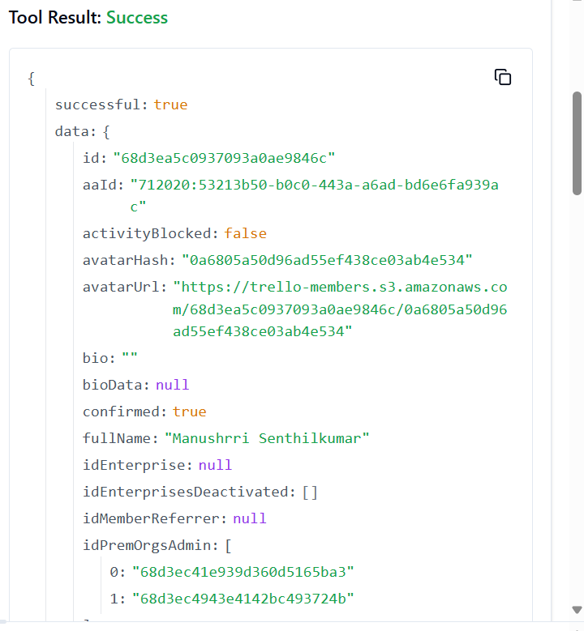

**268. TRELLO_UPDATE_MEMBER_SUMMARY_INTERVAL**

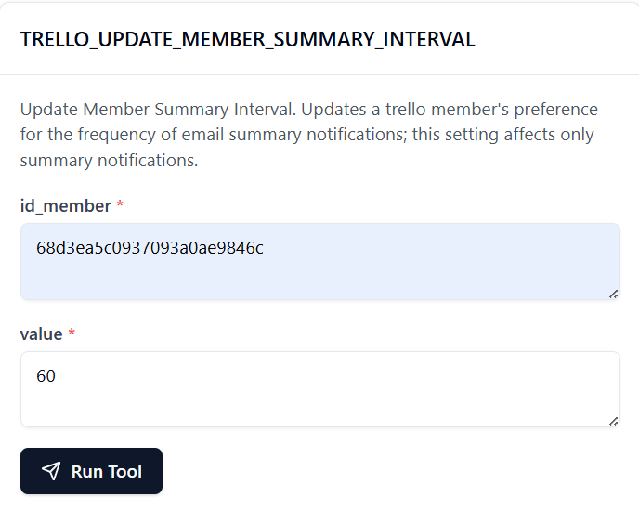

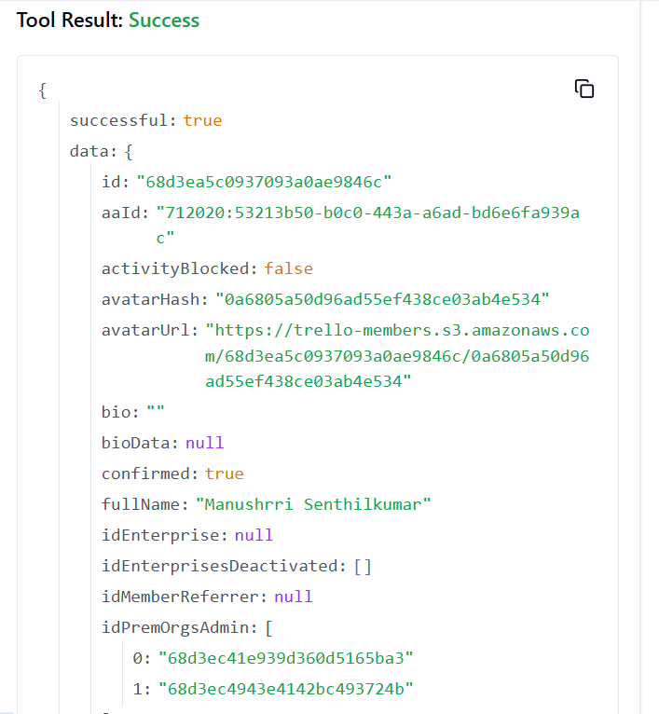

**269. TRELLO_REMOVE_CHECKLIST_ITEM_FROM_CARD_BY_IDS**

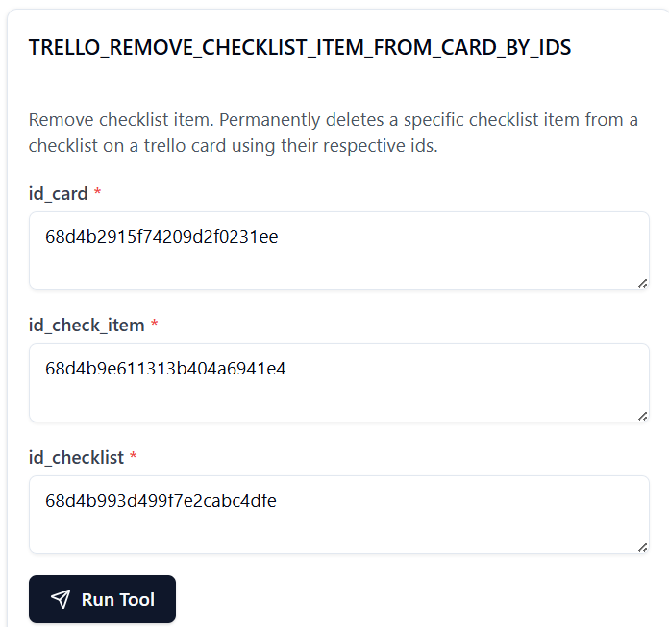

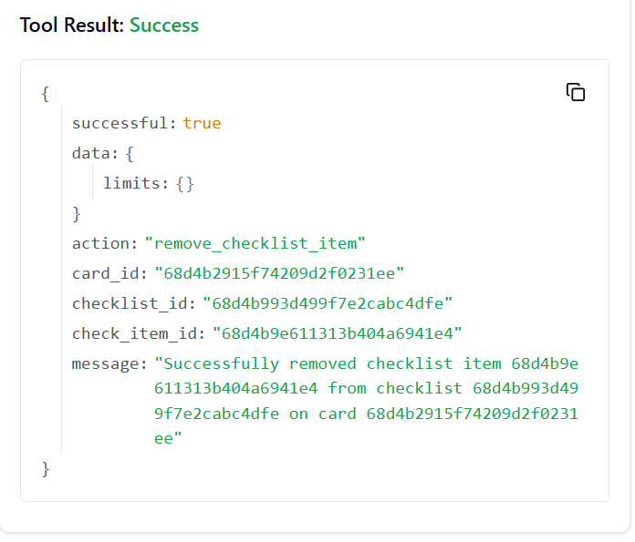

**270. TRELLO_REMOVE_SPECIFIC_MEMBER_S_BOARD_BACKGROUNDS**

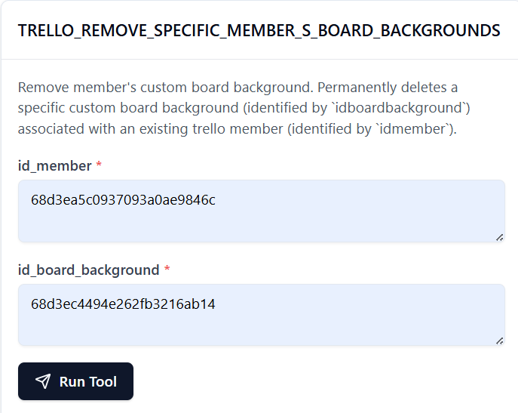

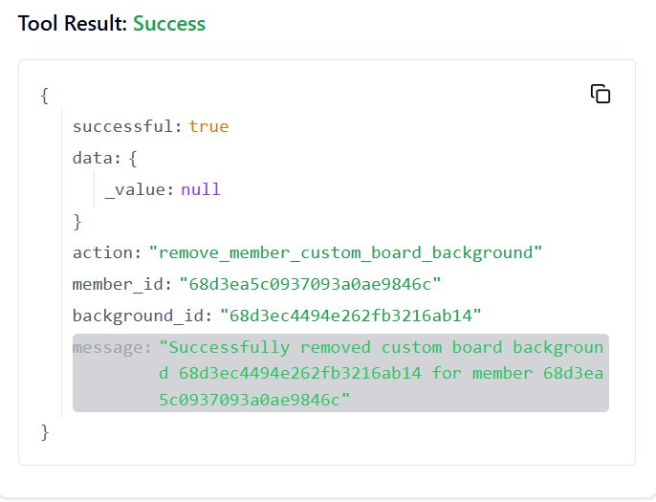

**271. TRELLO_GET_NOTIFICATIONS_MEMBER_CREATOR_BY_ID_NOTIFICATION**

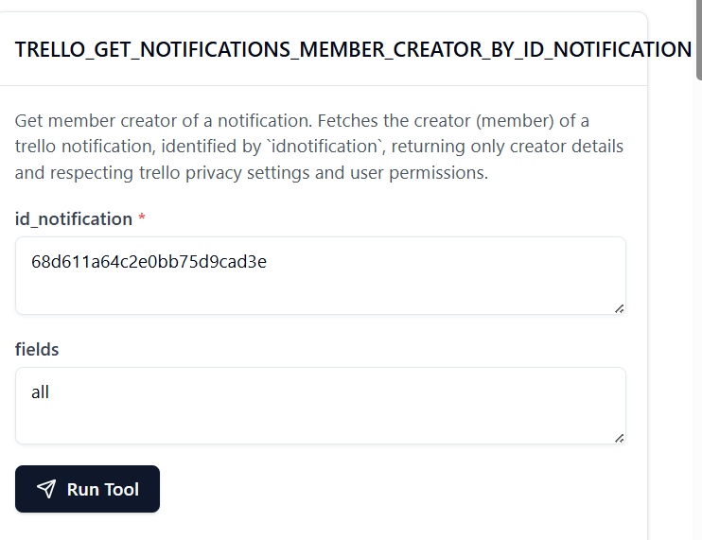

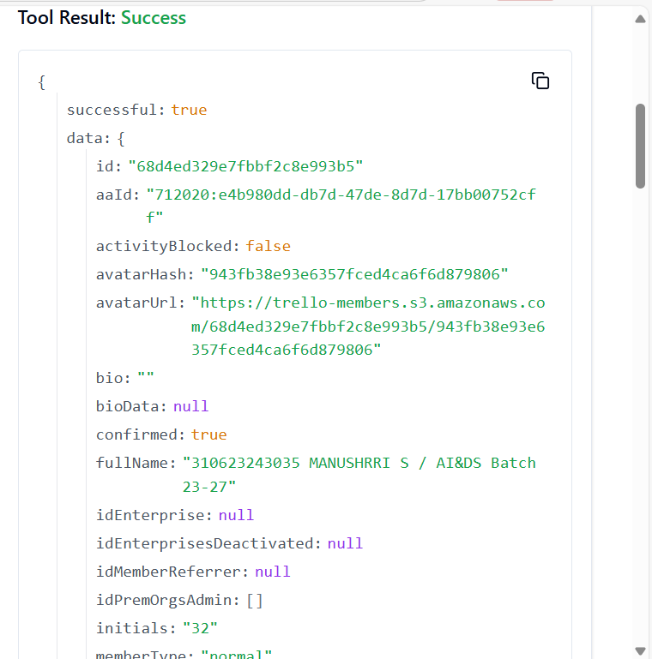

**272. TRELLO_GET_NOTIFICATIONS_ORGANIZATION_BY_ID_NOTIFICATION**

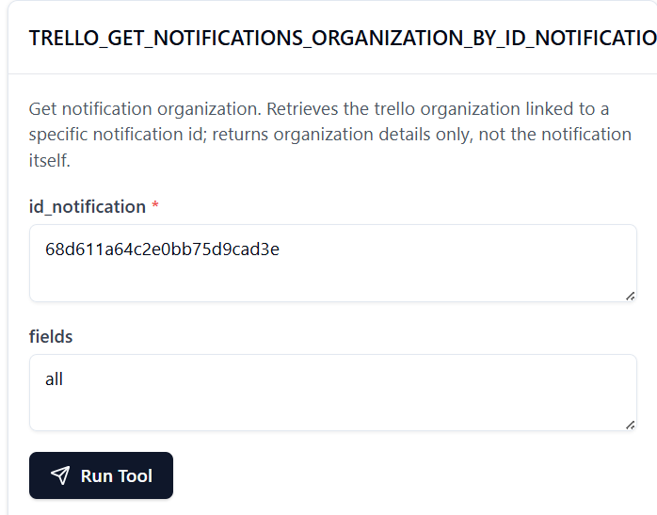

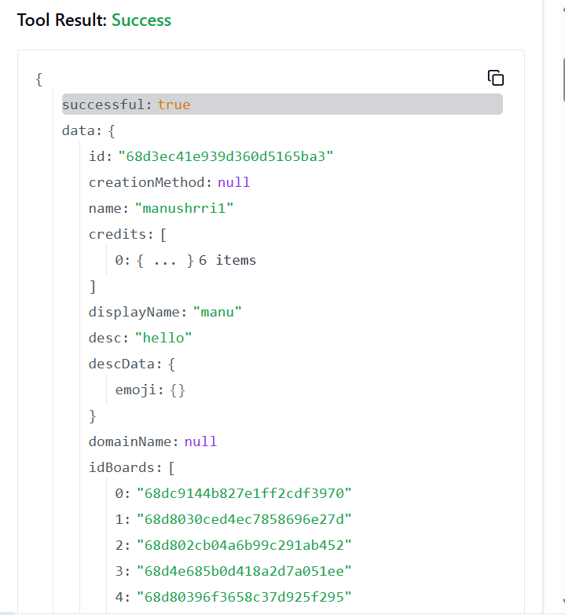

**273. TRELLO_GET_NOTIFICATIONS_ENTITIES_BY_ID_NOTIFICATION**

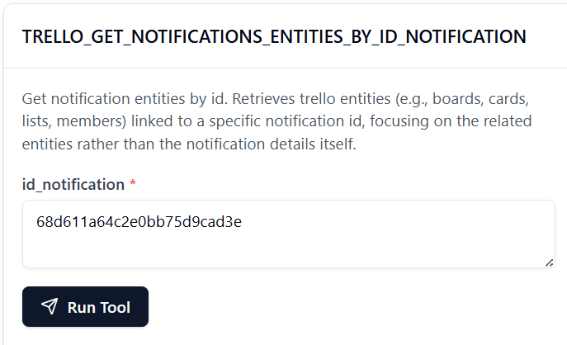

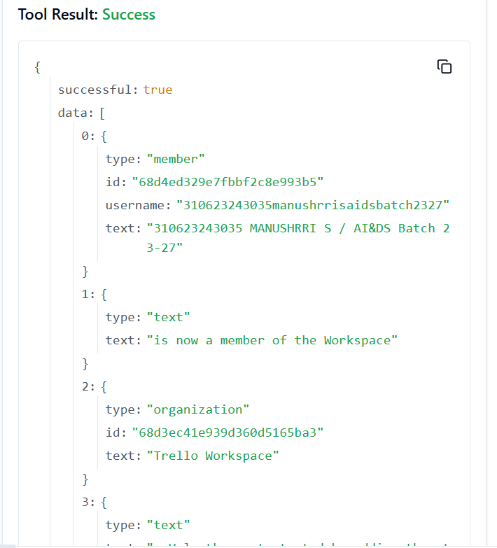

**274. TRELLO_GET_NOTIFICATIONS_CARD_BY_ID_NOTIFICATION**

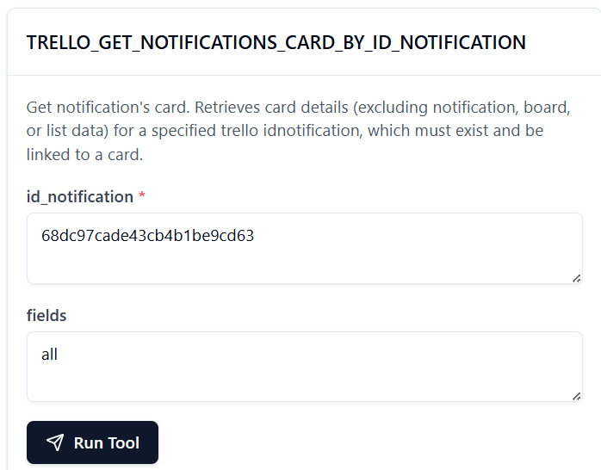

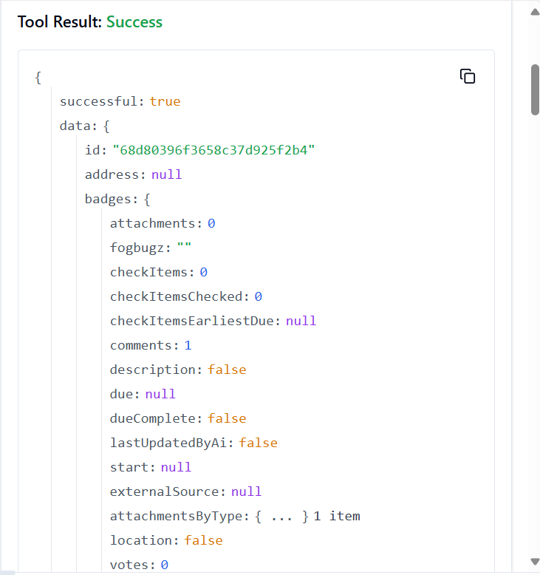

**275. TRELLO_GET_NOTIFICATIONS_CARD_BY_ID_NOTIFICATION_BY_FIELD**

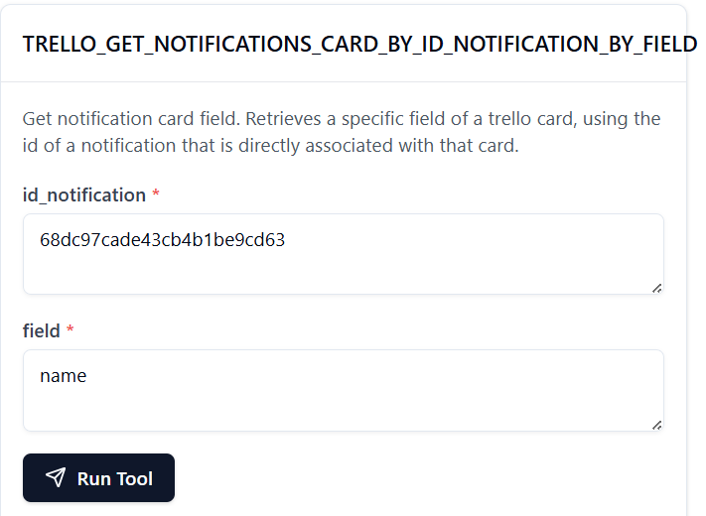

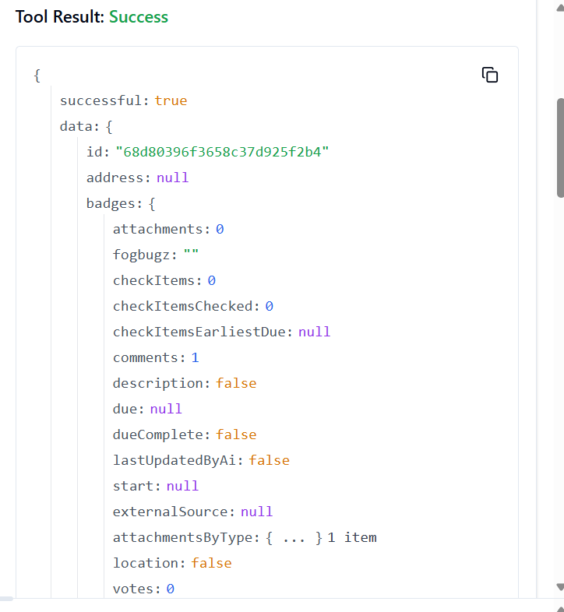

**276.** **TRELLO_GET_NOTIFICATIONS_LIST_BY_ID_NOTIFICATION**

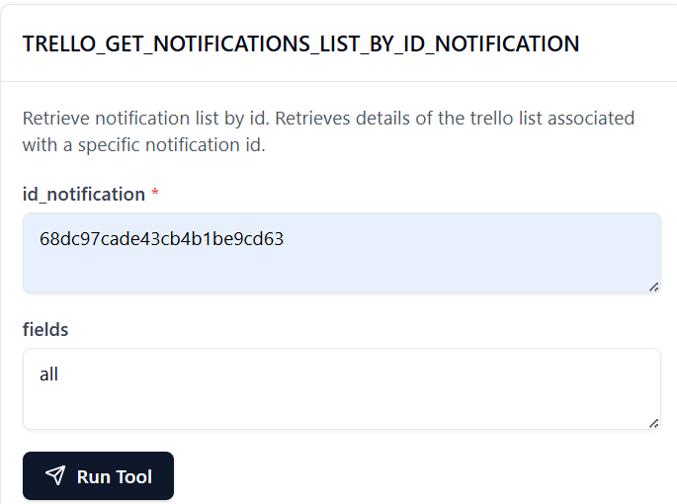

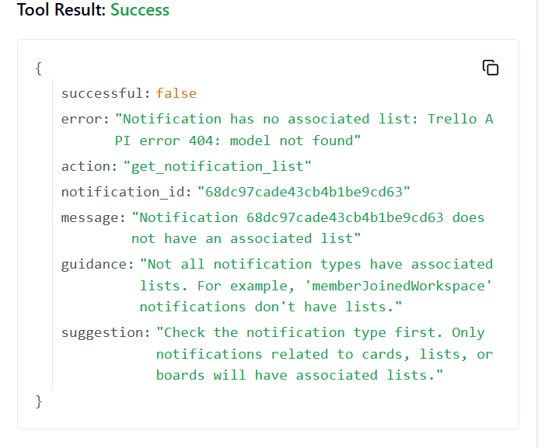

**277. TRELLO_GET_NOTIFICATIONS_LIST_BY_ID_NOTIFICATION_BY_FIELD**

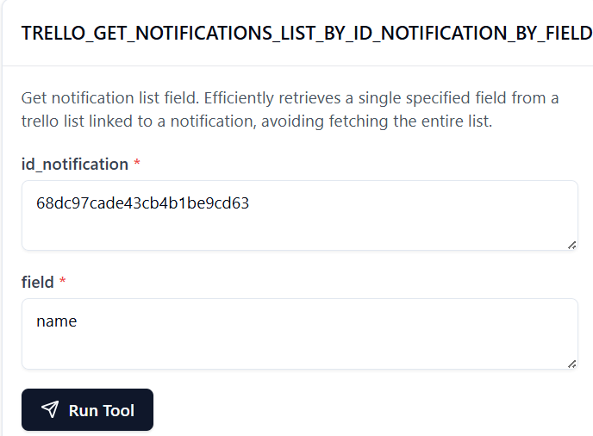

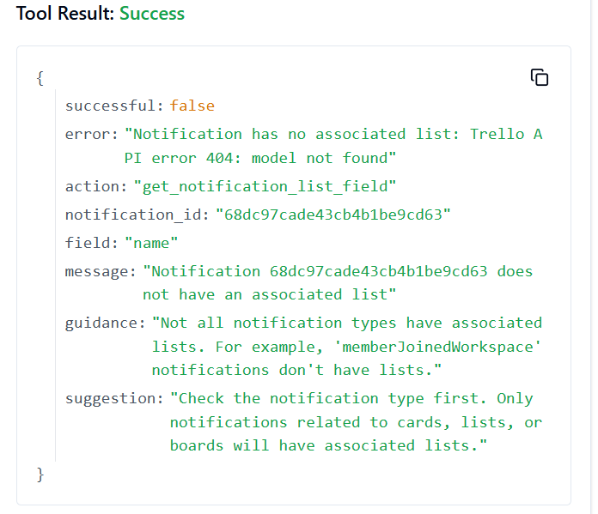

**278. TRELLO_GET_NOTIFICATIONS_MEMBER_BY_ID_NOTIFICATION**

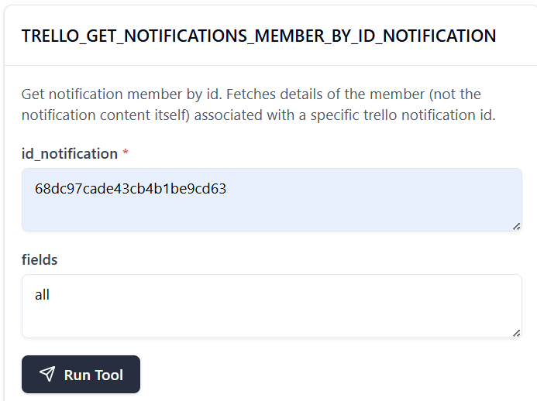

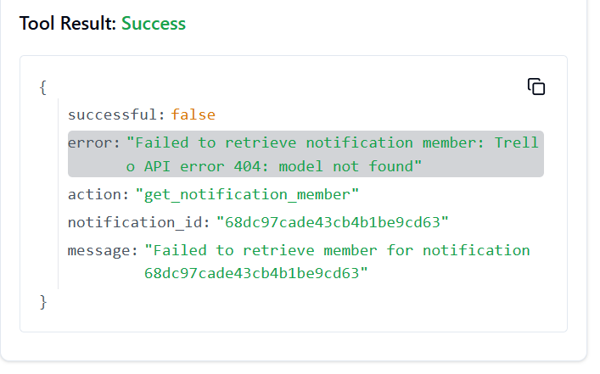

**279. TRELLO_GET_NOTIFICATIONS_MEMBER_BY_ID_NOTIFICATION_BY_FIELD**

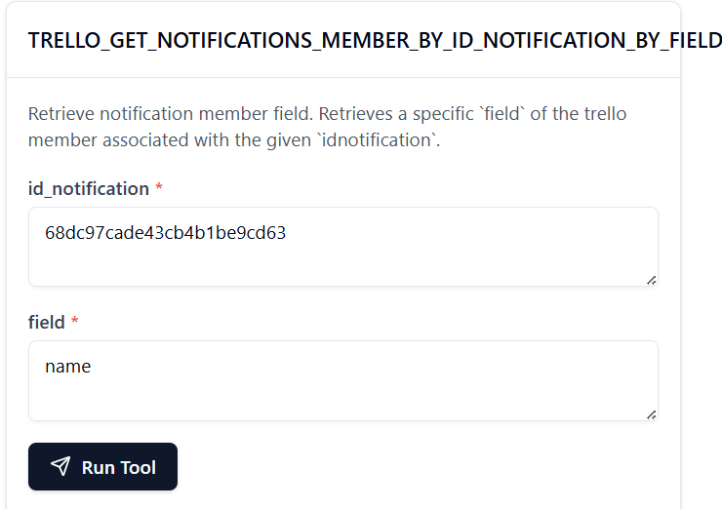

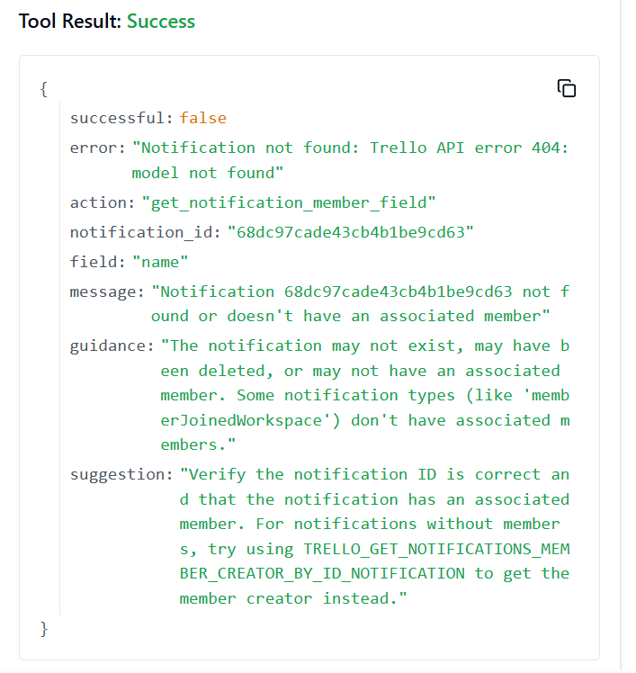

**280. TRELLO_GET_NOTIFICATIONS_BOARD_BY_ID_NOTIFICATION**

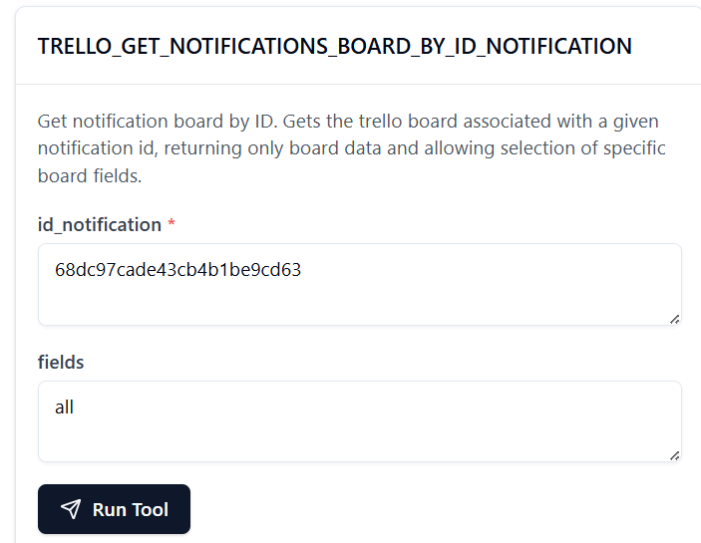

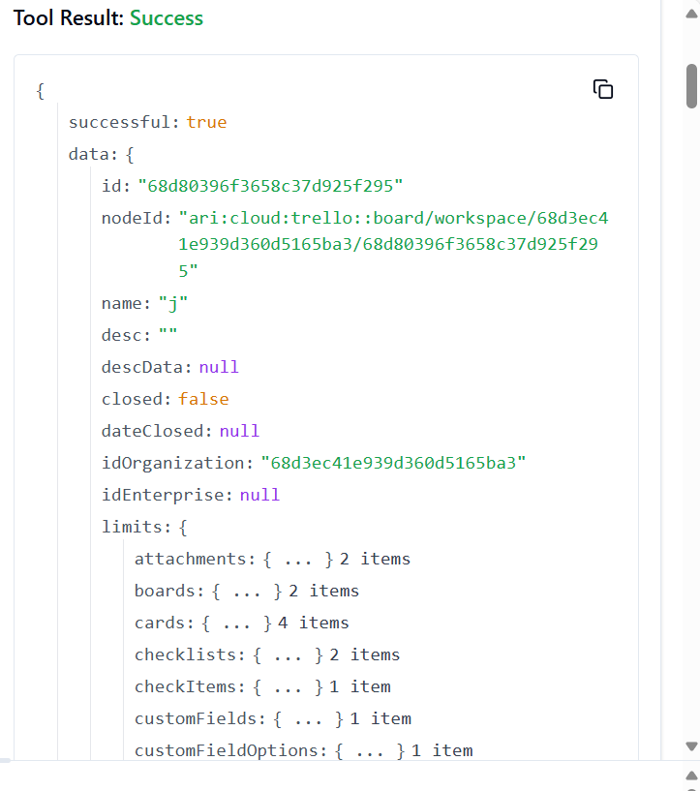

**281. TRELLO_GET_NOTIFICATIONS_BOARD_BY_ID_NOTIFICATION_BY_FIELD**

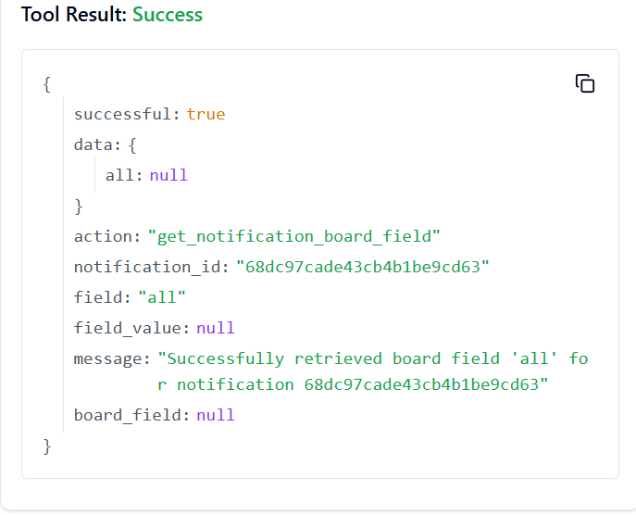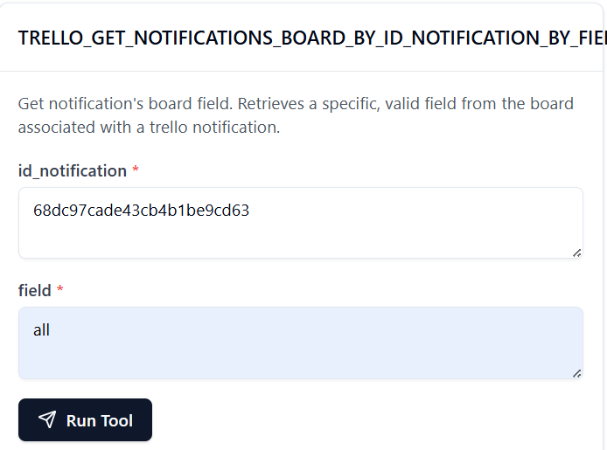

**282. TRELLO_GET_MEMBERS_CUSTOM_EMOJI_BY_ID_MEMBER**

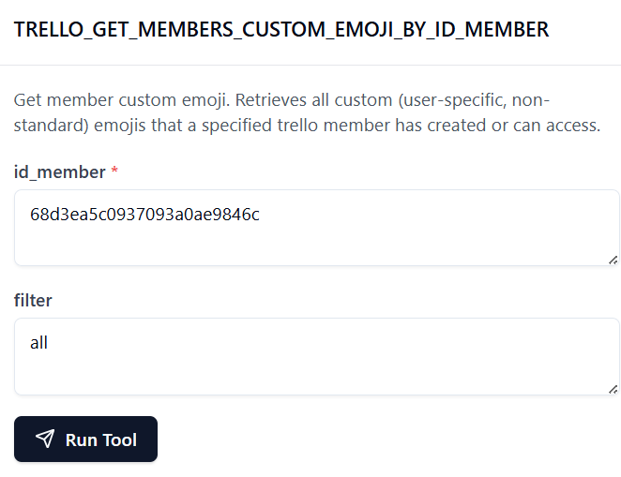

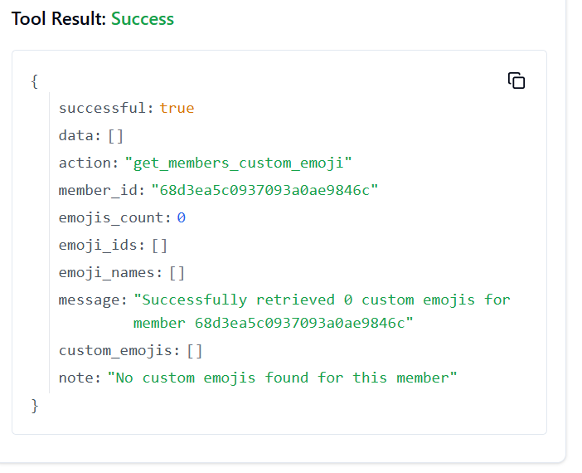

**283. TRELLO_DELETE_ACTIONS_BY_ID_ACTION**

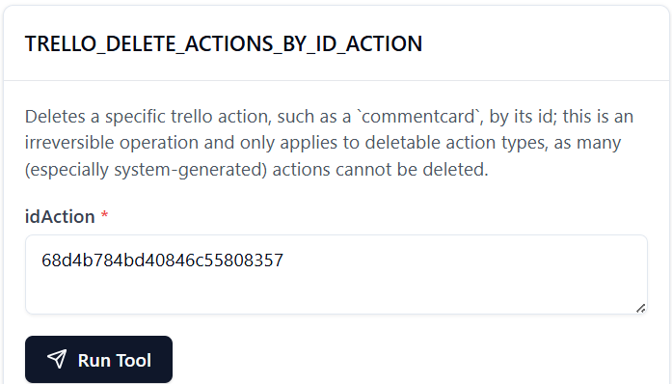

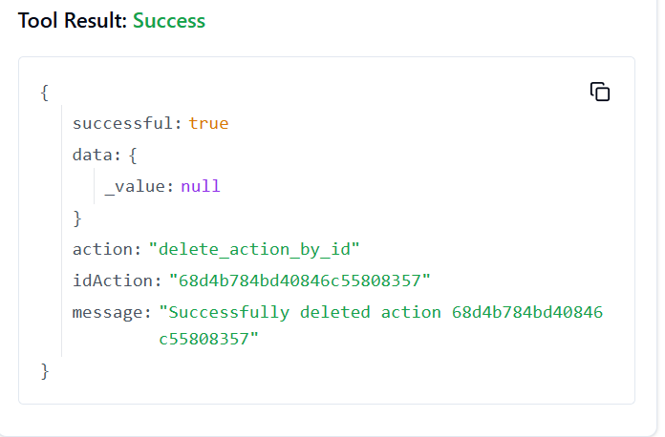

**284. TRELLO_DELETE_BOARDS_MEMBERS_BY_ID_BOARD_BY_ID_MEMBER**

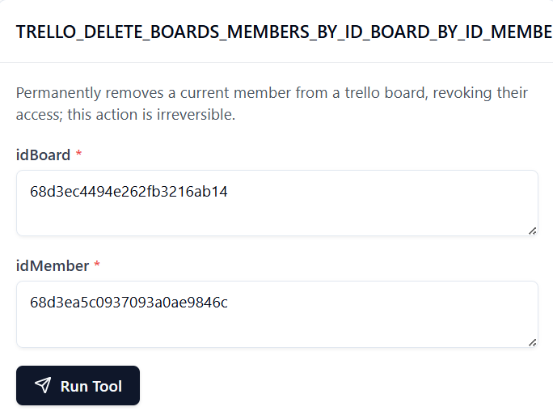

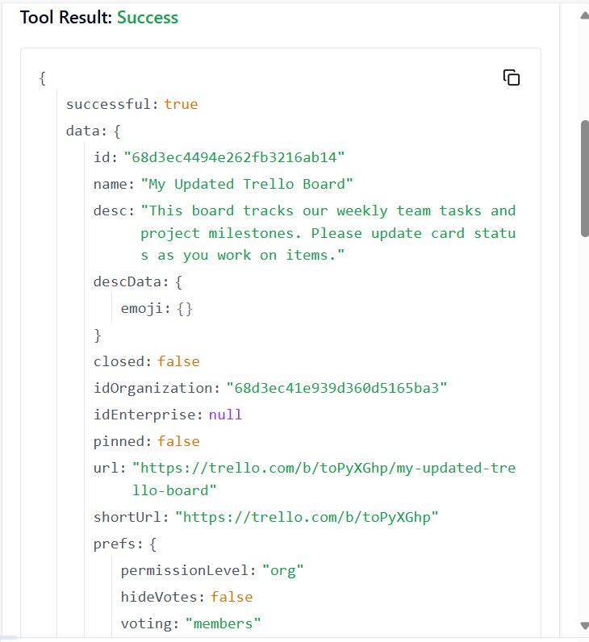

**285. TRELLO_DELETE_BOARDS_POWER_UPS_BY_ID_BOARD_BY_POWER_UP**

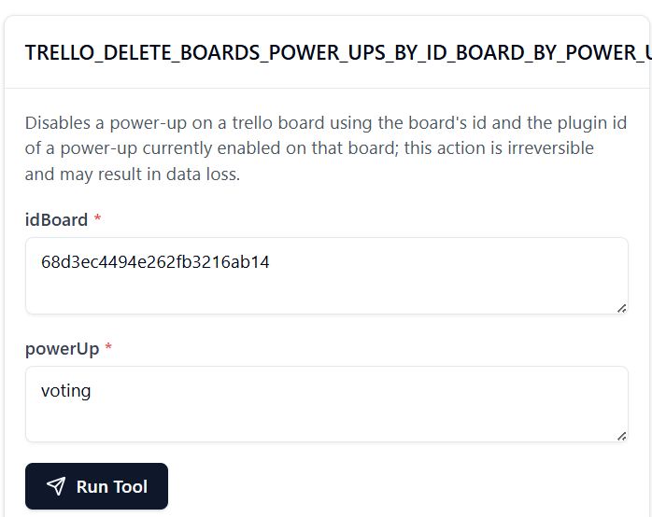

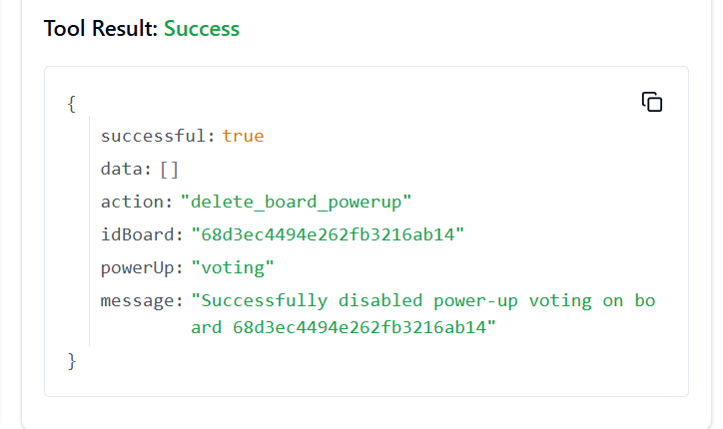

**286. TRELLO_DELETE_CARDS_ACTIONS_COMMENTS_BY_ID_CARD_BY_ID_ACTION**

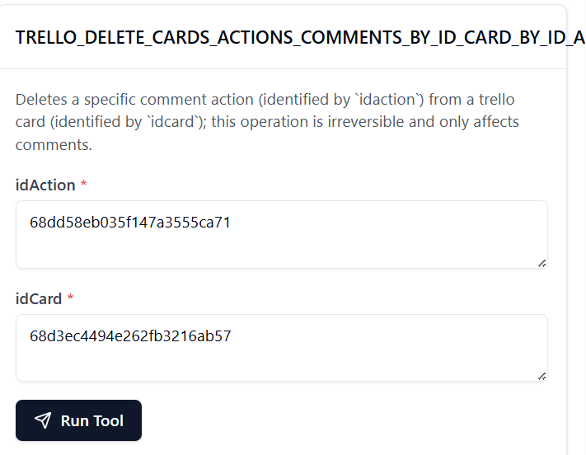

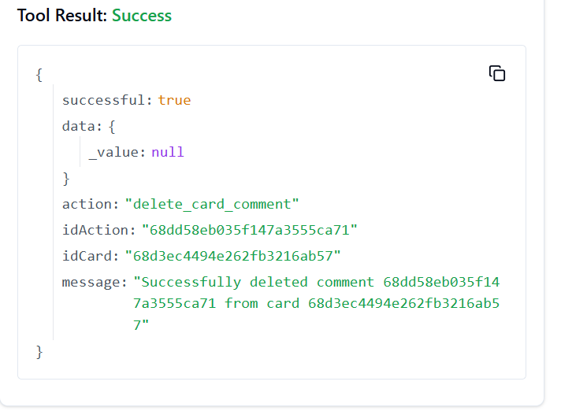

**287. TRELLO_DELETE_CARDS_BY_ID_CARD**

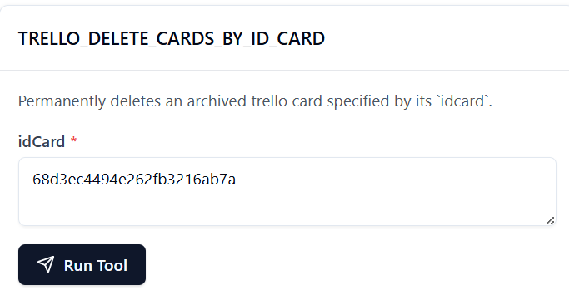

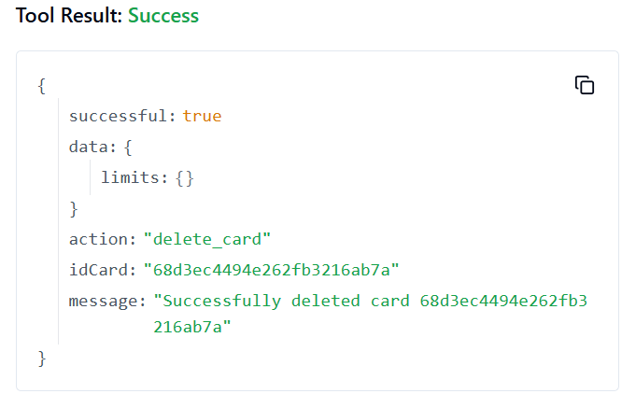

**288. TRELLO_DELETE_CARDS_CHECKLISTS_BY_ID_CARD_BY_ID_CHECKLIST**

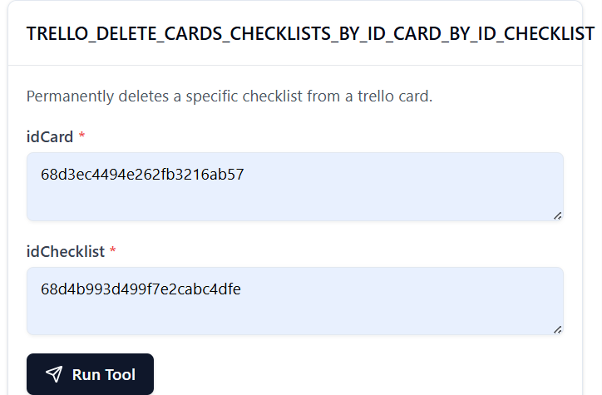

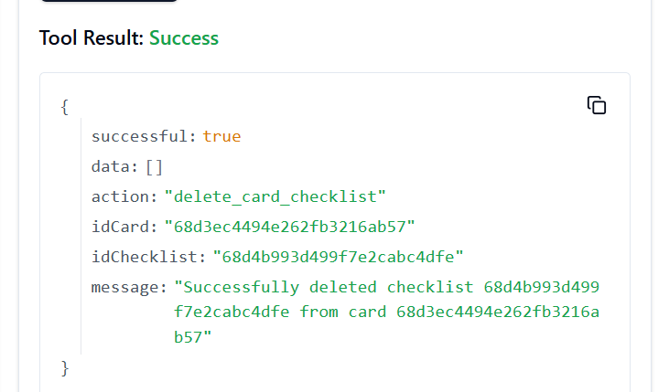

**289. TRELLO_DELETE_CARDS_ID_LABELS_BY_ID_CARD_BY_ID_LABEL**

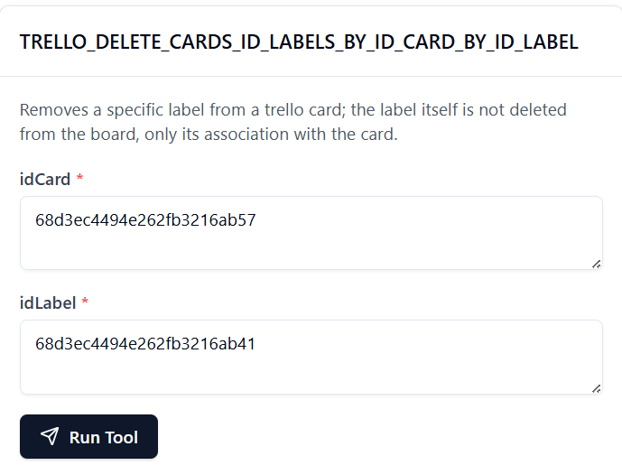

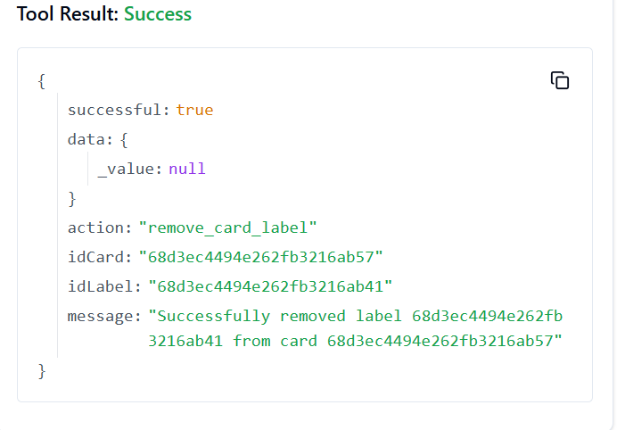

**290. TRELLO_DELETE_CARDS_LABELS_BY_ID_CARD_BY_COLOR**

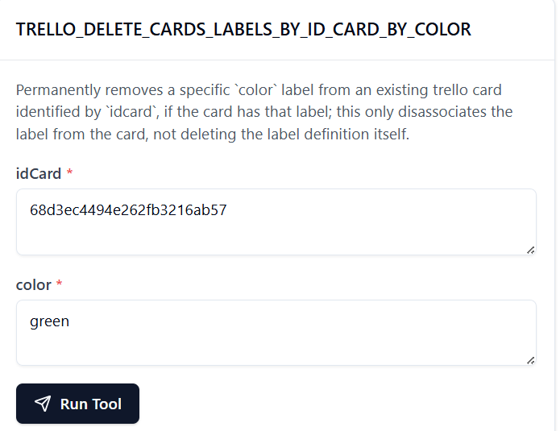

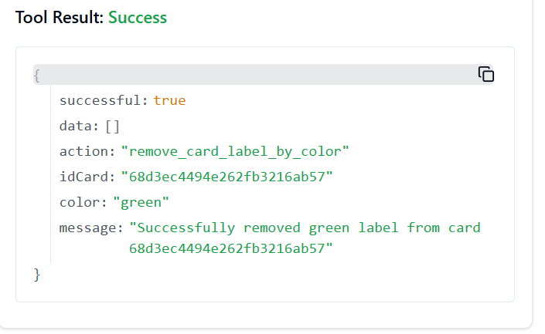

**291. TRELLO_DELETE_CARDS_STICKERS_BY_ID_CARD_BY_ID_STICKER**

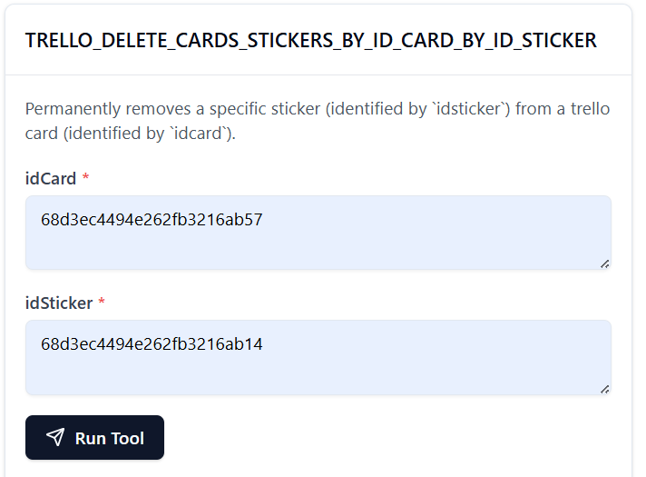

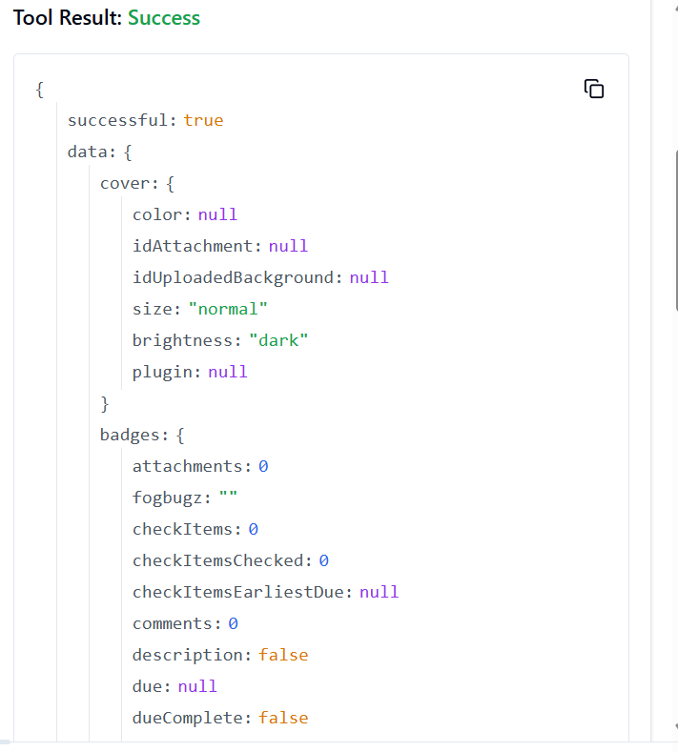

**292. TRELLO_DELETE_CARDS_ID_MEMBERS_BY_ID_CARD_BY_ID_MEMBER**

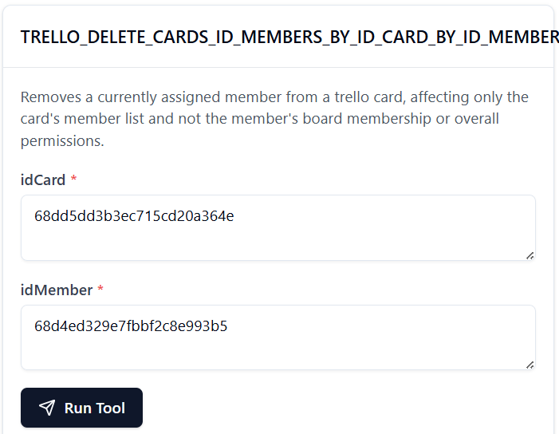

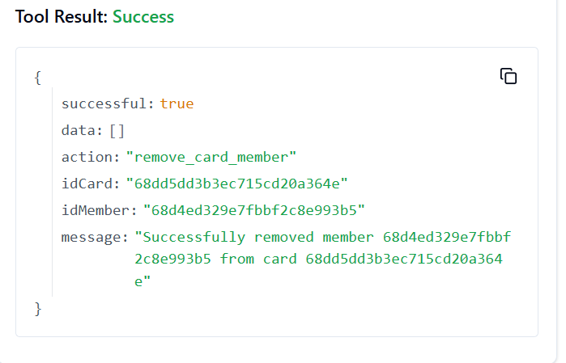

**293. TRELLO_DELETE_CHECKLIST_ITEM**

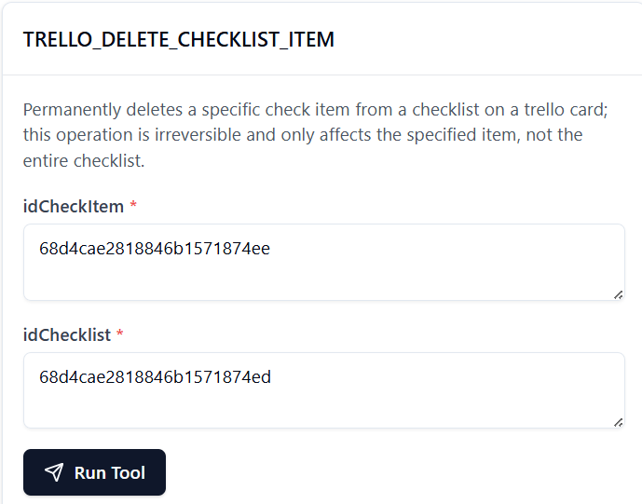

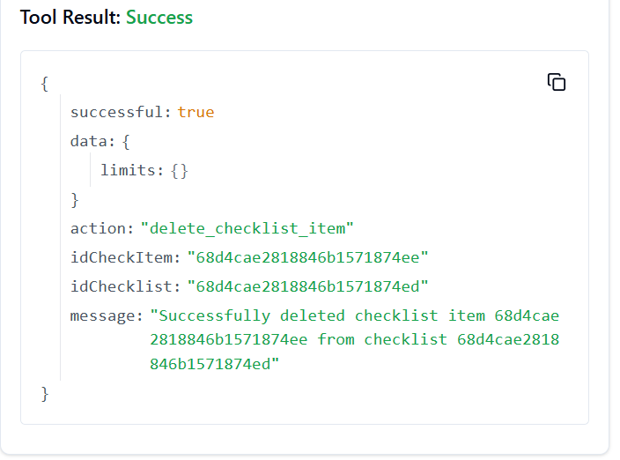

**294. TRELLO_DELETE_CHECKLISTS_BY_ID_CHECKLIST**

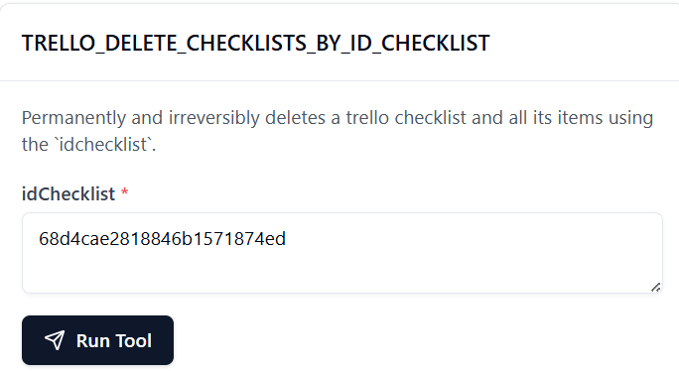

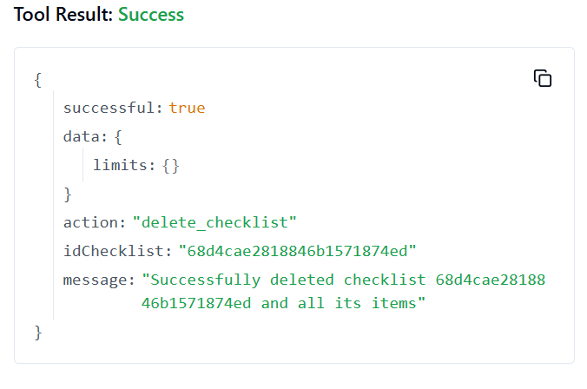

**295. TRELLO_DELETE_LABELS_BY_ID_LABEL**

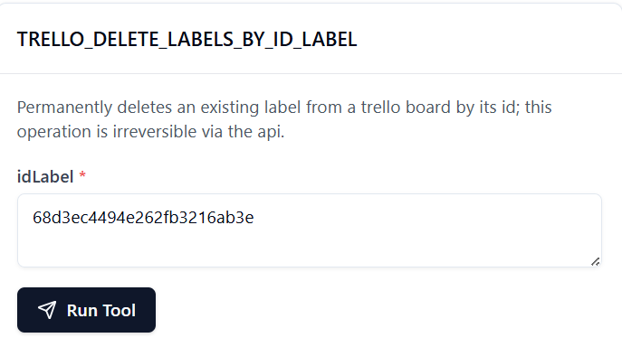

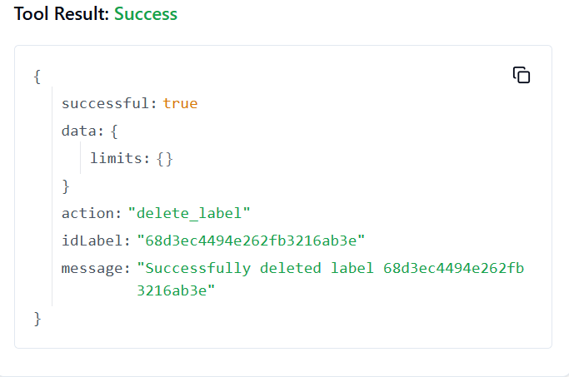

**296. TRELLO_DELETE_MEMBER_BOARD_BACKGROUND**

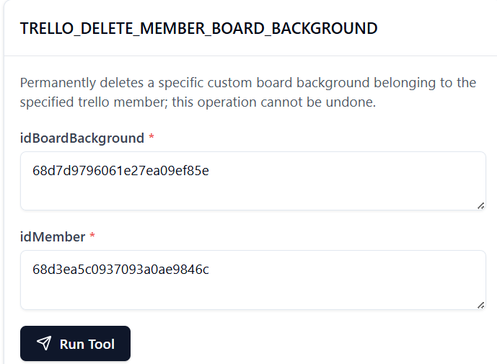

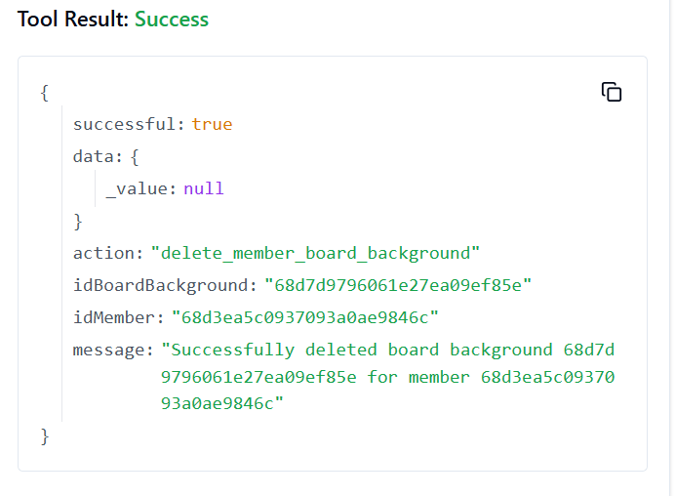

**297. TRELLO_DELETE_MEMBER_CUSTOM_STICKER**

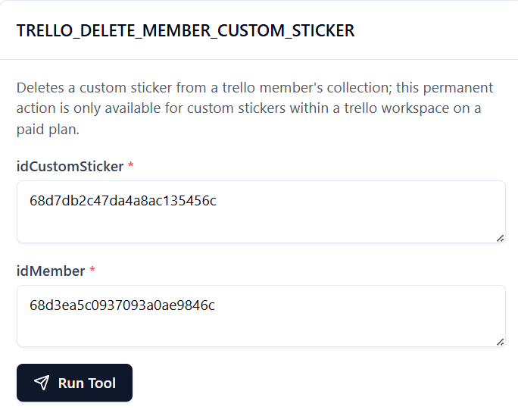

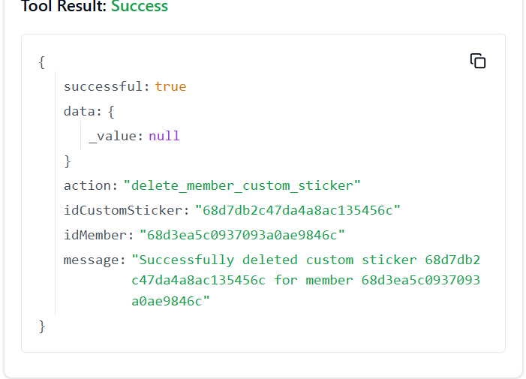

**298. TRELLO_DELETE_MEMBER_SAVED_SEARCH**

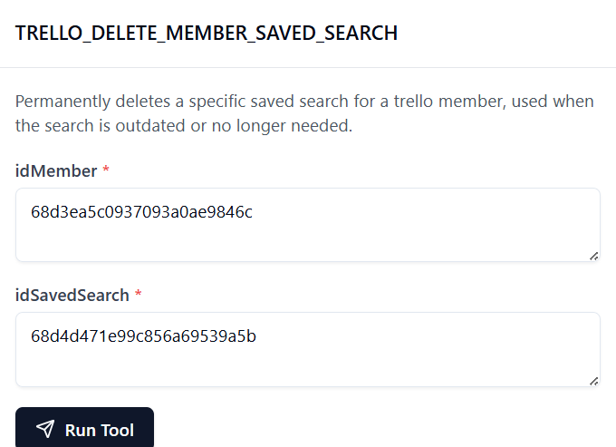

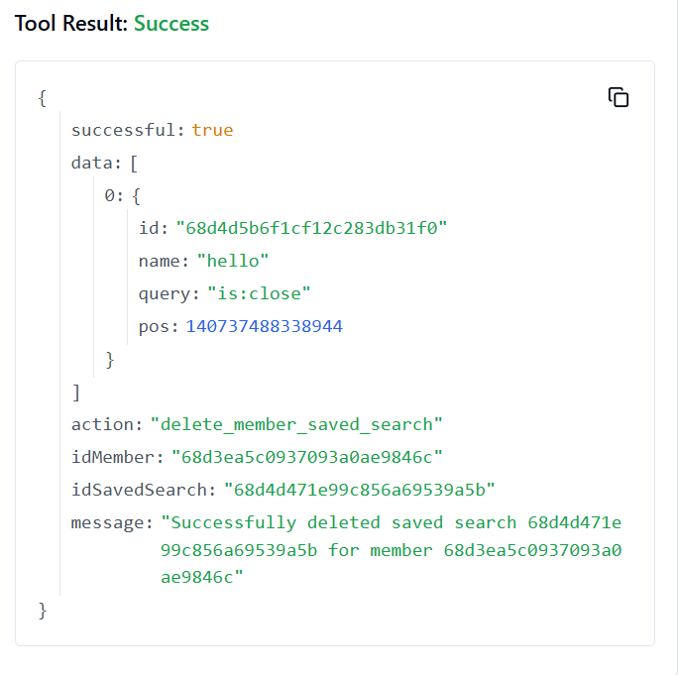

**299. TRELLO_DELETE_MEMBERS_BOARD_STARS_BY_ID_MEMBER_BY_ID_BOARD_STAR**

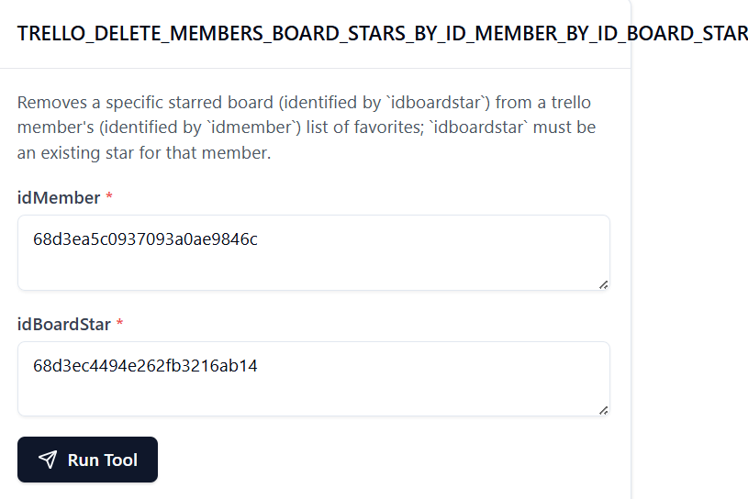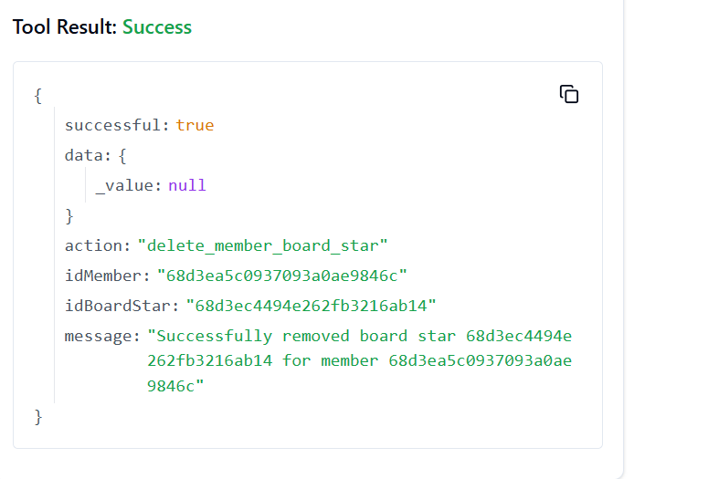

**300. TRELLO_DELETE_ORGANIZATIONS_LOGO_BY_ID_ORG**

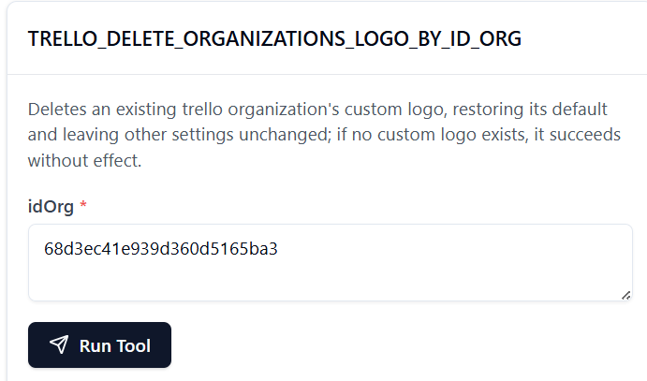

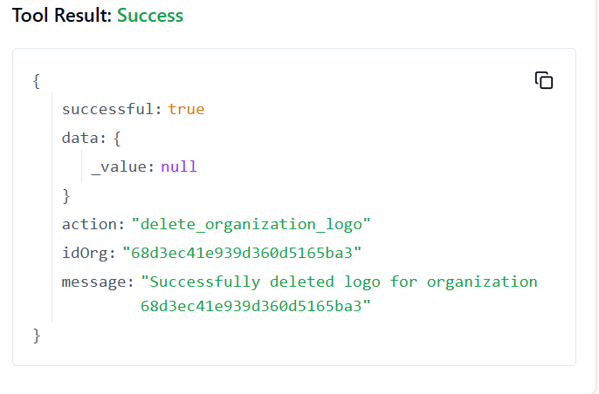

**301. TRELLO_DELETE_ORGANIZATIONS_BY_ID_ORG**

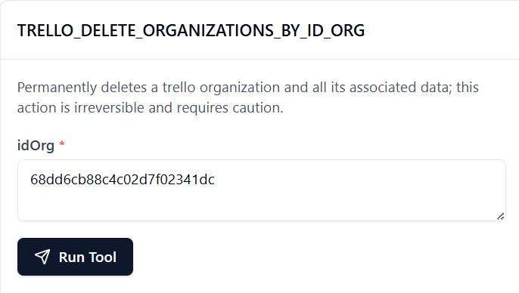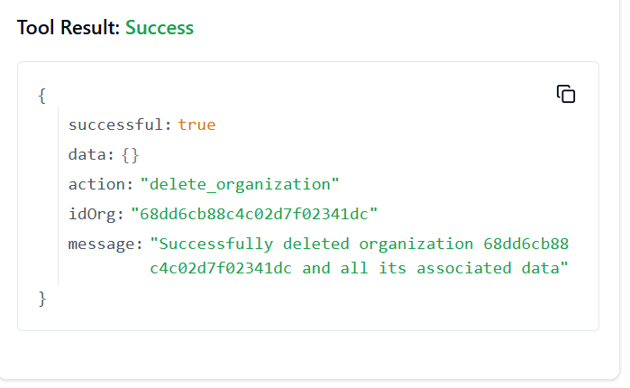

**302. TRELLO_DELETE_ORGANIZATIONS_MEMBERS_BY_ID_ORG_BY_ID_MEMBER**

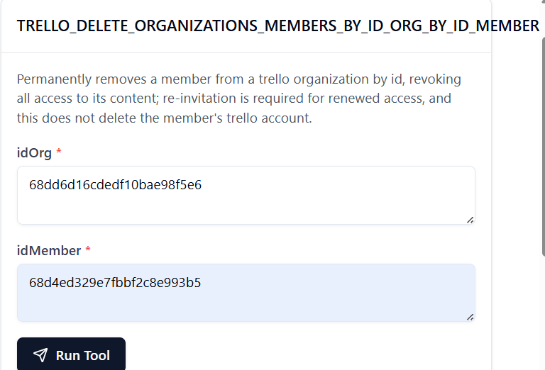

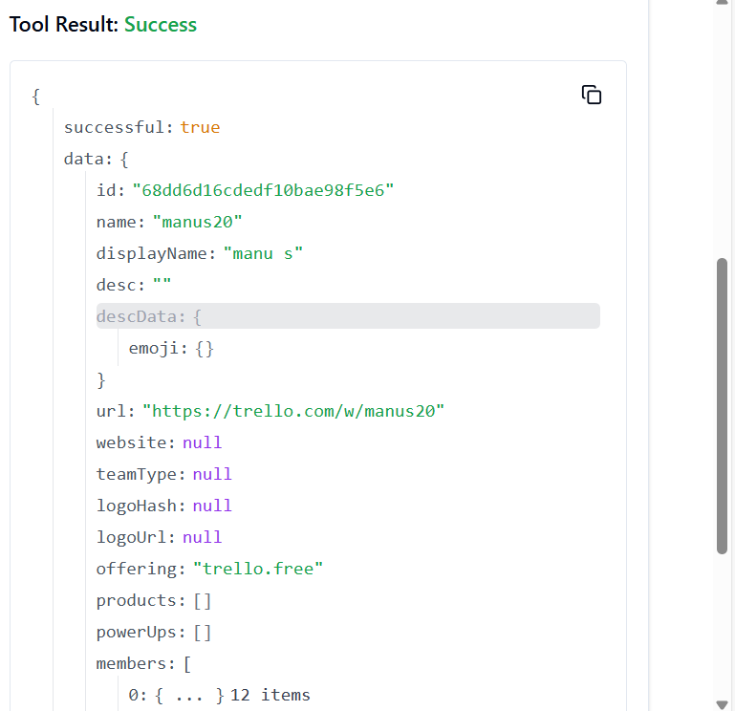

**303.TRELLO_DELETE_ORGANIZATIONS_MEMBERS_ALL_BY_ID_ORG_BY_ID_MEMBER**

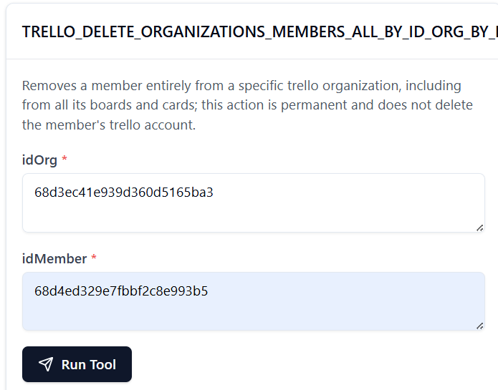

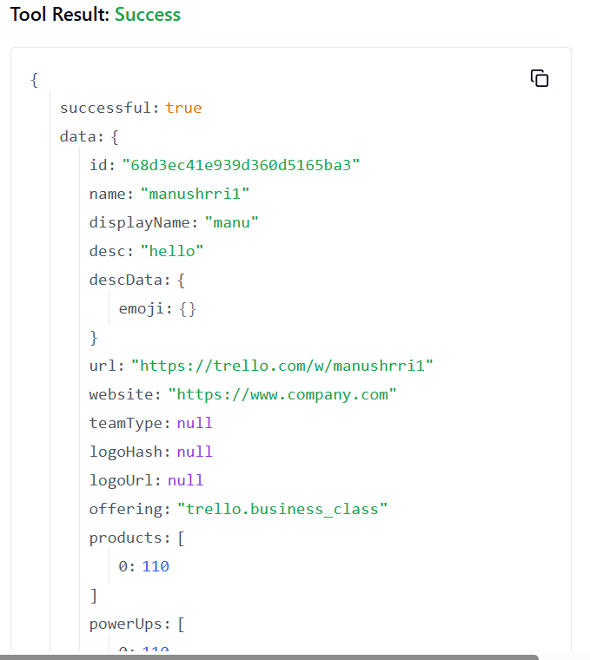

**304. TRELLO_DELETE_TOKENS_BY_TOKEN**

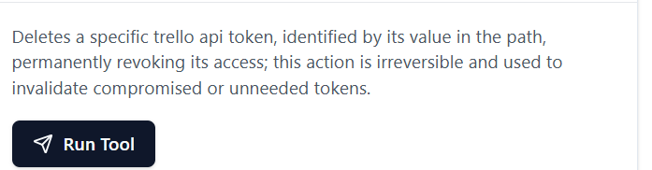

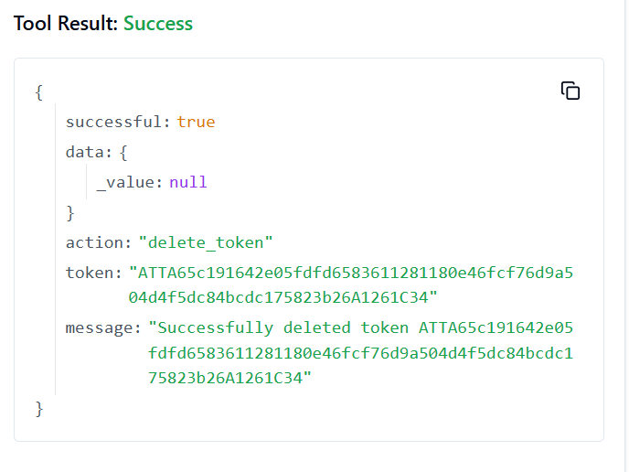

**305. TRELLO_DELETE_TOKENS_WEBHOOKS_BY_TOKEN_BY_ID_WEBHOOK**

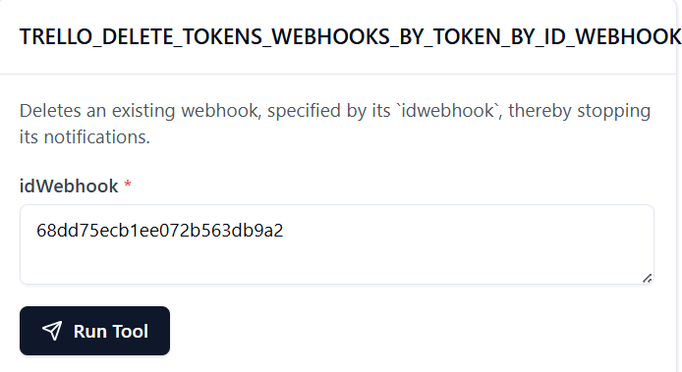

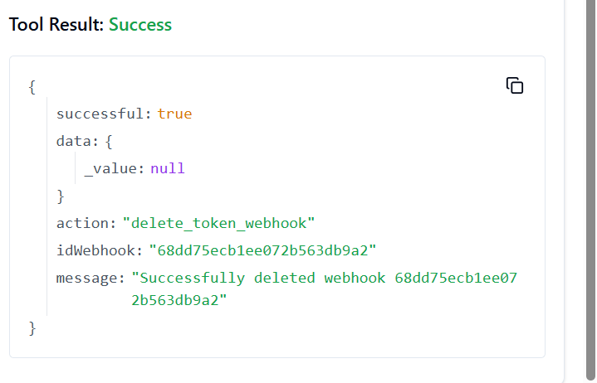

**306. TRELLO_DELETE_WEBHOOKS_BY_ID_WEBHOOK**

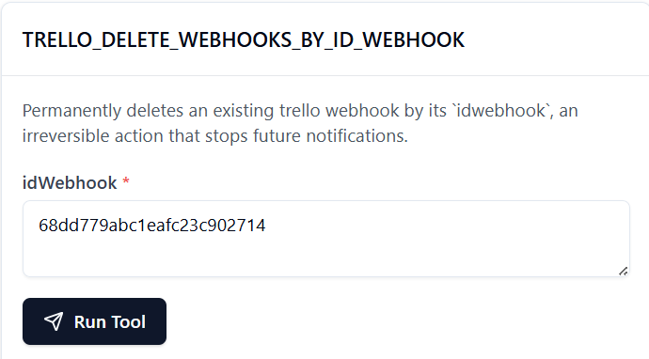

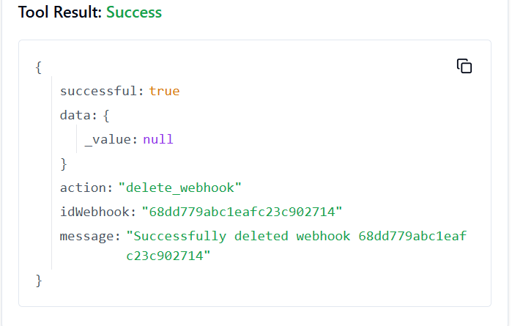

**307. TRELLO_DISMISS_MEMBER_MESSAGE**

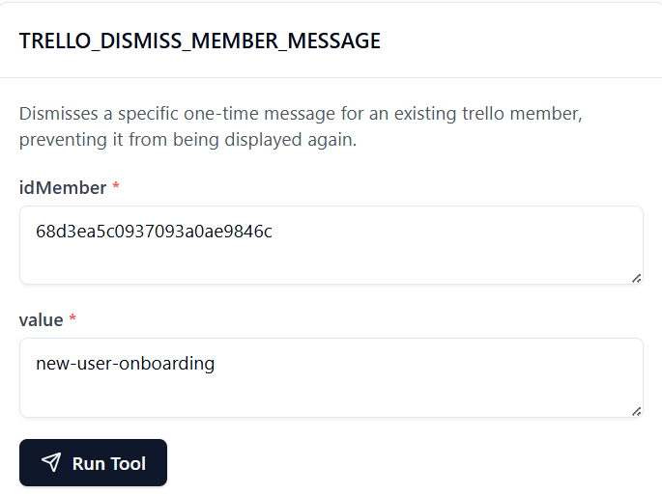

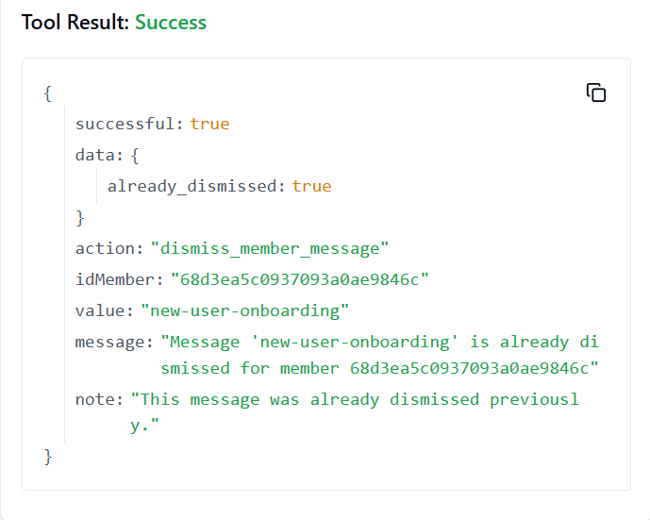

**308. TRELLO_DELETE_ORG_ASSOCIATED_DOMAIN**

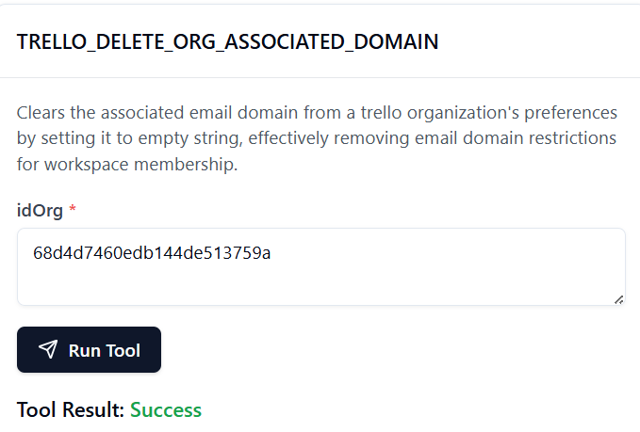

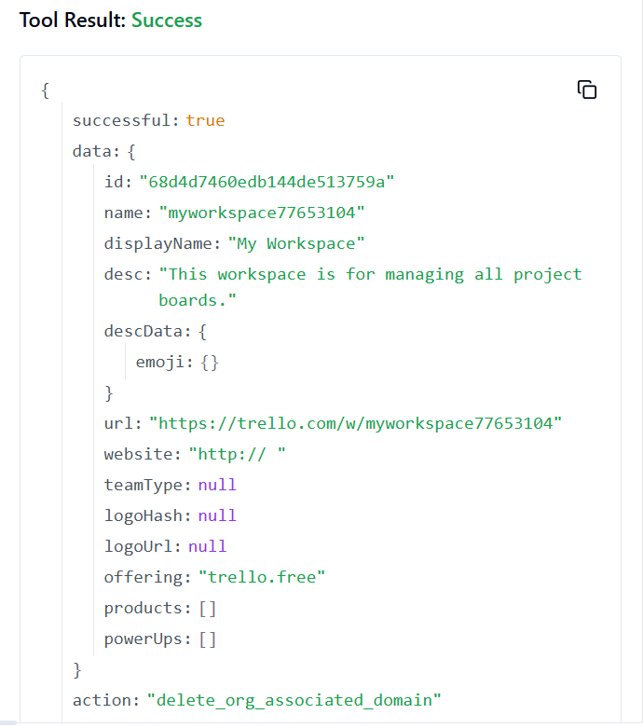

**309. TRELLO_DELETE_ORGANIZATIONS_PREFS_ORG_INVITE_RESTRICT_BY_ID_ORG**

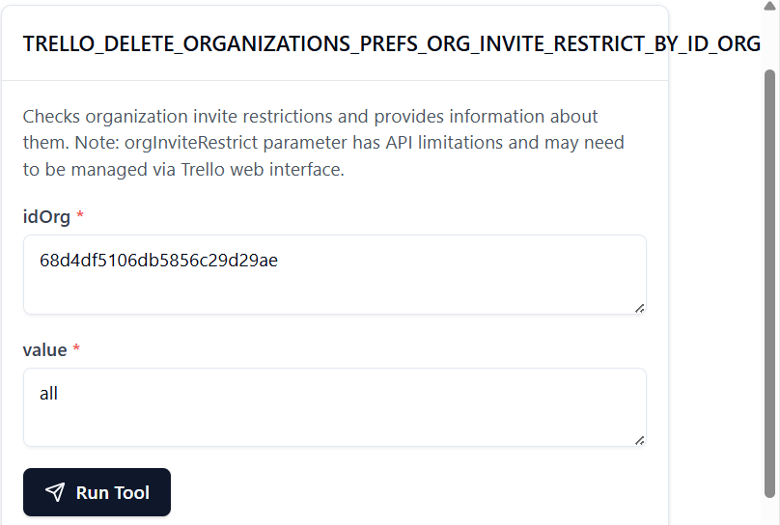

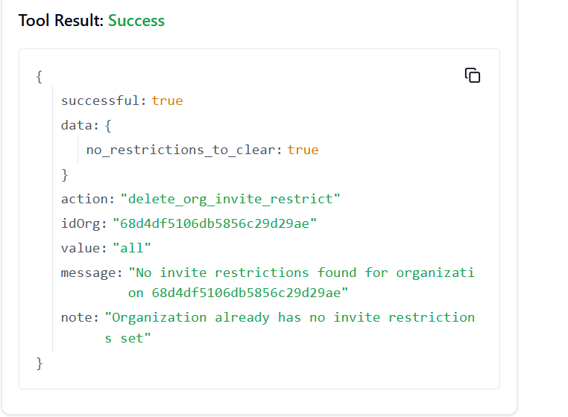

**310. TRELLO_DELETE_CARDS_MEMBERS_VOTED_BY_ID_CARD_BY_ID_MEMBER**

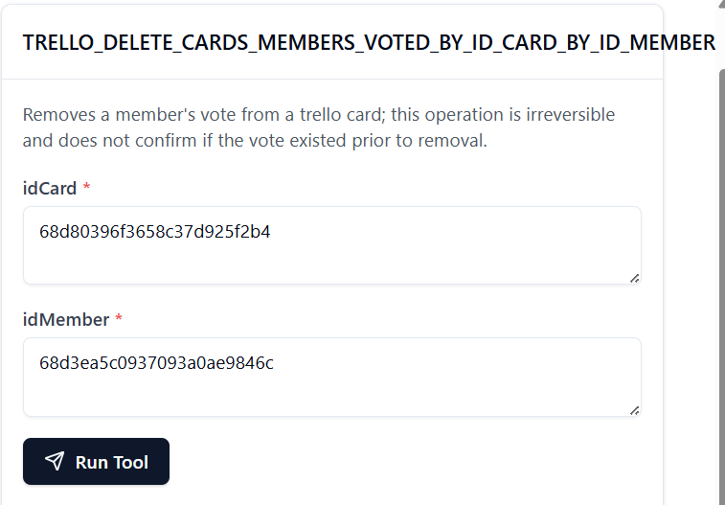

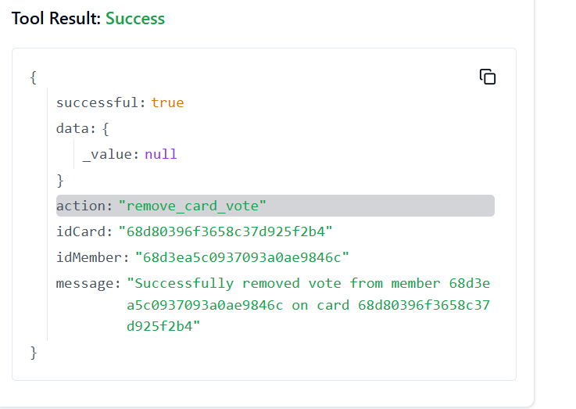

**311. TRELLO_UPDATE_MEMBERS_AVATAR_SOURCE_BY_ID_MEMBER**

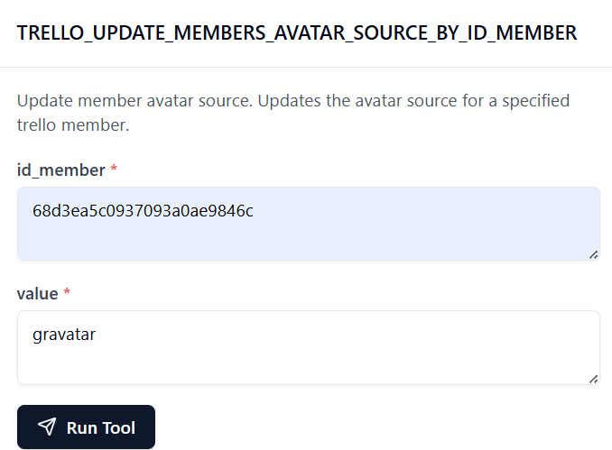

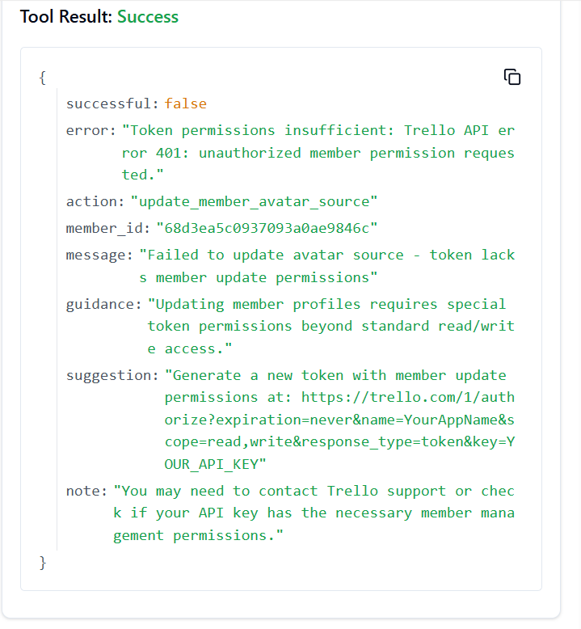

**312.** **TRELLO_UPDATE_MEMBERS_BY_ID_MEMBER**

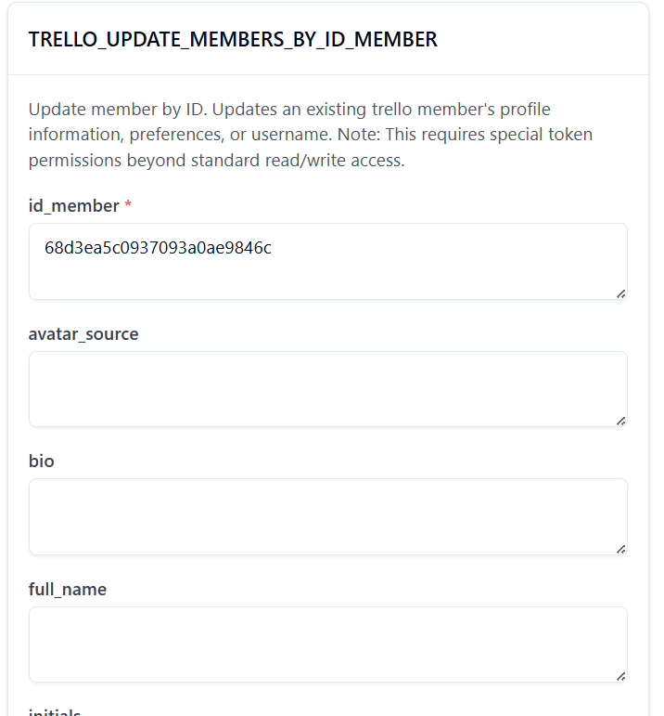

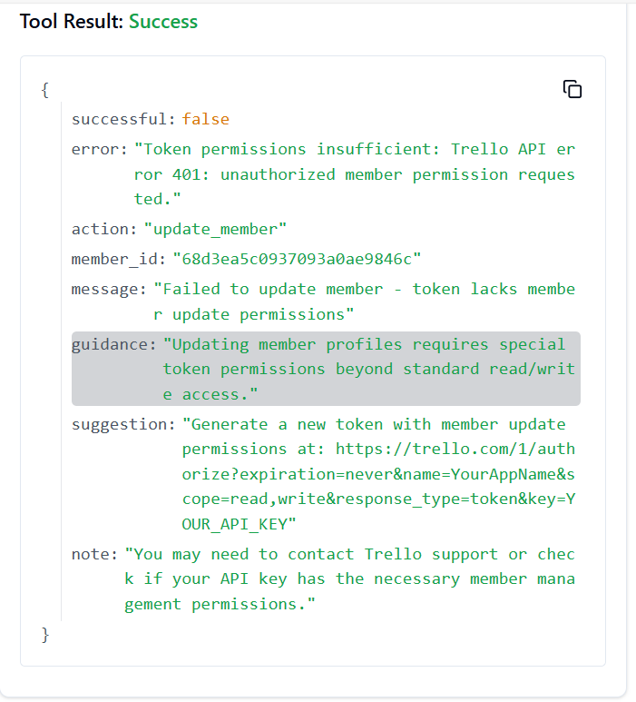

**313. TRELLO_UPDATE_MEMBERS_FULL_NAME_BY_ID_MEMBER**

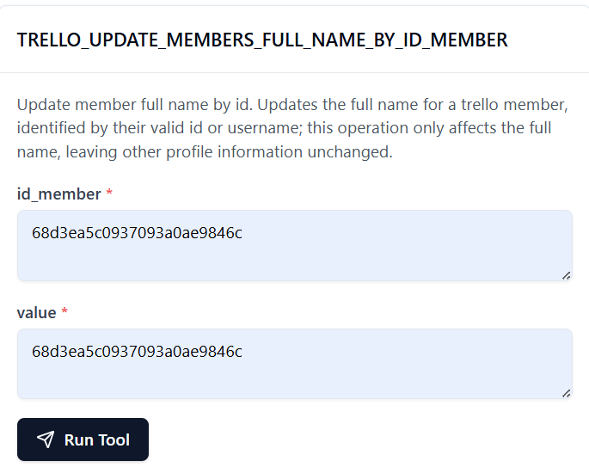

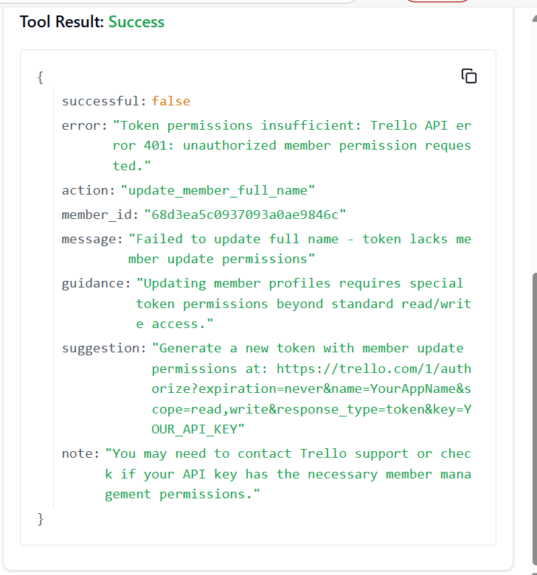

**314. TRELLO_UPDATE_MEMBERS_INITIALS_BY_ID_MEMBER**

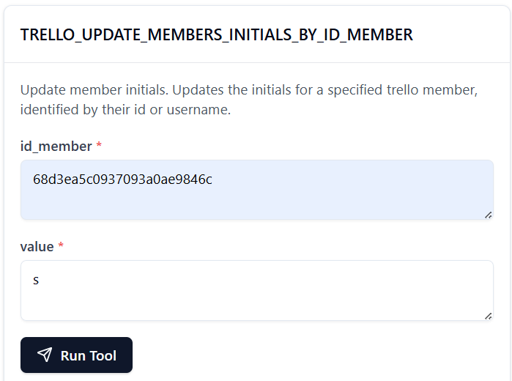

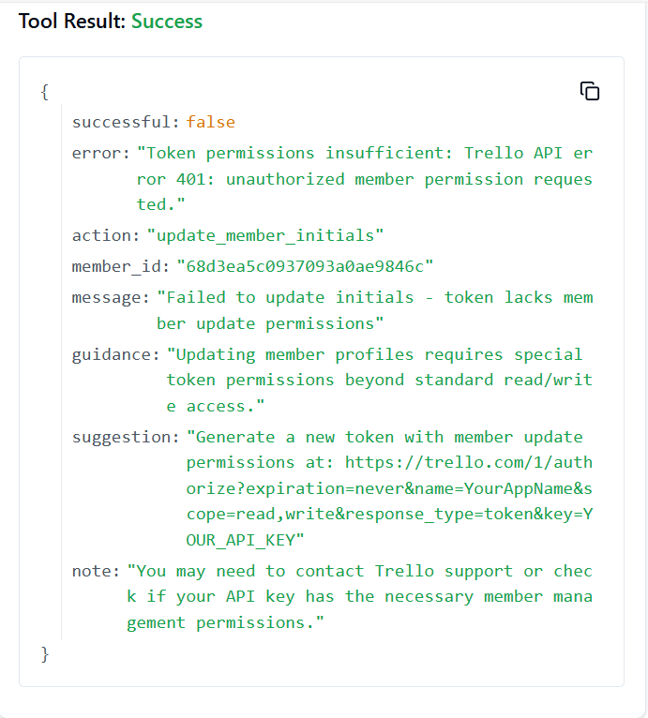

**315. TRELLO_UPDATE_MEMBERS_PREFS_COLOR_BLIND_BY_ID_MEMBER**

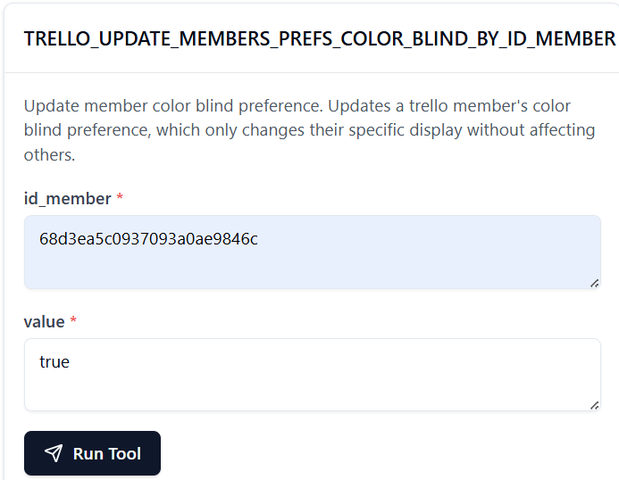

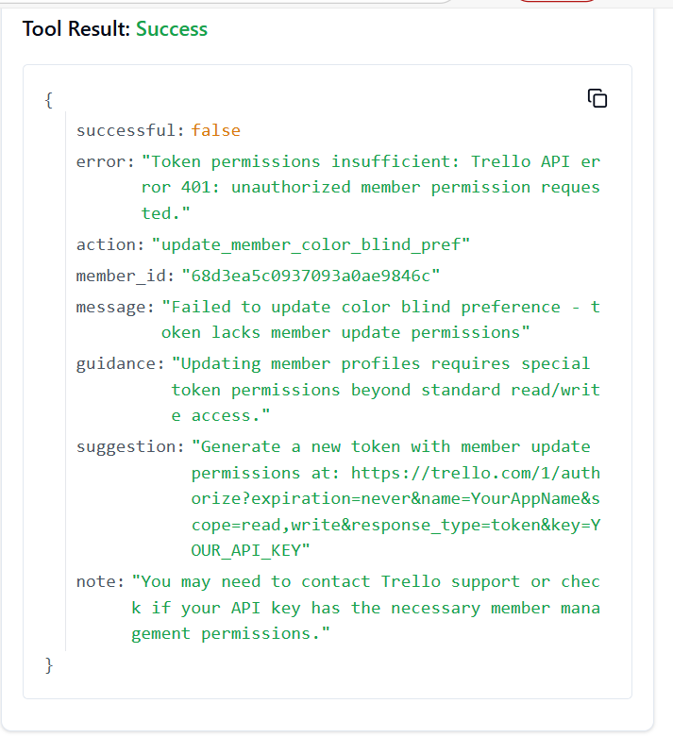

**316. TRELLO_UPDATE_MEMBERS_USERNAME_BY_ID_MEMBER**

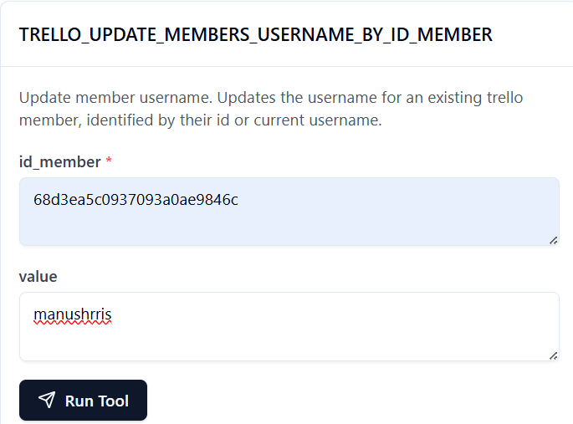

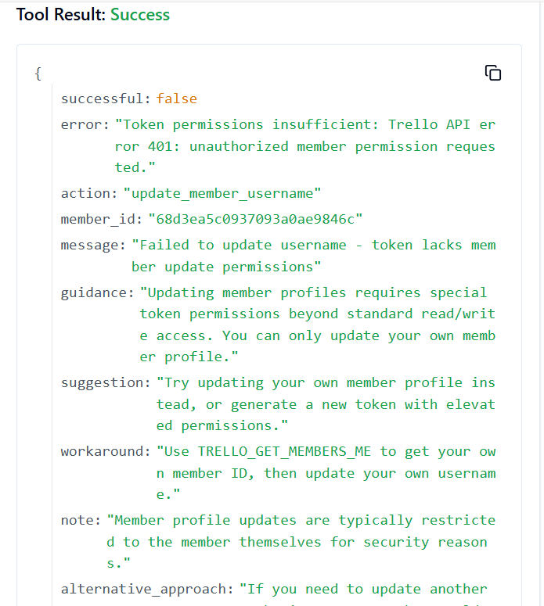

**317. TRELLO_UPDATE_BOARDS_MY_PREFS_SHOW_LIST_GUIDE_BY_ID_BOARD**

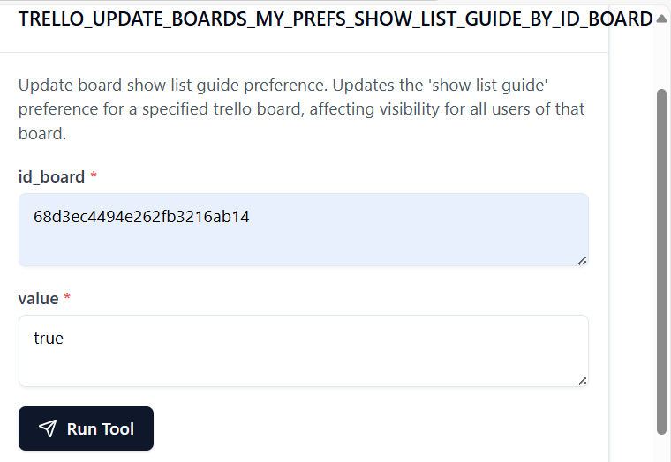

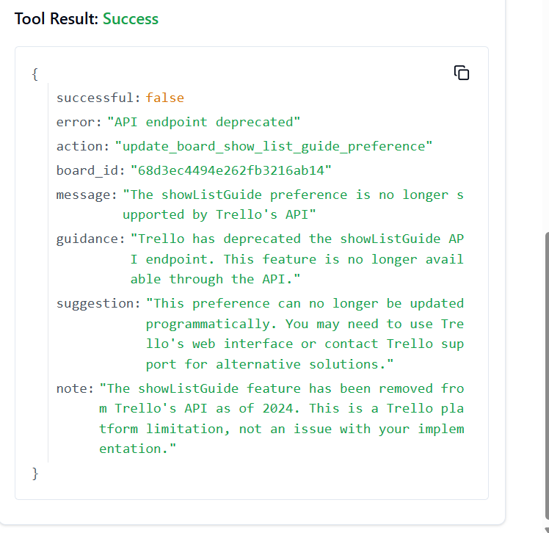

**ATTACHEMENT TOOLS:**

1. **TRELLO_ADD_CARDS_ATTACHMENTS_BY_ID_CARD**
2. **TRELLO_ADD_MEMBERS_AVATAR_BY_ID_MEMBER**
3. **TRELLO_ADD_MEMBERS_BOARD_BACKGROUNDS_BY_ID_MEMBER**
4. **TRELLO_ADD_MEMBERS_CUSTOM_BOARD_BACKGROUNDS_BY_ID_MEMBER**
5. **TRELLO_ADD_MEMBERS_CUSTOM_EMOJI_BY_ID_MEMBER**
6. **TRELLO_ADD_MEMBERS_CUSTOM_STICKERS_BY_ID_MEMBER**
7. **TRELLO_BOARD_GET_BY_ID**
8. **TRELLO_BOARD_GET_CARDS_BY_ID_BOARD**
9. **TRELLO_CARD_CREATE_AND_UPDATE**
10. **TRELLO_CARD_GET_BY_ID**
11. **TRELLO_CARD_UPDATE_BY_ID_CARD**
12. **TRELLO_DELETE_CARDS_ATTACHMENTS_BY_ID_CARD_BY_ID_ATTACHMENT**
13. **TRELLO_GET_BOARDS_CARDS_BY_ID_BOARD_BY_ID_CARD**
14. **TRELLO_GET_BOARDS_MEMBERS_CARDS_BY_ID_BOARD_BY_ID_MEMBER**
15. **TRELLO_GET_CARDS_ATTACHMENTS_BY_ID_CARD_BY_ID_ATTACHMENT**
16. **TRELLO_GET_CARDS_BY_ID_CARD**
17. **TRELLO_GET_CHECKLISTS_CARDS_BY_ID_CHECKLIST**
18. **TRELLO_GET_LISTS_CARDS_BY_ID_LIST**
19. **TRELLO_GET_MEMBERS_BY_ID_MEMBER**
20. **TRELLO_GET_MEMBERS_CARDS_BY_ID_MEMBER**
21. **TRELLO_GET_ORGANIZATIONS_MEMBERS_CARDS_BY_ID_ORG_BY_ID_MEMBER**
22. **TRELLO_GET_SEARCH**
23. **TRELLO_LIST_GET_CARDS_BY_ID_LIST**
24. **TRELLO_MEMBER_GET_BY_ID**
25. **TRELLO_SEARCH_GET_RESULTS**
26. **TRELLO_UPDATE_CARDS_BY_ID_CARD**
27. **TRELLO_UPDATE_CARDS_ID_ATTACHMENT_COVER_BY_ID_CARD**
28. **TRELLO_UPDATE_CARDS_STICKERS_BY_ID_CARD_BY_ID_STICKER**